MINUTES OF THE ORDINARY MEETING OF TEYNHAM PARISH COUNCIL HELD ON TUESDAY 5TH MAY 2026 AT TEYNHAM COMMUNITY HALL, 89 STATION ROAD, TEYNHAM DIRECTLY FOLLOWING THE ANNUAL PARISH COUNCIL MEETING.

Present: Cllr Dixon, Cllr Dunne, Cllr Mann, Cllr Jessup, Cllr Parr,
Cllr Townson (Chairman). and Clerk – Hayley Steel.

Absent: Cllr Sharman

- Apologies for absence.

Cllr Simester, Cllr Barnett, Cllr Macdonald, Cllr Saromi, SBC Speed, SBC Bowen and KCC Lehman.

- Declarations of Interests on Items on the Agenda.

None.

- To confirm that any changes to the Registers of Interests have been forwarded to the Monitoring Officer.

None.

- Public Session for 20 minutes to allow members of the public and Councillors with pecuniary interests to speak for no more than three minutes in respect of the business on the agenda. A question shall not require a response at the meeting nor start a debate on the question.

A member of the public asked about the poor state of the Frognal Place development as the fences are in a poor state and overgrown hedges. The Clerk will contact the Planning Officer at Swale Borough Council to report this. They also asked if Planning permission was still granted as the developer had pulled out and Cllr Townson said that planning permission was still in place. Member of the public asked if a GP surgery would be coming to Teynham. The Parish Council does not have an update on this.

A member of the public spoke about the Planning application for the George Public house and whether this is in a conservation area? We will try and find out.

- Receive brief update from ward councillor(s) on items relating to the parish of Teynham (total of 5 mins, max)

No Swale Borough Councillors were present at the meeting.

- To approve the minutes from the Annual Parish Meeting on 14th April 2026.

Carry forward to next meeting.

- Matter arising.

Carry forward to next meeting.

- To approve the minutes from the Ordinary Parish Council Meeting on 14th April 2026.

It was moved by Cllr Parr, seconded by Cllr Jessup and

RESOLVED: “That Teynham Parish Council take the minutes of the Ordinary Parish Council Meeting on 14th April 2026 as a true record.”

- Matters arising.

The Clerk will chase Amiga regarding the new sensor for the fire alarm.

- Chairman’s report.

It’s been a busy period, in particular work linked to research around the Community Hall and gathering community views. We have received an offer from Rodmersham Village Hall to visit their building to look at their heating system. Thank you to everyone for your continued commitment and time. Updates on individual projects later in the meeting.

Community Hall
- Receive an update on the heating and agree interim activities.
Community

Cllr Jessup advised the PC that we had received a quote for £38k to install new heating system. Another option was to do a temporary fix. We have been contacted by Rodmersham PC as they have had a new system installed much cheaper than our quote. A visit will be planned to go and have a look and find out more.

It was agreed that we would do some remedial work on the hall and spruce up the entrance hall and outside of the building.

It was moved by Cllr Jessup, seconded by Cllr Dunne and

RESOLVED: “That Teynham Parish Council would carry out remedial work to the Community Hall and decorate the entrance way and outside of the hall at low or no cost.”

- Receive update on Speedwatch campaign.

Eleven people have volunteered to take part and we will make contact with PC Divers and Allen and make arrangements for training etc.
- Note written report on current projects (sent in advance).
The Chair gave a brief overview on current projects and thanked everyone for their help.
- Allotments—Large pot holes reported on the access road.
- CH Fire Alarm—Fire alarm stage sensor had fault; Sensor de-activated.
- CH Emergency Lighting—Electrician scheduled to reviewed external lights.
- CH Heating—Currently seeking community views.
- CH side gate / front area—The front area has been jet washed and cleaned; Side gate painted with wood preserver.
- CH PAT—testing Clerk in process of finding an electrician
- Activities for young people—Draft list completed to be circulated
- Drop In Cafe—Dates for 2026 published on Facebook and noticeboards
- Drop In Cafe—Volunteers Rota Paul and Amanda Seymour are helping Clive set the tables up.
- Community planters—The planters have been painted with wood preserver.
- High Ball Fence—The high ball fence has been installed. Installation inspected. Currently generating a snagging list. Update sent to the National Lottery.
- Grass Cutting Contract—Getting additional quotes as price increased by c £500 pa
- Meadow Annual Inspection—Request to bring forward inspection. Quoted £420 plus VAT to complete in next 4 weeks for next agenda
- Speed Watch—11 Volunteers have come forward. Currently setting up online training.
- Forward Planning—Dates booked for Xmas Lantern Parade & Market (29th November).
Amenities
- Receive a brief update on The Meadow (concerns and opportunities).
The big round swing – work will be carried out by Cllr Jessup
The Muga – there are a few sharp edges – work will be carried out by Cllr Jessup
Roundabout – this will be looked at by the committee
Old goal posts – these will be moved by Cllr Jessup
- To consider whether to host a structured community meeting focused on the use, safety, and user experience of the Meadow play area, and to identify practical, proportionate actions to improve outcomes.

Offers of help were received from Cllr Jessup, Cllr Dunne, Cllr Parr, Cllr Townson and Cllr Mann. We would try and sort out a meeting for June.

It was moved by Cllr Dunne, seconded by Cllr Parr and

RESOLVED: “That Teynham Parish Council will host a structured community meeting focused on the use, safety and user experience of the Meadow play area, and identify practical, proportionate actions to improve outcomes.”
Finance
- Receive updated financial position (Scribe financial report).

The Clerk distributed printed copies the latest scribe reports (summary version), which were noted by the members present.

The Chair asked members of the Parish Council to read this report and send any questions/observations to the Clerk.

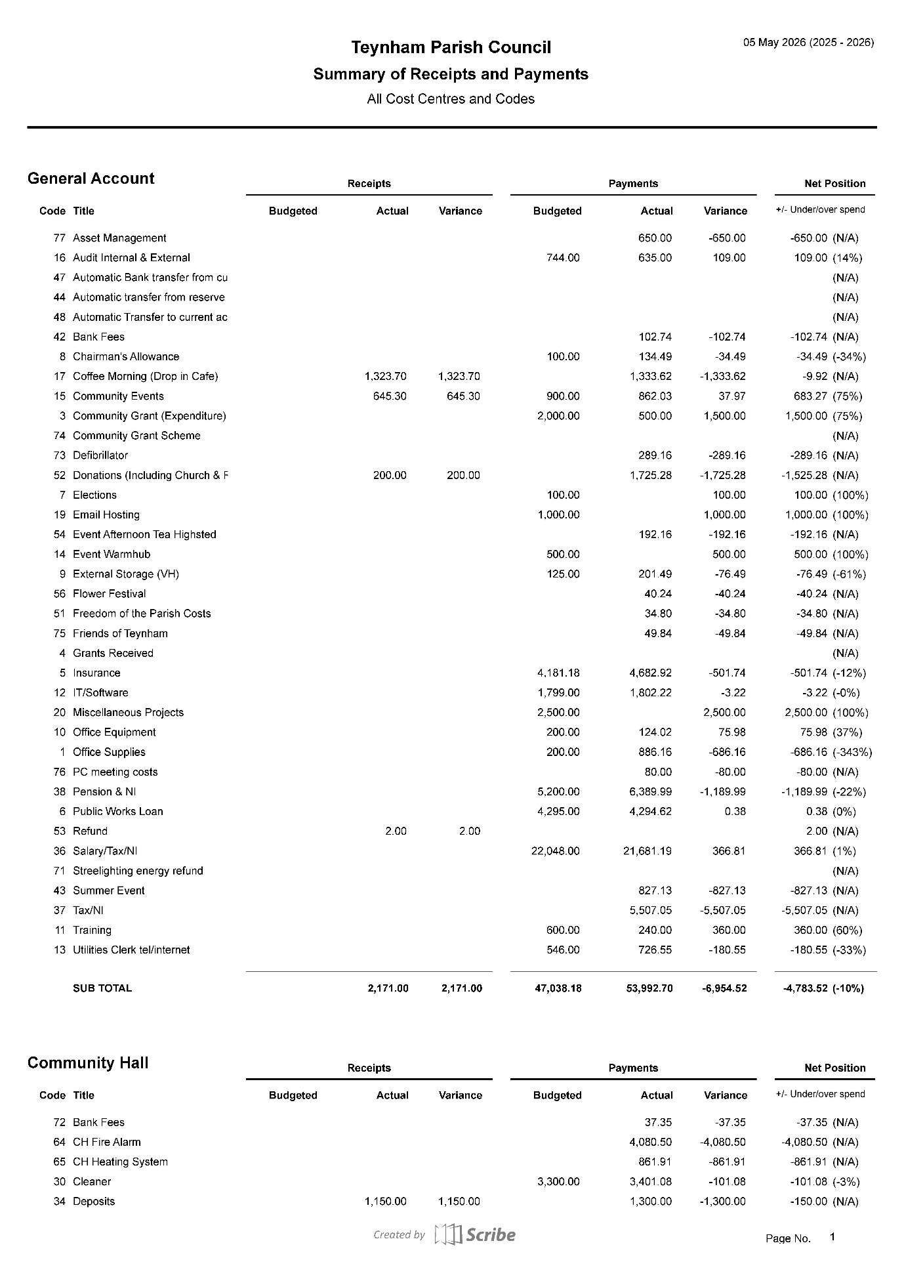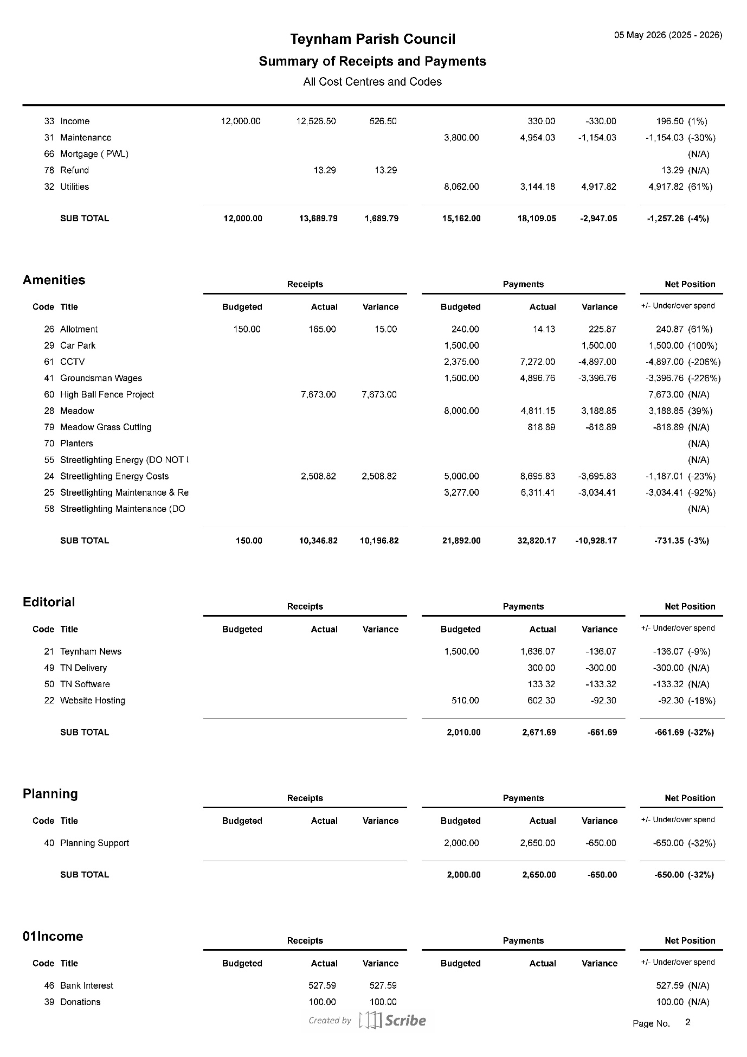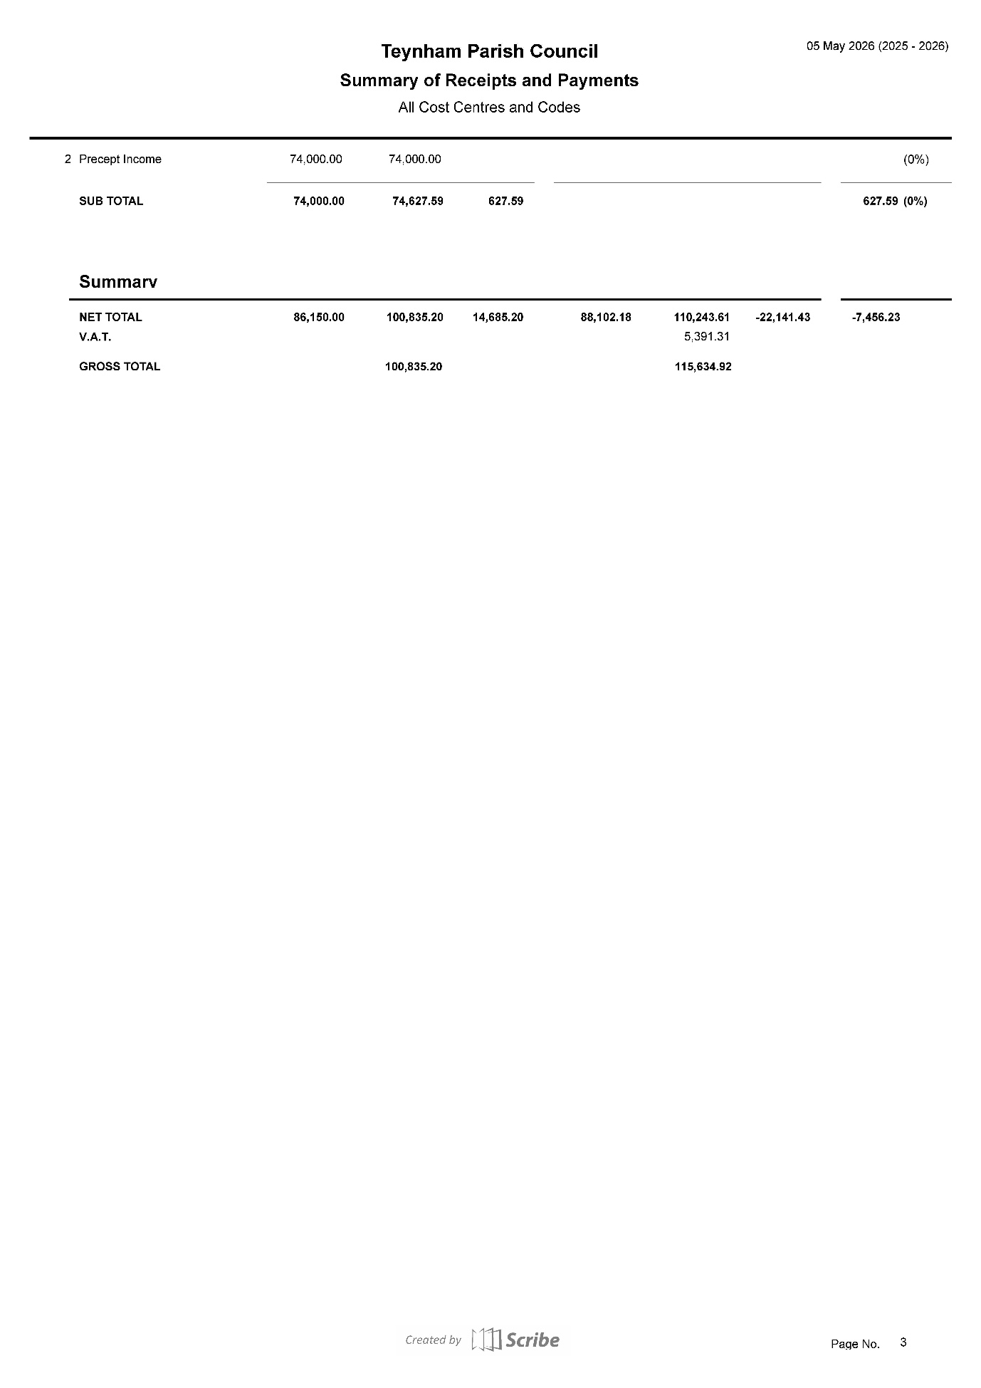

- To approve the Parish Council’s Zurich insurance policy for 2026-27 at a cost of £4,898.16 and agree payment.

Members of the council noted that the level of cover provided by the insurance company for the community hall had substantially increased.

It was moved by Cllr Dixon, seconded by Cllr Jessup and

RESOLVED: “That Teynham Parish Council agree Zurich’s insurance policy for 2026-27 at the cost of £4,898.16 and agree payment.”

- To approve temporary arrangements during the clerk's planned absence (12th May to 26th May 2026.

Noted.

The Chair advised that, following advice from the Monitoring Officer at Swale Borough Council, Agenda Item 19 would be considered in closed session at the end of the meeting due to the confidential nature of the matters to be discussed. The public were excluded from the meeting for the consideration of this item.

- To consider the position of Cllr Brian Sharman in relation to Section 85 of the Local Government Act 1972 (non-attendance), including whether previous Parish Council minutes constitute approval of absence.

It was moved by Cllr Mann, seconded by Cllr Dixon and

RESOLVED: “That the Council formally approves the reason for Cllr Sharman's ongoing absence due to ill health, with this approval to be reviewed at the Full Council meeting in July 2026.”

- Advanced Notice of Items for the Agenda of next Ordinary Meeting.

Send to Clerk.

To be added, AGAR approval, agree Hall options.

- To note next year’s meeting dates
    - Tuesday 16th June 2026 Extra Ordinary Meeting
    - Tuesday 7th July 2026 Ordinary Meeting
    - Tuesday 1st September 2026 Ordinary Meeting
    - Tuesday 6th October 2026 Ordinary Meeting
    - Tuesday 10th November 2026 Ordinary Meeting
    - Tuesday 15th December 2026 Budget/Precept & Ordinary Meeting

- Chairman’s Closing Remarks

The Chair thanked everyone for coming and the meeting closed at 9.30pm.

