DRAFT MINUTES OF THE ORDINARY MEETING OF TEYNHAM PARISH COUNCIL HELD ON TUESDAY 21ST OCTOBER 2025 AT TEYNHAM COMMUNITY HALL, 89 STATION ROAD, TEYNHAM AT 7.30PM.

Present: Cllr Brodigan, Cllr Dunne, Cllr Jessup, Cllr Mann, Cllr Mcdonald,
Cllr Townson (Chairman), Cllr Sharman, Clerk Hayley Steel.

Absent: Cllr Saromi

1. Apologies for absence

Cllr Simester, Cllr Barnett, Cllr Dixon, SBC Speed, SBC Bowen and KCC Lehman.

2. Declarations of Interests on Items on the Agenda.

Cllr Townson declared an interest as he is the owner of Frognal Farmhouse and we will be discussing Highsted Park Inquiry.

3. To confirm that any changes to the Registers of Interests have been forwarded to the Monitoring Officer.

None.

4.Public Session for 20 minutes to allow members of the public and Councillors with pecuniary interests to speak for no more than three minutes in respect of the business on the agenda. A question shall not require a response at the meeting nor start a debate on the question.

No members of the public were present.

5.Receive an update from ward and county councillor(s) on items relating to the parish of Teynham (max 5 mins each).

No ward of county councillors were present.

6.To approve the minutes of the Ordinary Parish Council Meeting on Tuesday 16th September 2025.

It was moved by Cllr Dunne, seconded by Cllr Jessup and

RESOLVED: “That the minutes of the Ordinary Parish Council Meeting on Tuesday 16th September 2025 be taken as a true record.”

7. Matters Arising.

None.

8. Chairman’s update (Sent in advance).

Chair’s Update
There is a lot going on at the moment. Here is a brief update.
Correspondence:
- Invitation received to join the Remembrance Sunday Service, St Mary’s.
- Invitation to review/update KCC’s Highway Improved Plan for our area. Will circulate.
- Successful grant for High Ball Fence.
Flower Festival: Thanks to Clerk Hayley Steel and Cllr Patricia Dunne for the excellent flower and produce display at St Mary’s Church. Also, sincere thanks to councillors and residents for their generous contributions — a true community effort.
Meadow: Tree reduction and bush management look excellent. Thank you to Dave Gurney.
Children’s Play Equipment: Thanks to Cllrs Lisa Simester, Colin ​​Jessup, Patricia Dunne, Fay Macdonald, Kate Barnett and Clive Brodigan for their help in the Meadow. Details later in the meeting.
Fundraiser: thank you to Hayley, Patricia Dunne, David Mann and the WI Team for a successful Afternoon Tea event. £632 raised for the Action Group.
Litter Pick: Successful event — 25 bags collected by around 20 volunteers and councillors. Thanks to Swale BC for prompt rubbish collection within an hour.
Defib: Great to see the defib back and operational. Thanks Clive.
Attended:
- LKPC Annual Parish Meeting: Topics included Kent Air Ambulance and Lynsted Community Kitchen Garden. An engaging meeting format.
- KALC Swale Area Committee: Community Governance Review, starts Dec 2025
- Highsted Park Planning Inquiry: Conditions Day #1
Hosted: Highsted Park Planning Inquiry — thanks to neighbouring parishes for attending (Beverly Smith, Tongue PC & Steve Coates, Doddington PC). Attendance was small but important to provide this type of opportunity.
Email & Website: teynhamparishcouncil.gov.uk live. Opportunities to refresh content.
Financial Reporting: First glance at the new financial reports look very good. Thank you to Hayley for putting in the time to enter the data. Committees please gather feedback
Finally, thank you to Fay and Colin for offering to share their comments on their first 6 months as councillors.

9.Committee Structure and Governance: To discuss current issues regarding he Council’s committees, to agree that the Chair will draft and circulate an options paper reflecting the discussion, and that the paper will be considered and agreed at the next Full Council meeting.

It was agreed to carry this over to the next meeting.

10. Community
  - To note that the Afternoon Tea event raised funds of £631 for the Action Group towards the costs of the Highsted Park Inquiry and that all costs incurred for the event were covered by a donation. No event costs were incurred by Teynham Parish Council.

Noted

  - To note that the Litter Pick event went ahead on 20 September and we thank everyone who took part on the day.

Noted.

  - To note that Teynham Parish Council’s display for the Flower Festival at St Mary’s Church was well received. Many thanks to everyone who contributed flowers, fruit, vegetables, or their time—it was truly a community effort.

Noted.

  - To agree the budget for the Christmas events and tree.

It was moved by Cllr Dunne, seconded by Cllr Mcdonald and

Resolved: “That the Parish Council agree the budget for the Christmas activities not to exceed £900”.

  - To agree to adopt the 2026 KALC Community Awards Scheme (see briefing notes).

It was moved by Cllr Mcdonald, seconded by Cllr Dunne and

RESOLVED: “That Teynham Parish Council adopt the 2026 KALC Community Awards Scheme.”

  - To consider a community group for Freedom of the Parish (see briefing notes).

It was agreed to look into the KALC Community Award scheme first to get ideas.

11.Finance & GP
  - To approve/note expenditure since the last meeting.

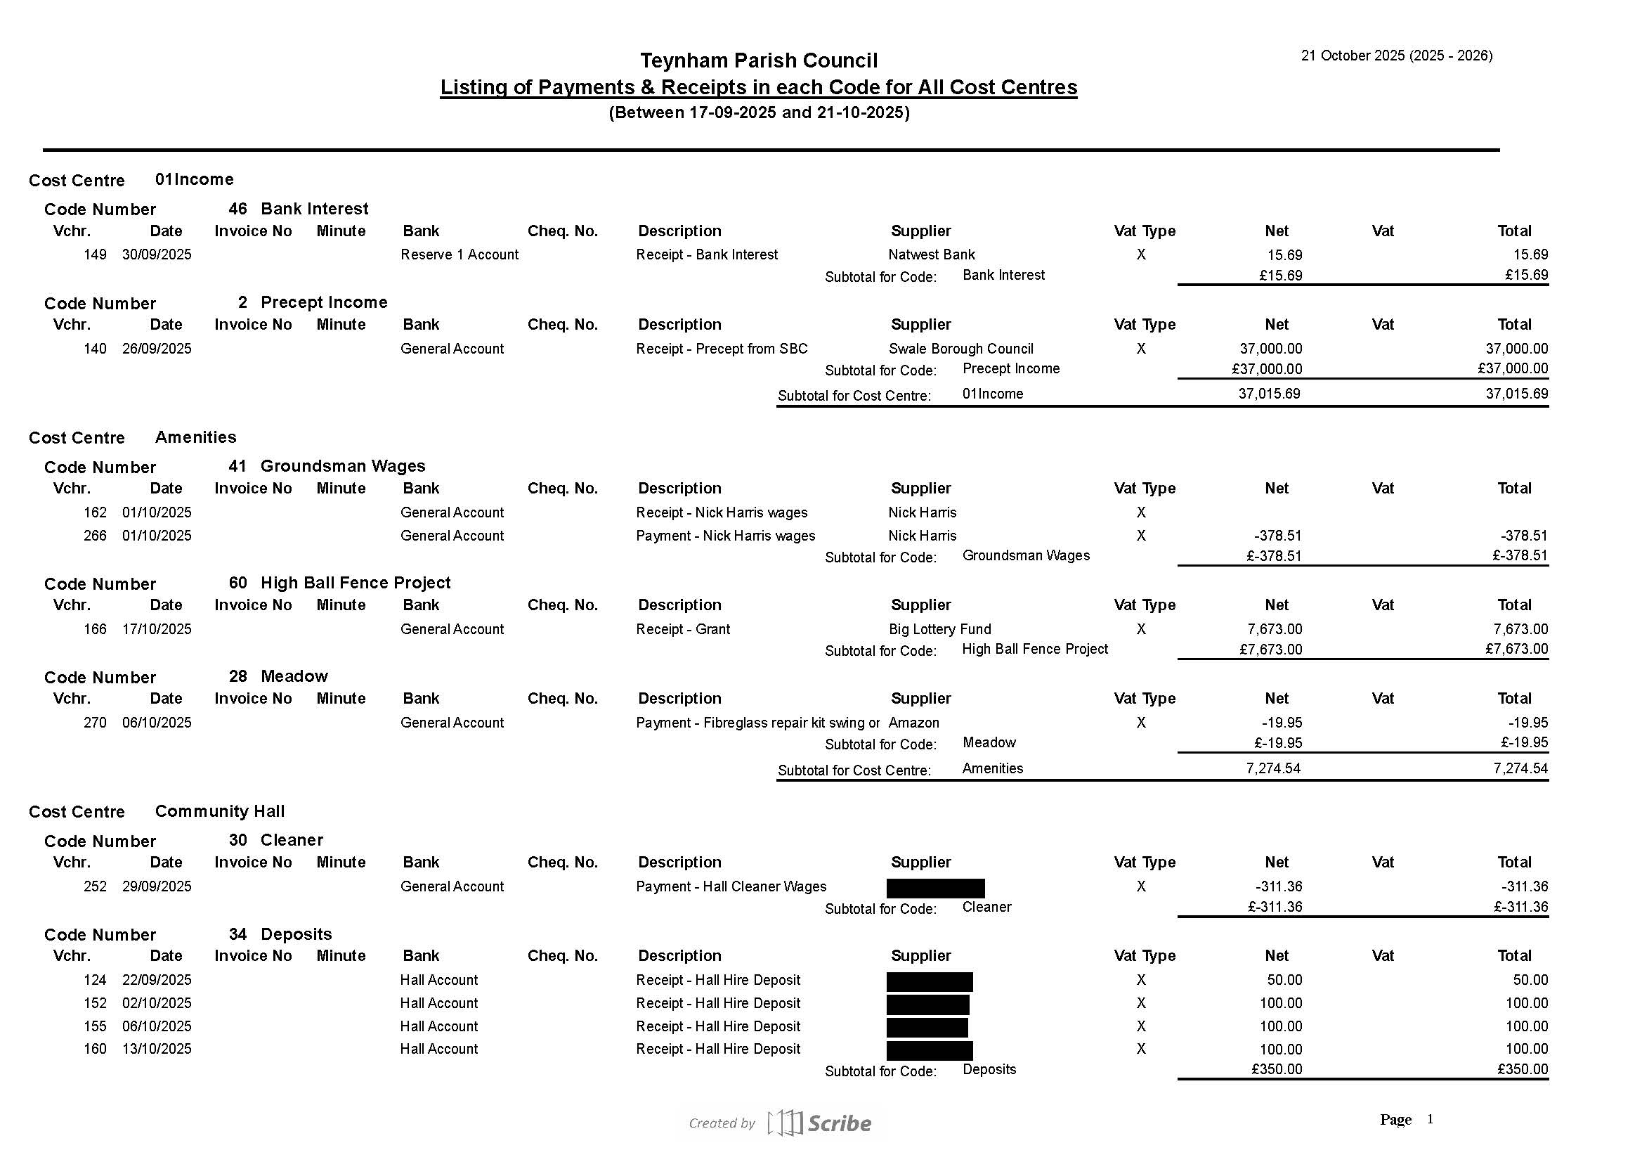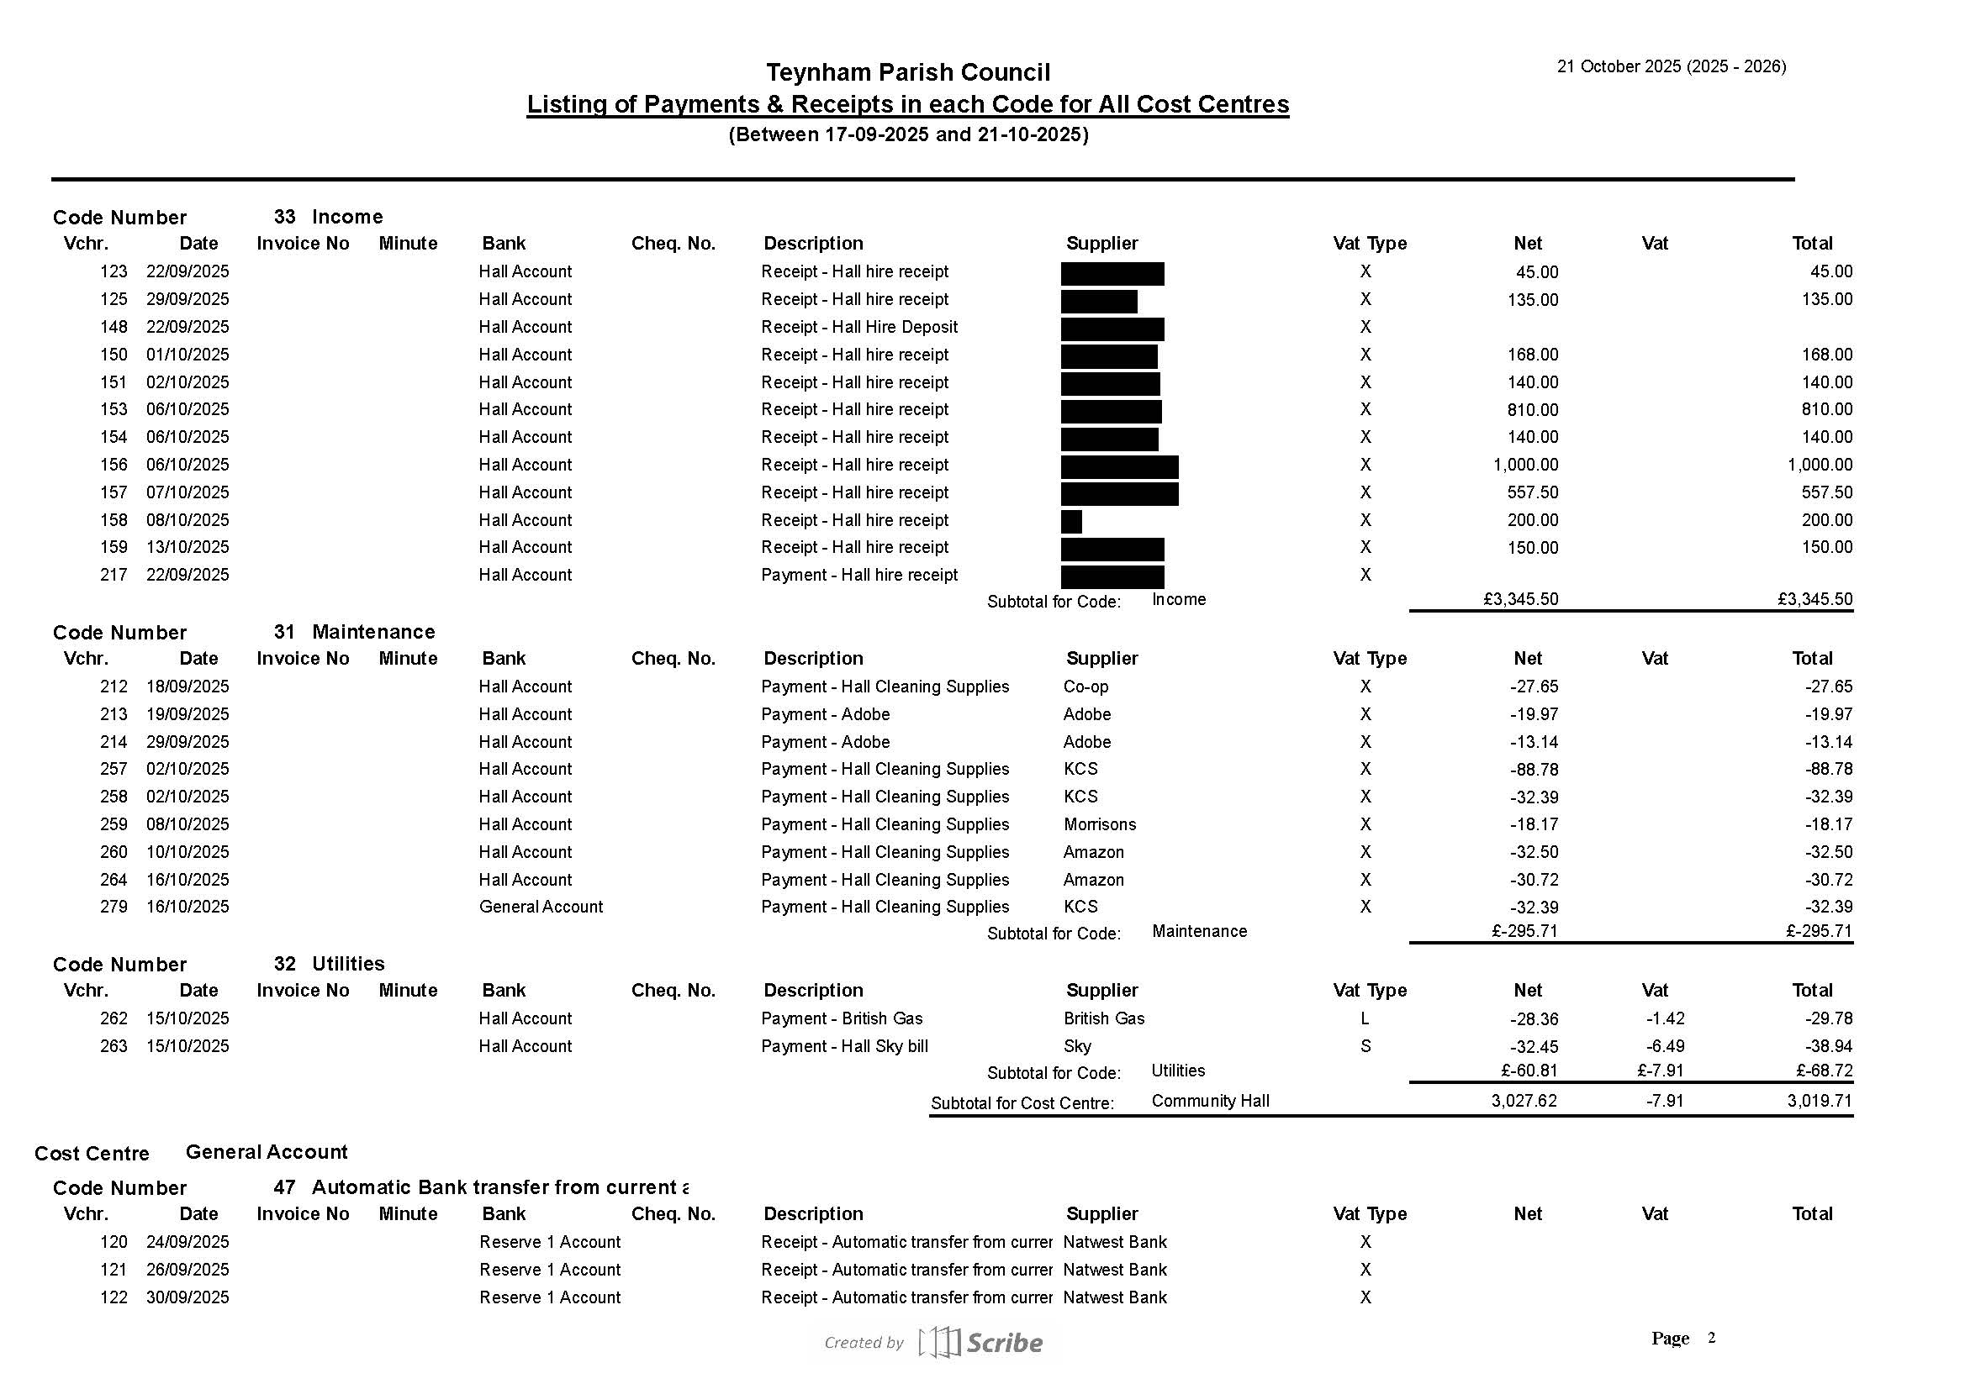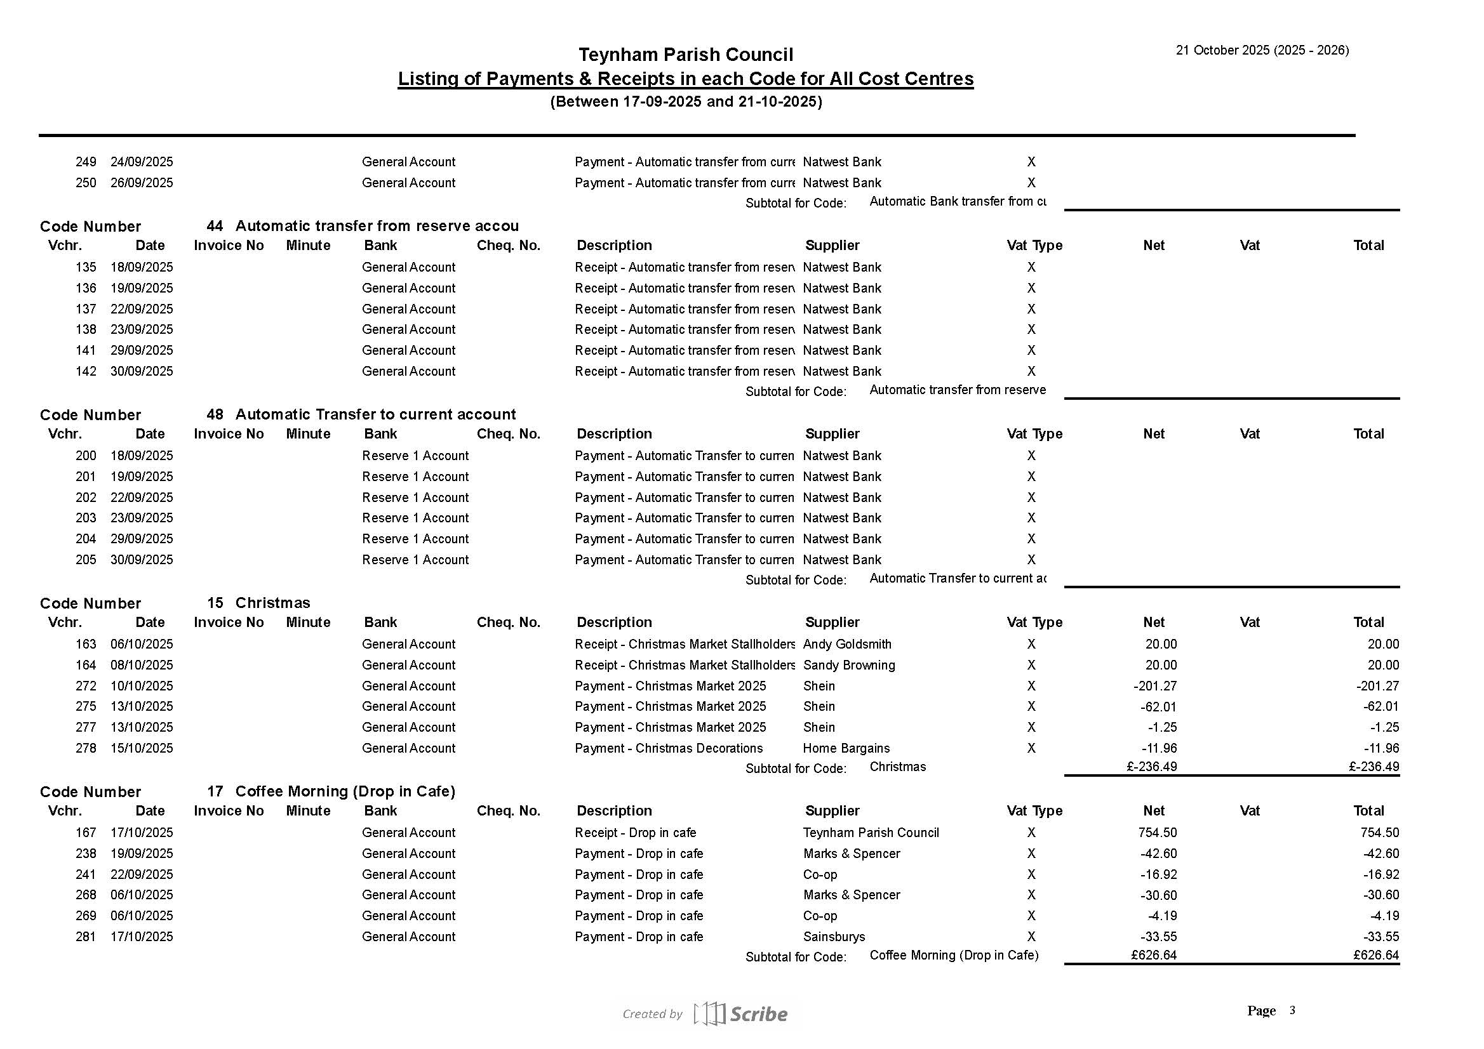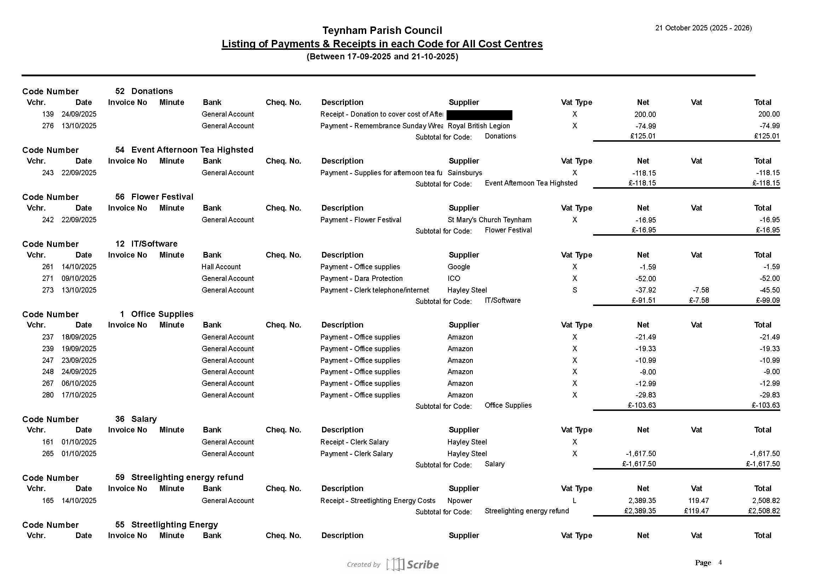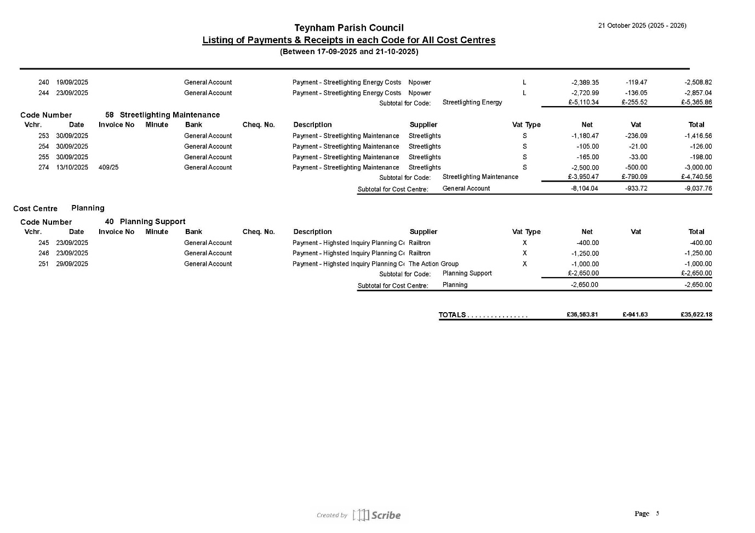

It was moved by Cllr Brodigan, seconded by Cllr Mcdonald and

RESOLVED: “That Teynham Parish Council approve the expenditure since the last meeting.”

  - Approve invoices for payment.

Nothing to approve.

  - Receive update on authorised bank signatories.

The Clerk informed the Council that Cllrs Simester and Mann have now been added as signatories. We will now go ahead and add Cllr Townson as previously agreed.

  - To note the conclusion of the Audit notice for 2024/25 has been displayed on noticeboards and website and copies circulated to the Parish Council.

Noted.

  - To note bank reconciliations for April to September 2025.

Noted.

  - To agree the Preparations for Change of Registered Address (see attached papers)

Preparations for Change of Registered Address
Background: | The Parish Clerk will be moving house on 1 November 2025, which means the Council’s registered address must also change.  The Council needs to agree how to manage this change to ensure continuous correspondence and compliance with statutory requirements.
Decision Required | - To agree the process and timing for updating the registered address.  - To approve postal redirection and associated cost.  - To authorise the Clerk to notify all relevant bodies and providers of the change of address.
ACTIONS TO BE AGREED
- Confirmation | The Parish Clerk confirms the full new address to all members of the council, via email, including the start of tenancy.
- Notifications | Inform the following organisations and groups  Statutory, Financial & Legal  - Swale Borough Council (HIGH PRIORITY)  - Monitoring officer  - Parish Council Contact List  - Finance Team  - Kent County Council  - Kent Pension Fund  - Bank (HIGH PRIORITY)  - HMRC (HIGH PRIORITY)  - Internal auditor (HIGH PRIORITY)  - Insurance provider (HIGH PRIORITY)  - Information Commissioner’s Office (ICO)  - KALC and NALC records  - Public Works Loan  Suppliers & Contractors  - Focus on suppliers who send us invoiches by post  Communication channels  - Website (‘contact us’ page)  - Noticeboards  - Stationery/headed paper  - Email footer (for Clerk)
- Redirection | Proposal: A Royal Mail redirection will be arranged from the current address to the new address for xx months, to ensure no correspondence is lost during the transition.  Cost:  - Up to 3 months £274.50  - Up to 6 months £403.00  - Up to 1 year £649.00

It was moved by Cllr Brodigan, seconded by Cllr Jessup and

RESOLVED: “That the Parish Council follow the proposed preparations for the Clerk’s change of address and to divert the post for three months at a cost of £274.50.”

  - Receive first draft of new financial report (Scribe software).

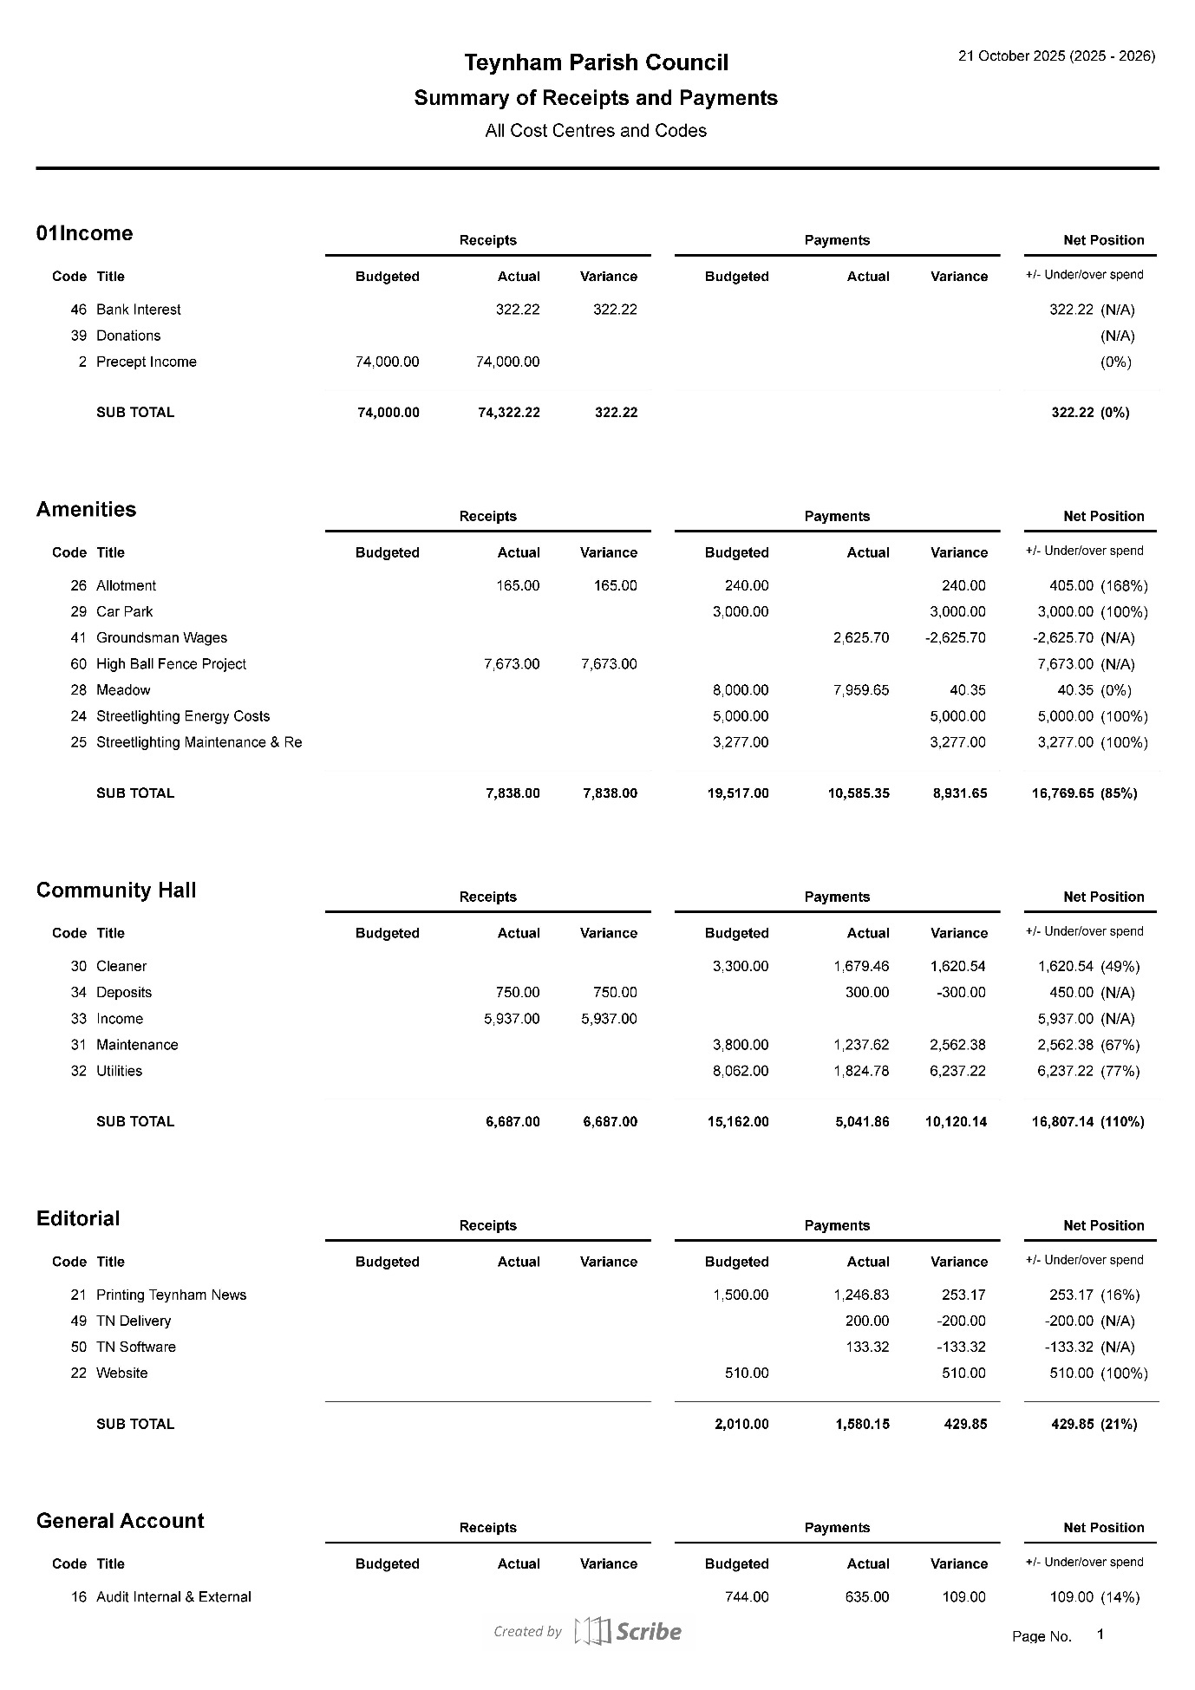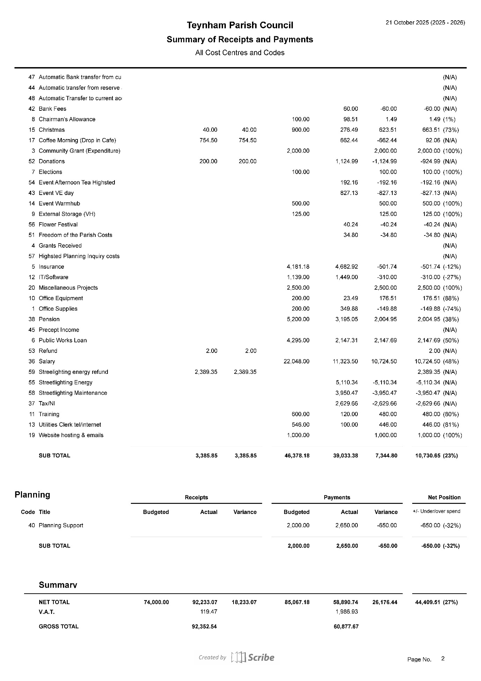
The Clerk talked the Council through the report and has asked if feedback can go through the committees.

  - To note dates for Committee meetings to prepare budgets for 2026-27.

It was noted that the meetings are as follows:-

Tuesday 4th November 10am Amenities Committee Meeting
Tuesday 11th November 10am Community Hall Committee Meeting
Tuesday 25th November 7.30pm Finance & General Purposes Committee Meeting
Tuesday 9th December 7.30pm – Budget/Precept Parish Council Meeting

The Clerk informed the Council that she will be preparing the Agenda’s and Financial reports by Friday 31st October to send to the committees.

  - To agree to switch Bank Accounts from Natwest Bank to Unity Trust Bank, and get guidance from internal auditor when is the best time to do this.

It was moved by Cllr Mcdonald, seconded by Cllr Dunne and

RESOLVED: “That Teynham Parish Council agree to switch Bank Accounts from Natwest Bank to Unity Trust Bank, and get guidance from internal auditor when is the best time to do this.”

  - To consider and approve interim operational arrangements during the Clerk’s forthcoming leave (commencing 5 November 2025).

The Clerk will work with the Chair to ensure preparations are made for the Clerk’s medical leave, and shared within the full council.

  - To note that the NALC pay scales for 2025-26 have been published and based on this information to agree the Clerk’s back pay of £399.42 and agree new rate going forward from 1st November.

The Council noted the National Association of Local Councils (NALC) recommended pay awards for the 2025/26 financial year.

It was moved by Cllr Brodigan, seconded by Cllr Mcdonald and

RESOLVED: “That the Parish Clerk’s salary be updated in line with the NALC agreed national pay award, backdated to 1 April 2025 and that the Finance & General Purposes Committee will calculate and confirm the revised salary figures in accordance with the agreed pay scales.”
  - Reflections from New Councillors: Experience and Opportunities.

Cllr Mcdonald noted that she has enjoyed her first six months on the Council and found it interesting to see how much the Parish Council do for the Community.

Cllr Jessup noted that time has “flown by” and he is really enjoying the experience . He thanked fellow Councillors and the Clerk for helping him settle in. He did note that he felt sometimes things get lost such as the issue of the station and asked if we could have a permanent list of ongoing issues so we can see where we are every month.

The Chairman acknowledged this and thought that was a good idea.

  - To note the updated Health & Safety overview and work in progress (see briefing notes).

It was noted that significant progress has been achieved with Health & Safety reviews since the July update.

- Planning
  - Receive update on Hightsted Park Planning Inquiry, including Action Group activities and funding.

The Planning Inquiry has restarted, and currently reviewing conditions. Cllr Townson informed the Council that The Action Group had now raised £42k and are expecting a bit more in from this weekends quiz and a further donation. We therefore have enough to cover our costs for the inquiry.

- Community Hall
  - FIRE ALARM: To (a) note that we missed the deadline for applying for the SBC Infrastructure Grant and to (b) agree to authorise expenditure of up to £3,000 to cover the full cost of the fire alarm (waiting for quote expected to be lower).

This is in progress and was agreed to be referred back to the Community Hall Committee who meet on 11th November and will address this then.

  - To (a) note that the basic asbestos survey was carried out, and on their advice a full survey is being recommended (b) to approve expenditure of up to £500 for the full asbestos survey (statutory requirement).

This is in progress and was agreed to be referred back to the Community Hall Committee who meet on 11th November and will address this then.

  - To (a) note that the Fixed electrical wiring has been tested and remedial work required (b) to approve the cost up to xxx

This is in progress and was agreed to be referred back to the Community Hall Committee who meet on 11th November and will address this then.

- Amenities
  - To receive an update on essential works being carried out on the Meadow.

The replacement swings have been ordered and the Clerk is going to check with our insurers as to whether we can install them ourselves.

- Streetlights
  - To (a) note that we missed the deadline for applying for the SBC Infrastructure Grant and to (b) agree to upgrade the Streelights over a period of up to two years to make them more economical and add this to our budget for 2026/27.

It was agreed to refer this to the Amenities committee who meet on 4th November and this will be added to the Agenda.

  - To note that our new energy supplier has changed.

It was noted that our new supplier is Valda.

  - To receive an update on Streetlight No. 44.

It was agreed to refer this to the Amenities committee who meet on 4th November and this will be added to the Agenda.

- Editorial
  - Receive update on the.gov.uk domain address and the new email addresses

The Chairman noted that the website and email addresses have changed, there are a few minor teething problems but he hopes they will be rectified by the end of this week.

- Reports of Committee Chairmen
  - Planning – Nothing to report
  - Amenities – Meeting on 4th November
  - Finance and General Purposes – Meeting on 25th November
  - Editorial – Nothing to report
  - Teynham Community Hall – Meeting on 11th November

- Reports by representatives on outside organisations
  - TVHMC – meeting took place and was attended by Cllrs Brodigan, Mcdonald and Dunne.
  - KALC Swale Area Committee – The Chairman attended this meeting on Monday 20th October.

- Advance Notice of Items for the Agenda of next Ordinary Meeting.

Please send to the Clerk.

- To note the next meeting dates
Tuesday 9th December 2025 Budget/Precept & Ordinary Meeting

- Chairman’s Closing Remarks

The Chairman thanked everyone for coming and the meeting closed at 9.52pm.

