MINUTES OF THE EXTRA ORDINARY MEETING OF TEYNHAM PARISH COUNCIL HELD ON TUESDAY 7TH JULY 2026 AT TEYNHAM COMMUNITY HALL, 89 STATION ROAD, TEYNHAM AT 7PM.

Present: Cllr Barnett, Cllr Dixon (arrived at 8.10pm – train running late), Cllr Jessup, Cllr Parr, Cllr Saromi, Cllr Townson (Chairman). and Clerk – Hayley Steel.

Absent: Cllr Sharman

- Apologies for absence.

Cllr Mann, Cllr Macdonald, SBC Bowen and KCC Lehman.

- Declarations of Interests on Items on the Agenda.

None.

- To confirm that any changes to the Registers of Interests have been forwarded to the Monitoring Officer.

SBC have not updated them.

- Public Session for 20 minutes to allow members of the public and Councillors with pecuniary interests to speak for no more than three minutes in respect of the business on the agenda. A question shall not require a response at the meeting nor start a debate on the question.

A member of the public talked about the WI offer to run the kitchen at the drop-in-café sessions every other Friday. Cllr Townson advised that this is on the agenda later on.

- Receive brief update from ward and county councillor(s) on items relating to the parish of Teynham (total of 5 mins, max)

SBC Speed gave the following updates:-

- Swale Planning are close to getting s resolution with the retrospective planning application at the old Barber Shop. He thinks that Planning Officer will refuse the retrospective application. This would send a strong message to the Community that you cannot make changes and then seek planning permission.
- LGR – Local Government Reorganisation is ongoing.
- Highsted Planning Inquiry – Planning Inspector has sent her report to the Secretary of State and we hope for a decision August/September.
- Swale Planning objected to planning reforms for local councils
- A member of the public thanked Cllr Speed for his service to Lynsted with Kingsdown Parish Council now that he has stepped down.

- To approve the minutes of the Extra Ordinary Parish Council Meeting on 16th June 2026.

It was moved by Cllr Barnett, seconded by Cllr Parr and

RESOLVED: “That Teynham Parish Council approve the minutes of the Extra Ordinary Parish Council Meeting on 16th June 2026 as a true record.”

- Matters arising.

Noted with minor change to spelling of Frognal Place on page 1 agenda item 5.

- Chairman’s report.

Road Safety
- Letters raising concerns about road safety have been sent to KCC.
- New contact established at KCC Highways.
- Attended the first JTB (Joint Transportation Board) meeting with representatives from KCC, Swale Borough Council and KALC member parish councils.
- Community Speed Watch training session scheduled for Wednesday 8 July 2026.

Highsted Park
- The Planning Inspector has completed her report and submitted it to the Secretary of State. A decision is expected by the end of September.
- Helen Whately MP has written to the Secretary of State raising concerns about water supply and requesting that the application be refused.
- Thank you to SBC Julien Speed for his contribution in helping to prepare Helen's letter.

Allotments
- Invoices have been sent to allotment holders.
- Thank you to Cllr Lisa Simester for all her support with the allotments.

Planters
- Thank you to Cllrs Colin Jessup and Patricia Dunne for planting the additional flowers in the planters.
- We have received a request for an additional planter outside Jo Eleanor's Café.

Administration
- New legal requirement to retain annual leave records for six years. We will be using BrightPay to record this information. This is part of the new Employment Rights Act.
- Clerk Hayley Steel is now sharing a monthly payroll summary with the Finance & General Purposes Committee.
- The new digital AGAR is coming. Statutory reporting for local councils will move online during 2027.

- Community
To review the membership of Teynham Parish Council and agree to advertise any councillor vacancies.

It noted at the start of the meeting that we have 1 vacancy after Cllr Simester resigned. We will re-visit this at the end of the meeting as Cllr Sharman may still join the meeting.

- To agree to hold the 2026 Christmas Market and Lantern Parade on Sunday 29th November, and establish a Christmas Working Group to organise the event.

It was moved by Cllr Parr, seconded by Cllr Barnett and

RESOLVED: “That Teynham Parish Council Christmas Market and Lantern Parade will take place on Sunday 29th November and we will set up a Christmas Working Group to organise the event.”

- To agree to participate in the 2026 Flower Festival at St Mary’s Church, Teynham, on 11th & 12th September 2026, with a maximum budget of £100 from the Events budget.

It was moved by Cllr Barnett, seconded by Cllr Parr and

RESOLVED: “That Teynham Parish Council will participate in the Flower Festival at St Mary’s Church on 11th & 12th September 2026 with a maximum budget of £100 from the Events budget.”

- To note correspondence requesting fencing around the Meadow and ask the Amenities Committee to prepare a costed proposal, including funding options, for the September meeting.

Noted.

- Knowledge Share
To remind members of the six-month attendance rule under Section 85 of the Local Government Act 1972. Councillors must attend a qualifying meeting within every six-month period unless the Council has approved a reason for absence before the expiry of that time.

Noted.

- Community Hall
To note that Cllr Colin Jessup has been appointed Chair of the Community Hall Committee and Cllr Patricia Dunne as Vice Chair.

Noted.

- To note that the Community Hall Committee has established the Friends of Teynham Community Hall Working Group. Volunteers welcome.

Noted.

- To consider Operation Open Doors, an 18-month programme to increase community use of Teynham Community Hall and improve its long-term viability.

‘Operation Open Doors’
The Community Hall Committee is responding to the request from the Parish Council in June 2026 and recommending the following proposed framework.

Proposed project: Operation Open Doors
An 18-Month Improvement & Sustainability Programme for Teynham Community Hall

Summary: Following a comprehensive review of the Community Hall, the Parish Council has approved an 18-month programme to strengthen the Hall, increase its community value and help inform future decisions. The proposed high-level framework is outlined below.

Our Objectives
Over the next 18 months we will:
- Keep the Hall open, safe and welcoming.
- Increase community use and participation.
- Improve financial sustainability.
- Strengthen governance and volunteer involvement.
- Gather the evidence needed to determine the Hall's long-term future.

How We Will Deliver This
- Keep the Hall Open — Complete essential repairs including temporary heating and contingency plans, meet statutory safety requirements and keep the Hall available for community use.
- Increase Usage — Promote the Hall, encourage new activities, improve online information and respond to community feedback. Improve user experience.
- Improve Financial Sustainability — Control costs, monitor finances, review income opportunities, and secure grants, sponsorship and fundraising.
- Strengthen Governance — Clarify roles, improve reporting (inc communication) recruit volunteers and create flexible opportunities for residents to get involved.
- Plan for the Future — Monitor the building, explore energy-saving opportunities and develop an evidence-based long-term strategy.

Measuring Success
Progress will be reviewed quarterly using:
- Hall usage and bookings
- Financial performance
- Volunteer involvement
- Community feedback
- Delivery of key actions

Working Together: The Community Hall belongs to everyone. Whether you hire the Hall, volunteer some time, support fundraising or simply spread the word, every contribution will help secure its future. Together, we can keep the Hall at the heart of village life for years to come. Working Group scheduled for Thursday 23rd July at 7pm

It was moved by Cllr Barnett, seconded by Cllr Parr and

RESOLVED: “That Teynham Parish Council agree to Operation Open Doors – an 18 month programme to increase community use if Teynham Community Hall and improve it’s long-term viability.”

- To approve the revised Terms of Reference for the Community Hall Committee (minor amendments).

Carry over to next meeting.

- To discuss and agree possibility of Matter2Me using the community hall during the Summer Holidays.

The Finance & General Purposes Committee agreed a rate it would offer Matters2Me.

It was moved by Cllr Parr, seconded by Cllr Dunne and

RESOLVED: “That Teynham Parish Council would allow Matters2Me use of the Community Hall during the School Holidays at a reduced rate.”

- Planning
To ratify the Council’s response to planning application 20/503223/OUT.

Planning 20/503223/OUT
Draft Response to Planning Application 20/503223/OUT

Teynham Parish Council objects to this application and requests that the following matters are fully addressed before any determination is made.

Incorrect Statement Regarding the Parish Council
The Council rejects the statement contained within the submitted correspondence that "the Parish are happy with it." Teynham Parish Council has never resolved to support this application, and no authority has been given for such a statement to be made. (Planning application response ‘Email correspondence Transport Consultant’ dated 16 June 2026).

Highway Safety – Lower Road Access
The proposed vehicular access joins Lower Road at a location that already gives rise to highway safety concerns. The Council has recently requested a multi-agency review of Lower Road because of the frequency and severity of collisions along this route. The introduction of additional vehicle movements at this access has the potential to increase highway risk and should be carefully reassessed.

Pedestrian Safety Within the Site
The proposed development does not include a dedicated pedestrian footway serving the dwellings. The Council is concerned that pedestrians would be required to share the access road with all vehicular traffic from the site. The application has not demonstrated that this shared-surface arrangement provides a safe environment for future residents.

Pedestrian Access via French's Row
The application relies on pedestrian access via French's Row. The Council notes the continuing uncertainty over the legal status of this route and whether the applicant has the necessary rights to rely upon it for public pedestrian access. Kent Highways has previously requested evidence to demonstrate that lawful pedestrian access can be secured before this route can be relied upon.

Visibility Splays
The proposed visibility splays appear to depend upon land and hedgerow maintenance outside the applicant's control. The Council remains concerned that there is no demonstrated legal mechanism to secure and maintain these visibility splays for the lifetime of the development.

Conclusion
For these reasons, Teynham Parish Council objects to the application and requests that planning permission is refused unless the above concerns can be satisfactorily resolved.

It was moved by Cllr Barnett, seconded by Cllr Saromi and

RESOLVED: “That Teynham Parish Council will send the above response to Planning Application 20/503223/OUT.”

- Finance
  - To note that Cllr Paul Townson has been appointed Chair of the Finance and General Purposes Committee.

Noted.

  - To receive the Income and Expenditure Report for April & May 2026.

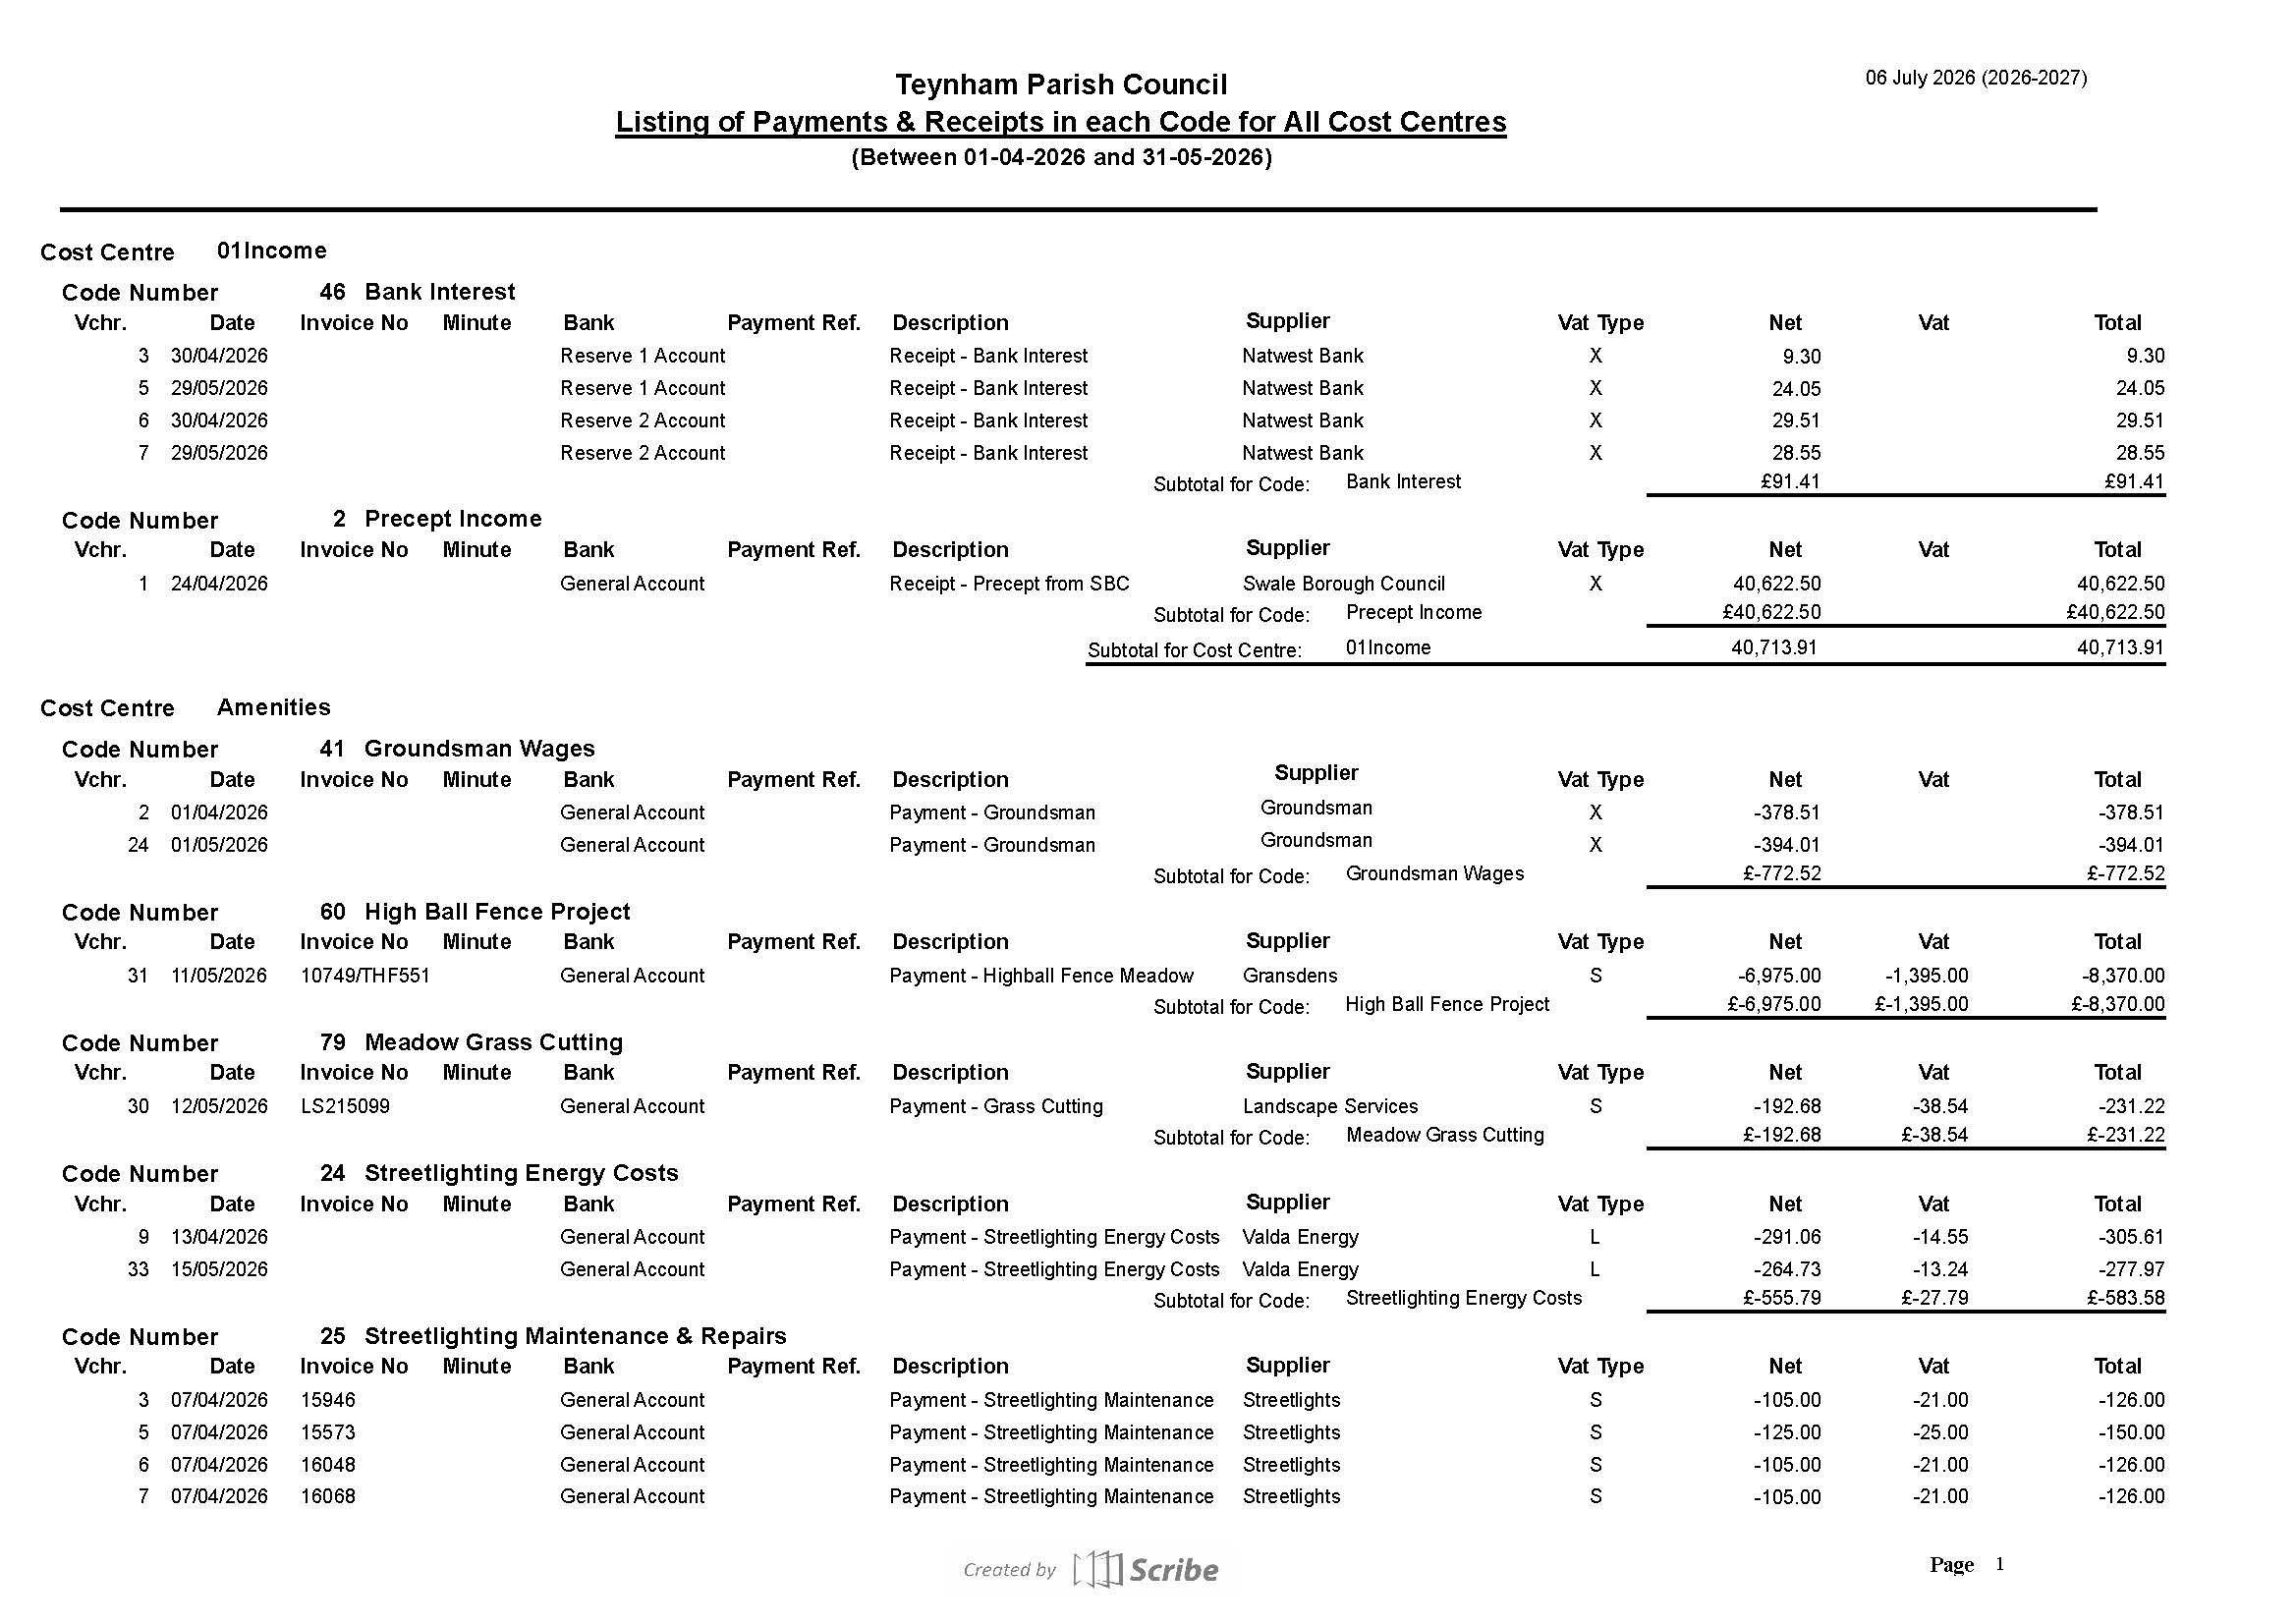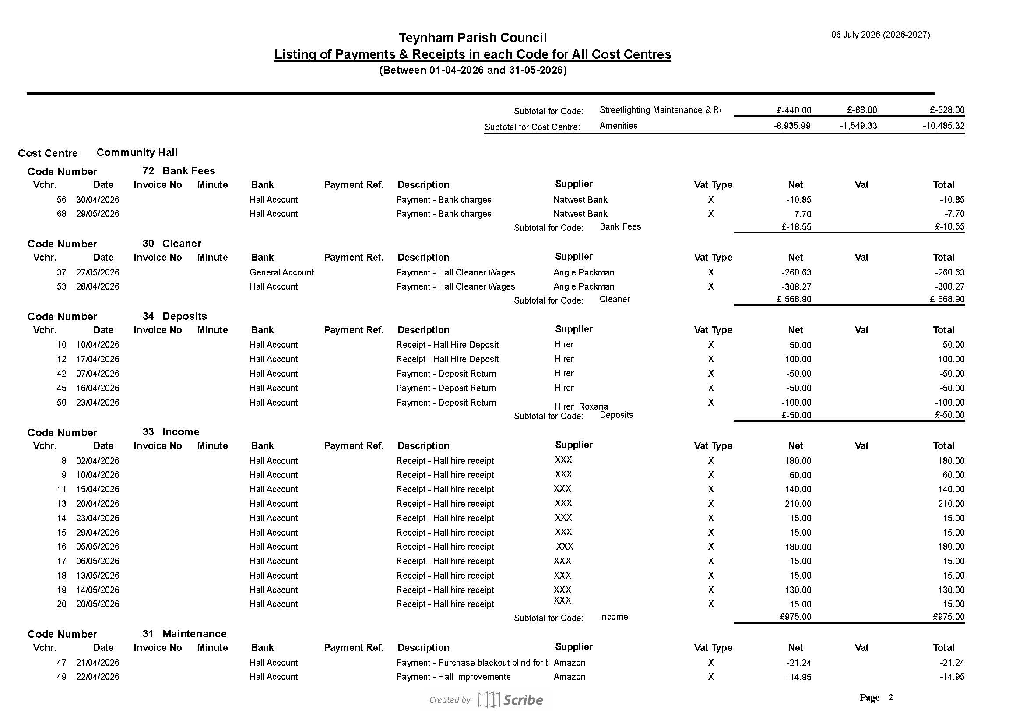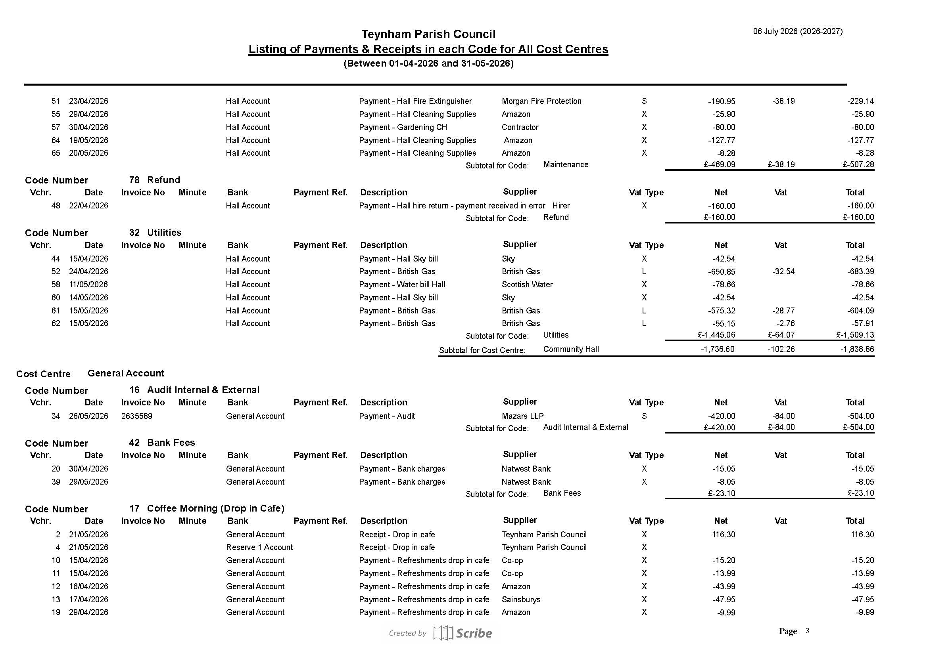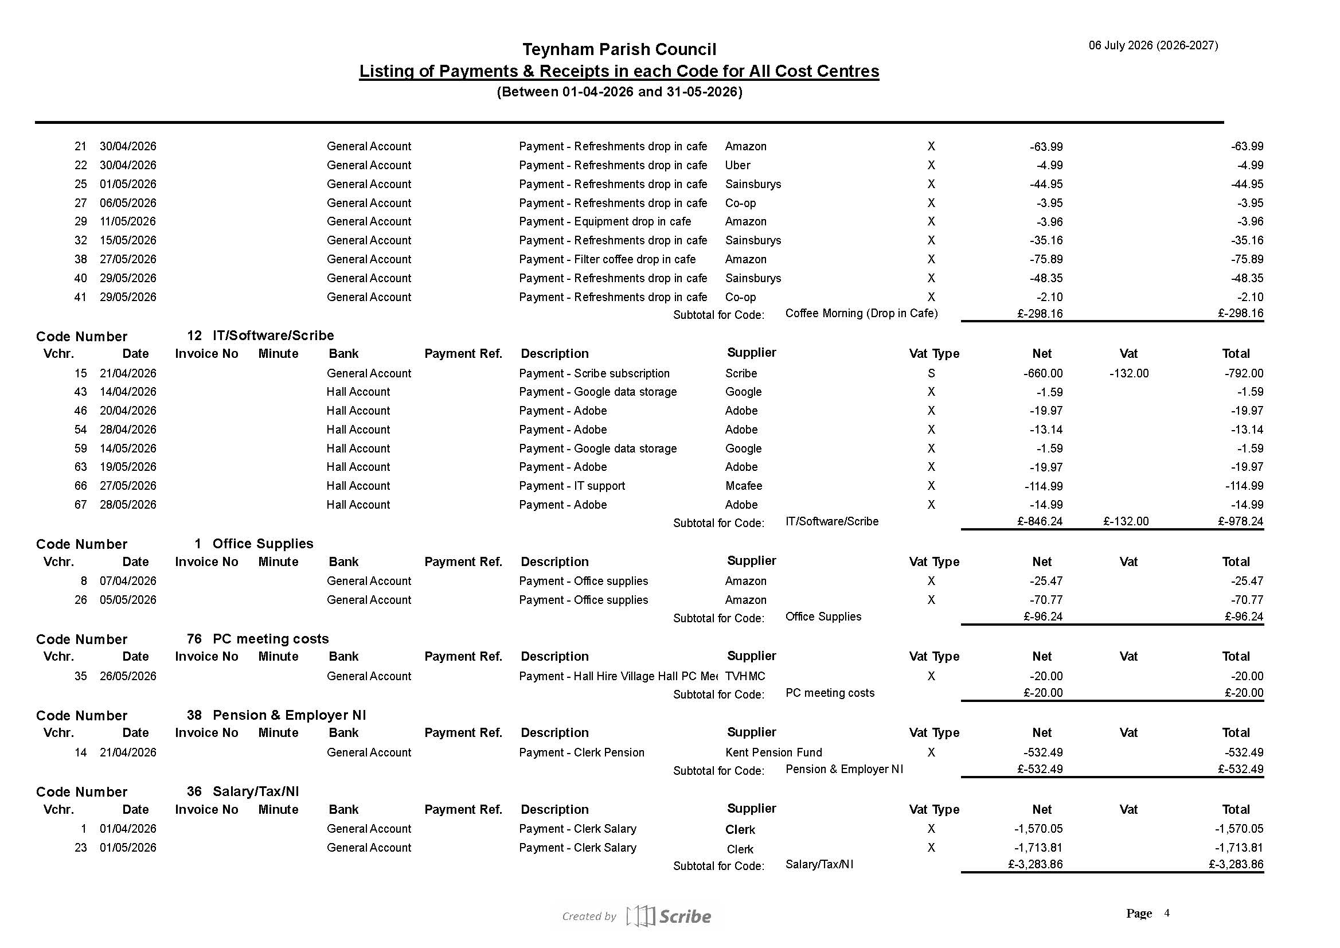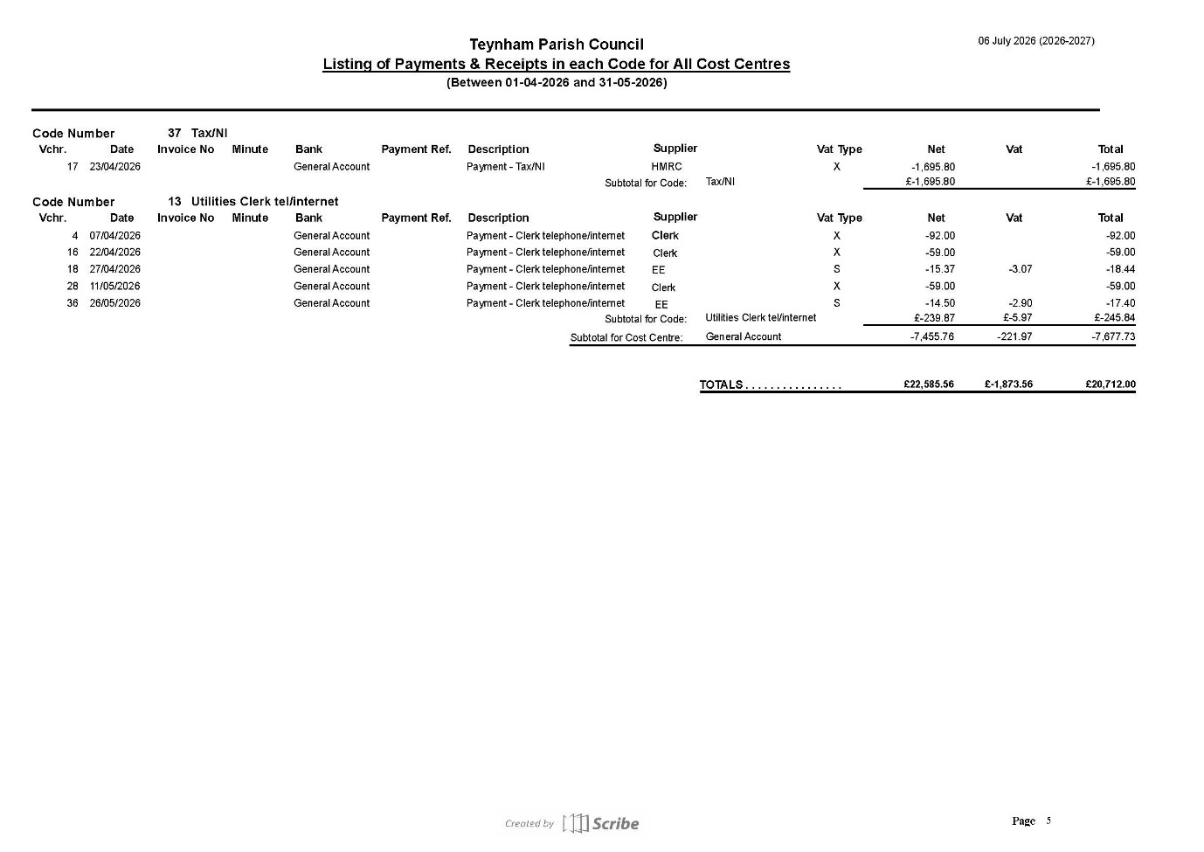
It was noted that the redacted report will be published on the website.

  - To consider and approve recommendations from the Finance Committee.
    - To approve the revised Terms of Reference for the Finance and General Purposes Committee.
Carry over to next meeting.
20.3.2.To approve the appointment of a new internal auditor (Note: Existing internal auditor has served 5+ years; rotation aligns with industry best practice).
It was moved by Cllr Parr, seconded by Cllr Saromi and
RESOLVED: “That Teynham Parish Council approve the appointment of a new internal auditor (Note existing internal auditor has served 5+ years; rotation aligns with industry best practice).”
20.3.3.To approve the publication of all council committee minutes on the parish website (for committee meetings held on or after 1 April 2026).
It was moved by Cllr Parr, seconded by Cllr Saromi and
RESOLVED: “That Teynham Parish Council approve the publication of all council committee minutes on the parish website (for committee meetings held on or after 1st April 2026).”
20.3.4.To approve the 2027/28 budget preparation timetable.
20.3.4 | Proposed 2027/28 budget timetable | - Proposal: Start budget planning cycle earlier  - Why? Enables better decision making  - September — Discuss at committees  - September — Create first draft budget  - October — Finance Committee Review  - December — Refinement & Tax Base Check  - January — Submit precept request

It was moved by Cllr Parr, seconded by Cllr Saromi and
RESOLVED: “That Teynham Parish Council approve the 2027/28 budget preparation timetable.”

20.3.5.To adopt the timetable for transitioning to the new banking provider.
20.3.5 | New Bank Transition Timetable | - Current situation: Parish Council banks with Natwest  - Previously Agreed: Move to new bank  - Why? Reduce costs; accounts designed for Parish Councils  Complete – Research & Council Resolution  - Research suitable banks offering dual authorisation.  July/August – Open Account  - The full Council approves the account signatories.  - Clerk submits the application and Council authority.  - Signatories complete identity and security checks.  September – Test & Set Up  - Transfer a small balance.  - Test dual-authorisation payments.  - Move Direct Debits, payroll, HMRC and regular payees.  October/November – Parallel Running  - Keep both accounts open.  - Complete at least one full payment cycle through the new account.  November/December – Complete Transition  - Transfer the remaining balance.  - Close the old account with the required authorised signatures.

It was moved by Cllr Saromi, seconded by Cllr Parr and
RESOLVED: “That Teynham Parish Council adopt the timetable for transitioning to the new banking provider.”

20.3.6.To approve the updated list of authorised bank signatories.
20.3.6 | Authorised bank signatories | Currently: Paul; Colin (in progress); Lisa; David; Brian  Proposed: Current members of the Finance & General Purpose Committee to be signatories.  Paul; Colin; David; Patricia and Kate.  Why? Multiple signatories have provided operational resilience during changes in councillor membership and periods of absence.  (continues overleaf)  Note: Chair’s role is one of oversight and rarely authorises payments. As part of the new bank account, the Parish Council will be moving to online dual authorisation.

It was moved by Cllr Saromi, seconded by Cllr Parr and
RESOLVED: “That Teynham Parish Council approve the list of updated signatories to include all members of the Finance & General Purposes Committee.”
20.3.7.To approve the cash management, banking and raffle arrangements for the Drop-In Café.
20.3.7 | Drop-In Café cash,banking and raffle | Proposals: Publish arrangements for handling cash, banking and raffle  Why: To ensure activities are transparent, lawful and in accordance with the Parish Council’s Financial Regulations  Background:  Community events are organised primarily for the benefit of the residents of Teynham and the wider community. Any raffle or fundraising activity shall be incidental to the event and shall not become its principal purpose.  Income  All income will:  - be received, recorded and banked as Teynham Parish Council income.  - be managed in accordance with the Council’s Financial Regulations; and  - remain under the control of the Council until Full Council determines their use.  Community Nominations  - Event participants may nominate a local charity, voluntary organisation, community group or other local good cause.  - Nominations are advisory only and do not create an entitlement to receive funding.  - Publicity shall make clear that any donation is subject to a formal resolution of Full Council.  Council Approval & Legal Powers  Any grant from raffle proceeds shall be considered as a separate agenda item by the full Parish Council.  Before approving any payment, parish council members shall be satisfied that:  - an appropriate statutory power exists (for example, Section 137 of the Local Government Act 1972);  - the expenditure provides a direct benefit to the parish or its inhabitants;  - the expenditure represents value for money; and  - the decision is properly recorded in the Council’s minutes.  Financial Accountability  The Responsible Financial Officer shall account for all income, process any approved payments through the Council’s normal financial procedures and maintain appropriate financial records.  In practice, this will include:  - Record income on the day in the receipt book.  - Bank within 5 working days

It was moved by Cllr Dixon, seconded by Cllr Parr and
RESOLVED: “That Teynham Parish Council approve the cash management, banking and raffle arrangements for the drop in café.”

20.3.8.To consider the WI proposal for managing the Drop-In Café refreshments and the allocation of proceeds to the Community Hall.
It was moved by Cllr Saromi, seconded by Cllr Parr and
RESOLVED: “That Teynham Parish Council accept the WI proposal for managing the Drop-In-Café refreshment and the allocation of proceeds to the Community Hall.”
20.3.9. To request a proposal from Amenities committee for a second CCTV including funding options.
It was moved by Cllr Saromi, seconded by Cllr Dixon and
RESOLVED: “That Teynham Parish Council request that the Amenities committee submit a proposal for a second CCTV including funding options.
- Forward Planning
To approve the Committee Meeting Schedule for 2026/27.

Carry over to September PC meeting.

- Advanced Notice of Items for the Agenda of next Ordinary Meeting.

- Approve donation to Vincent from drop in café fundraising.
- Ask PC Divers to attend meeting.
- Financial Reporting timeline.
- Problems on ISP land.

Send any other agenda items to Clerk.

- To note next year’s meeting dates
    - Tuesday 1st September 2026 Ordinary Meeting
    - Tuesday 6th October 2026 Ordinary Meeting
    - Tuesday 10th November 2026 Ordinary Meeting
    - Tuesday 15th December 2026 Budget/Precept & Ordinary Meeting

Noted.

- Chairman’s Closing Remarks

We returned to Agenda Item 9 as Cllr Sharman was given the opportunity to attend the meeting at any point. He did not attend the meeting so it was noted. The Parish Council recognises his many years of dedication and service. We agreed to seek an opportunity to thank him for his service and ask the Clerk to make contact with him.

It was moved by Cllr Barnett, seconded by Cllr Jessup and
RESOLVED: “That Cllr Sharman’s membership to the Parish Council has ceased and we thank him wholeheartedly for his commitment and dedication over the years.”

The Chair thanked everyone for coming and the meeting closed at 8.42pm.

