MINUTES OF THE ORDINARY MEETING OF TEYNHAM PARISH COUNCIL HELD ON TUESDAY 14TH APRIL 2026 AT TEYNHAM VILLAGE HALL, BELLE FRIDAY CLOSE, TEYNHAM DIRECTLY FOLLOWING THE ANNUAL PARISH MEETING.

Present: Cllr Barnett, Cllr Dunne, Cllr Mann, Cllr Jessup, Cllr Mcdonald, Cllr Parr, Cllr Saromi
Cllr Townson (Chairman). SBC Bowen, PC Divers and Clerk – Hayley Steel.

Absent:

- Apologies for absence.

Cllr Dixon, Cllr Simester, Cllr Sharman, Cllr Saromi, SBC Speed and KCC Lehman.

- Declarations of Interests on Items on the Agenda.

None.

- To confirm that any changes to the Registers of Interests have been forwarded to the Monitoring Officer.

None.

- Public Session for 20 minutes to allow members of the public and Councillors with pecuniary interests to speak for no more than three minutes in respect of the business on the agenda. A question shall not require a response at the meeting nor start a debate on the question.

A member of the public asked about the possibility of erecting a fence in the Meadow and a gate. We explained that this would be an expense that would have to be considered and a grant sought to cover the cost.

PC Divers gave an update:-

- An update was provided regarding a local criminal matter involving an arrest for sexual assault; the individual remains under monitoring pending a court appearance.
- It was noted that multiple incidents of shoplifting have been reported, resulting in several recent arrests.
- A prolific burglar has been arrested in Teynham and will not be coming back to the area.
- There was a plane clothes operation in February where nuisance bikes were targeted, an arrest made and a prosecution made and the bike crushed.

Top 3 priorities are:

- Fly tipping
- Road safety issues
- Nuisance motorbikes

- Receive brief update from ward councillor(s) on items relating to the parish of Teynham (total of 5 mins, max)

SBC Bowen informed the PC that the SBC have agreed their budget for the coming year and that car parking fees are being increased.

Local Government Review is the most important thing to happen in local government. We will hear from the government when they have made their decision.

The Highsted Park planning inquiry will not be decided until late summer at the earliest.

Local Plan: SBC has formally adopted Option 4 for the proposed housing allocations. This strategy focuses development on Faversham, Wises Lane (Borden), and Bobbing, effectively removing the Highsted Park site from the forthcoming Local Plan.

- To approve the minutes from the Ordinary Parish Council Meeting on 9th December 2025.

It was moved by Cllr Barnett, seconded by Cllr Dunne and

RESOLVED: “That the minutes of the Ordinary Parish Council Meeting on 9th December 2026 be taken as a true record.”

- Matter arising.

None.

- Chairman’s report.

- Litter Pick: A litter pick was held on Saturday, 11th April. The Chairman thanked the 12 volunteers and councillors who took part. It was noted that there was noticeably less rubbish around the village than in previous events.
- Community Hall Maintenance: Several repairs have been completed, including repainting the side wooden gate and front bollards, and jet-washing the front area. Thanks were recorded to Colin and his team.
- Play Area: Many thanks to Lisa and her team for addressing safety concerns in the children’s play area, specifically the removal of metal bolts and the repair of sharp edges on the large green swing seat.
- Fire Alarm: A faulty sensor on the stage caused three false alarms, requiring an engineer to isolate the device. Thanks were recorded to Fay for responding and to residents for reporting the issue.
- Highsted Park: The Action Group and the Five Parishes Group have written to the Secretary of State raising concerns regarding potential predetermination. The letter requests full transparency to ensure the planning decision is based solely on inquiry evidence.

- To approve the minutes from the Ordinary Parish Council Meeting on 9th March 2026.

It was moved by Cllr Barnett, seconded by Cllr Mcdonald and

RESOLVED: “That the minutes of the Ordinary Parish Council Meeting on 9th March 2026 be taken as a true record.”

- Matters arising.

None.

Community Hall

- To note RICS survey received.
It was noted that the RICS Survey has been completed and received by the Council. The report, which exceeds 100 pages, had been circulated to all Parish Councillors in advance of the meeting for their review and consideration.
- To Determine the future of Teynham Community Hall and resolve either:
The Council received a comprehensive report regarding the future of Teynham Community Hall (circulated to all members in advance), which provided a detailed assessment of the building's heritage, financial standing, and structural risks. Members noted the critical failure of the heating system and the significant long-term liabilities identified in the RICS survey, including an estimated £50k–£100k required for roof works. A thorough discussion ensued, weighing the hall's value as a community asset against the 'sunk cost' risks and the potential 20-year debt associated with a Public Works Loan. Consequently, the Council sought to expand upon the strategic options presented in the report as follows:
- To approve a £38,000 capital investment in a new heating system (funded via Grant/PWLB) subject to the 24-month viability trial; OR
- To cease further capital investment and instruct the Clerk to bring forward a detailed Exit Strategy, to include the feasibility of a Third-Party Lease (Option D) or, failing that the decommissioning and disposal of the asset Option E).

The Parish Council had a lengthy discussion and wish to add more options to include…
Option 1 – Cllr Townson to ask Lloyd Bowen to see if we can merge with the Village Hall and work together. We would then have a further discussion at an extra ordinary meeting.

It was moved by Cllr Barnett, seconded by Cllr Saromi and

RESOLVED: “That Cllr Townson to ask Lloyd Bowen to see if we can merge with the Village Hall and work together. We would then have a further discussion at an extra ordinary meeting.”

Option 2 – Inform the community what position we are in with the Community Hall and get feedback – should we carry on funding the hall through precept?

It was moved by Cllr Townson, seconded by Cllr Saromi and

RESOLVED: “That Teynham Parish Council will inform the community what position we are in with the Community Hall and get feedback – should we carry on funding the hall through precept?.”

Option 3 – Defer any decision for 12 months and do a temporary repair to the heating, low-cost improvements and test viability.

It was moved by Cllr Jessup, seconded by Cllr Barnett and

RESOLVED: “That Teynham Parish Council will defer any decision for 12 months and do a temporary repair to the heating, low-cost improvements and test viability.”

Option 4 – Fact finding – Ask solicitor to look at wording of our clawback clause in our purchase agreement. What does it mean?

It was moved by Cllr Barnett, seconded by Cllr Dunne and

RESOLVED: “That Teynham Parish Council will ask solicitor to look at wording of our clawback clause in our purchase agreement. What does it mean?.”

Option 5 – To apply for grants to cover the total rejuvenation of the hall to include the heating and new roof.

It was moved by Cllr Barnett, seconded by Cllr Townson and

RESOLVED: That Teynham Parish Council would consider applying for grants to cover the total rejuvenation of the hall to include the heating and new roof.”

The Parish Council wishes to note that it does not want to borrow money via a public works loan as it is a burden for future generations, however they would find grants acceptable.

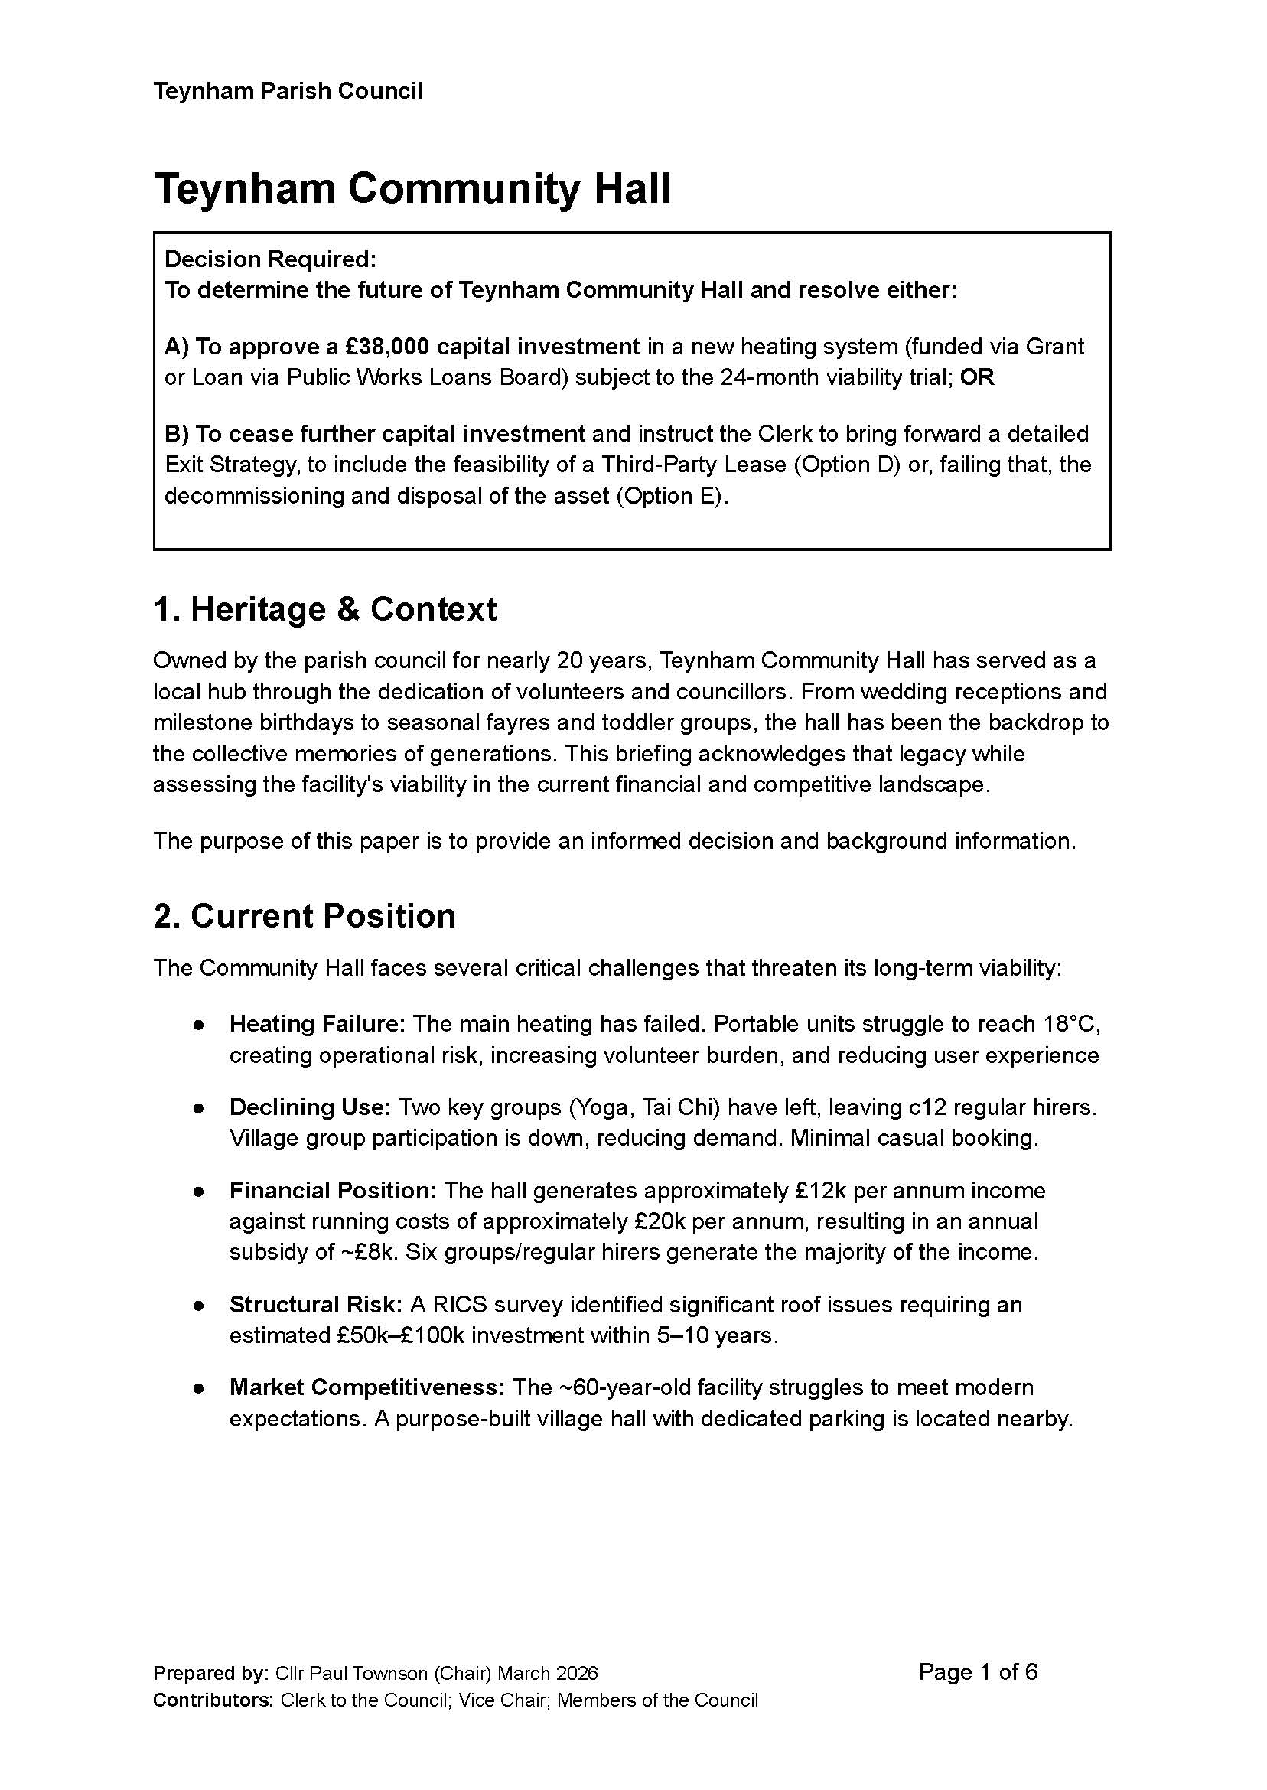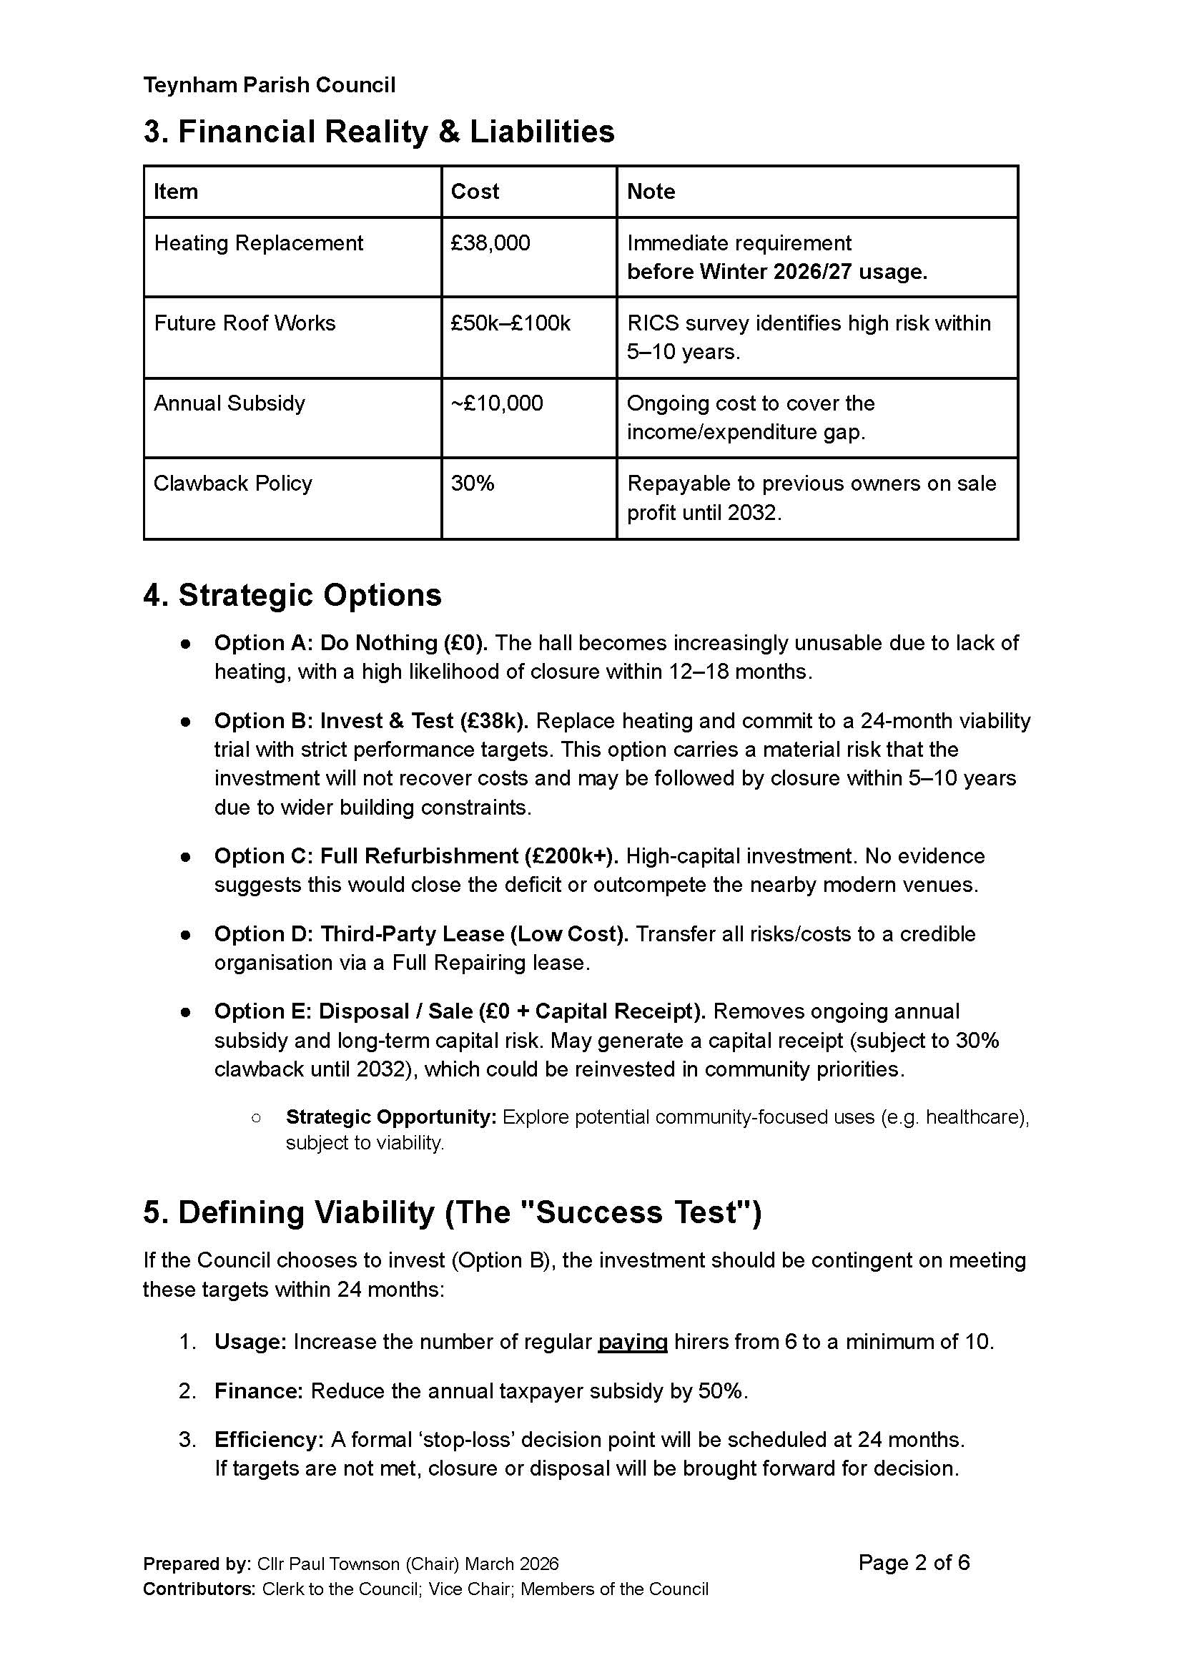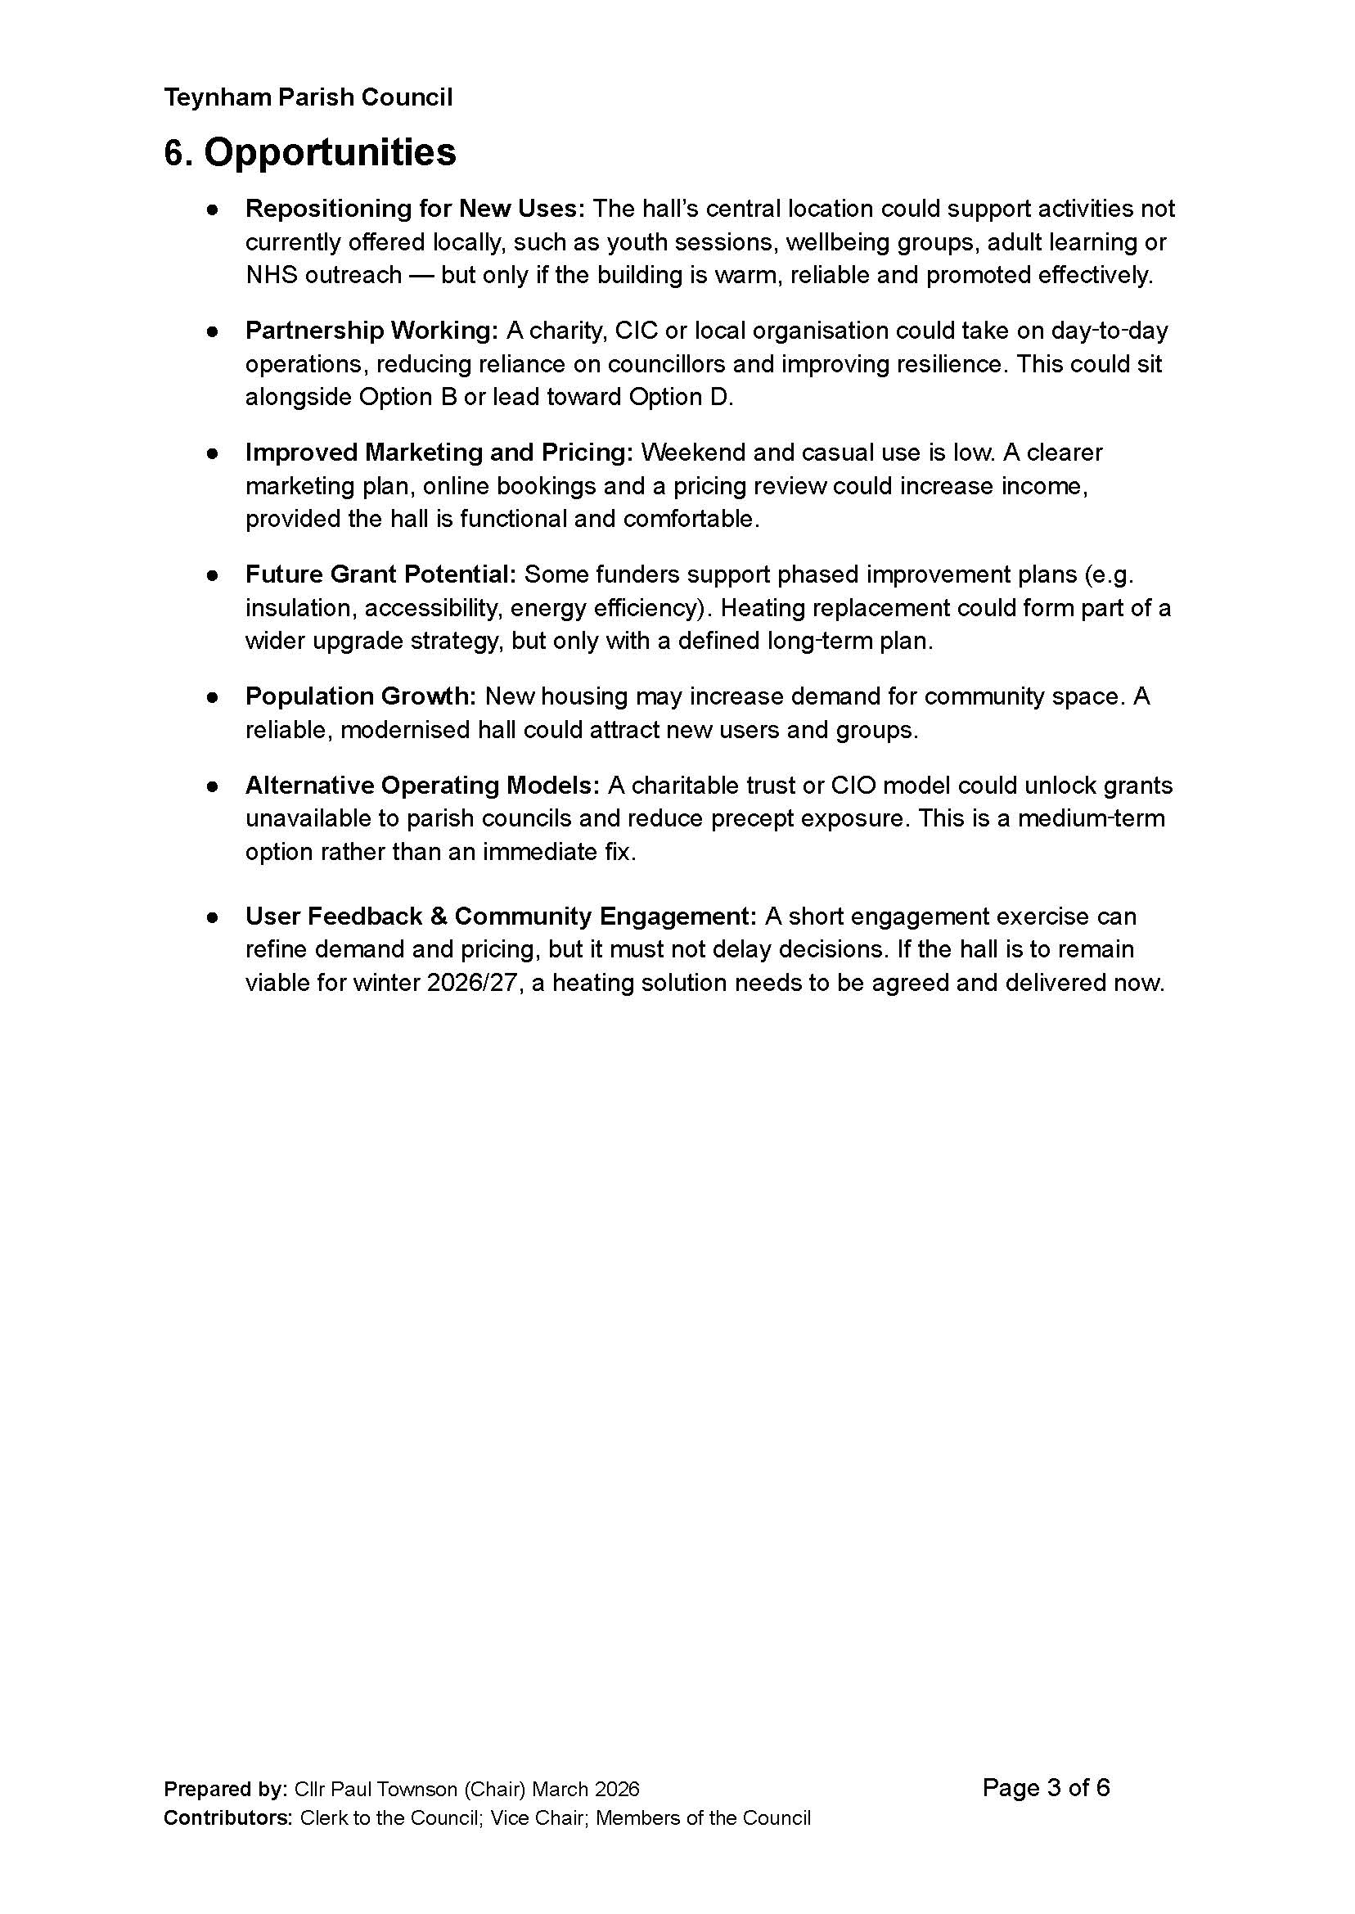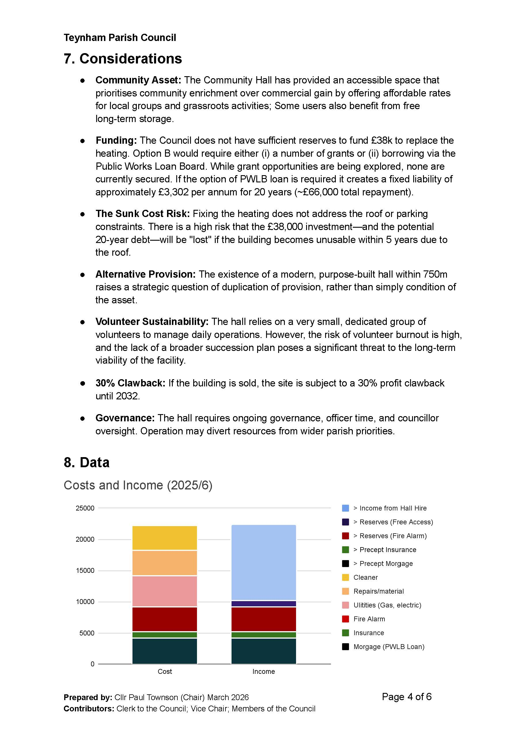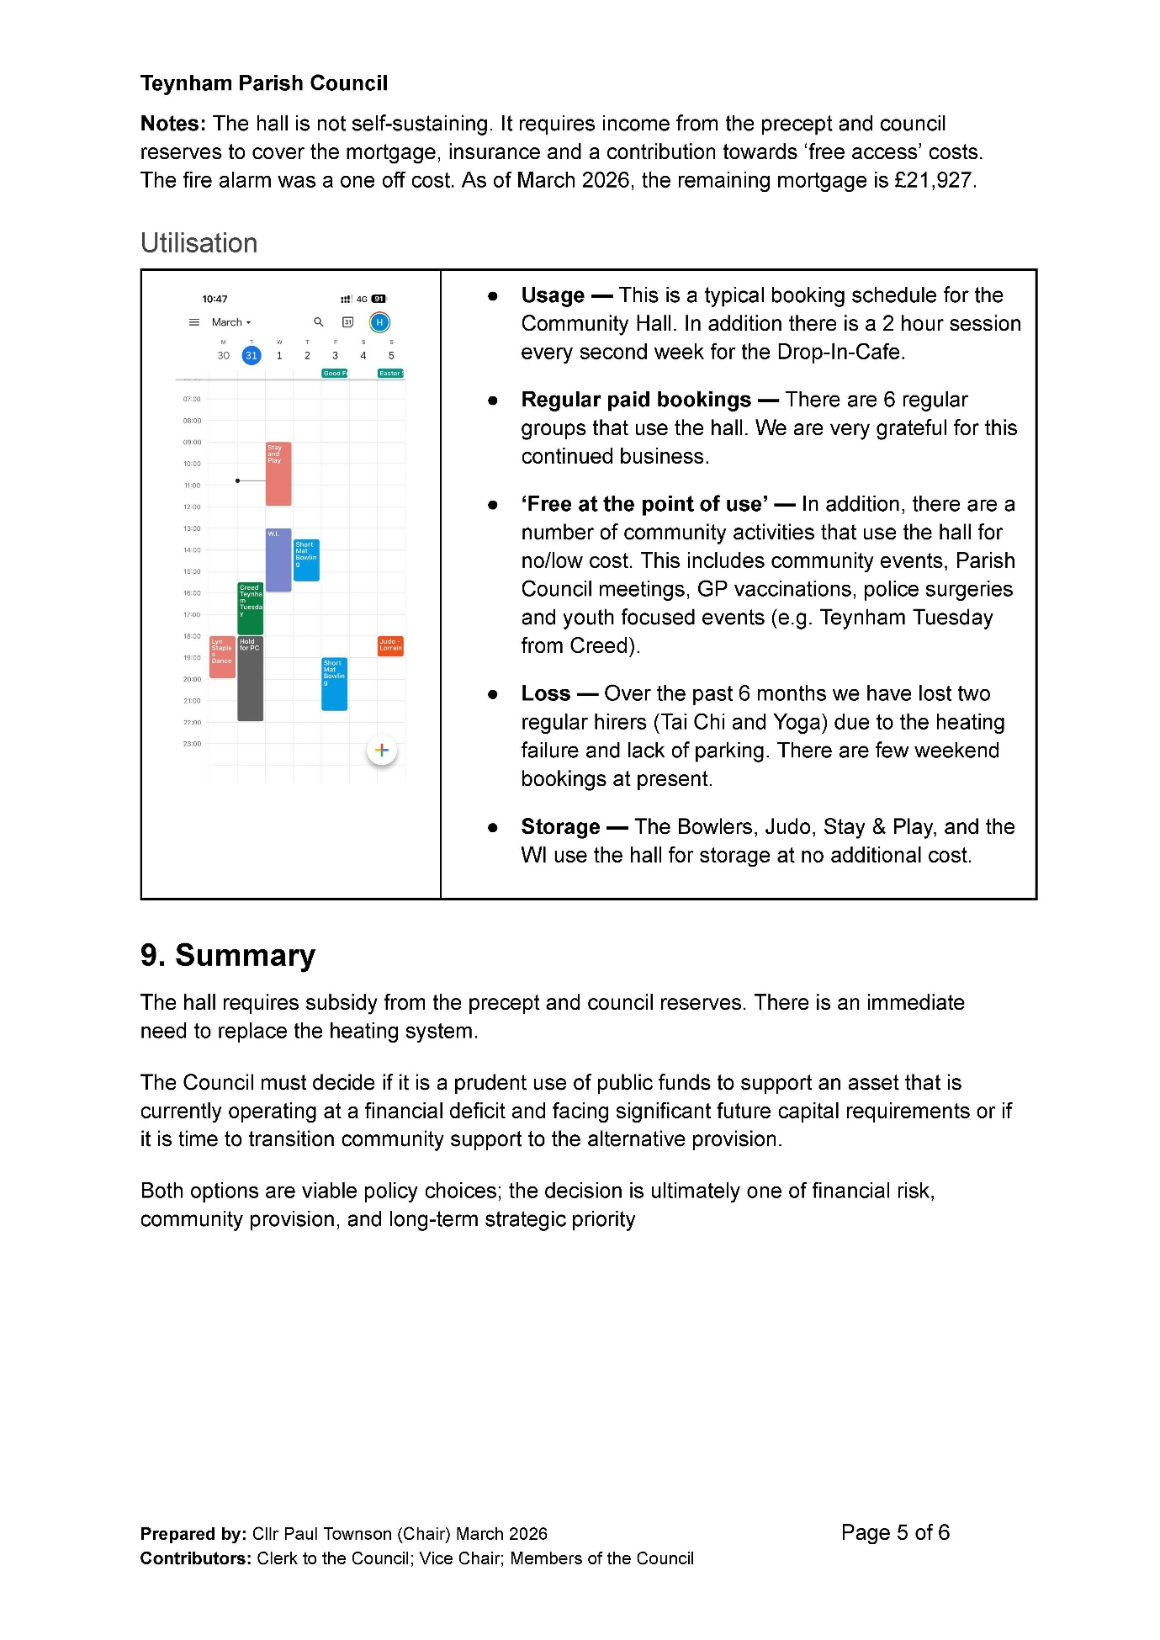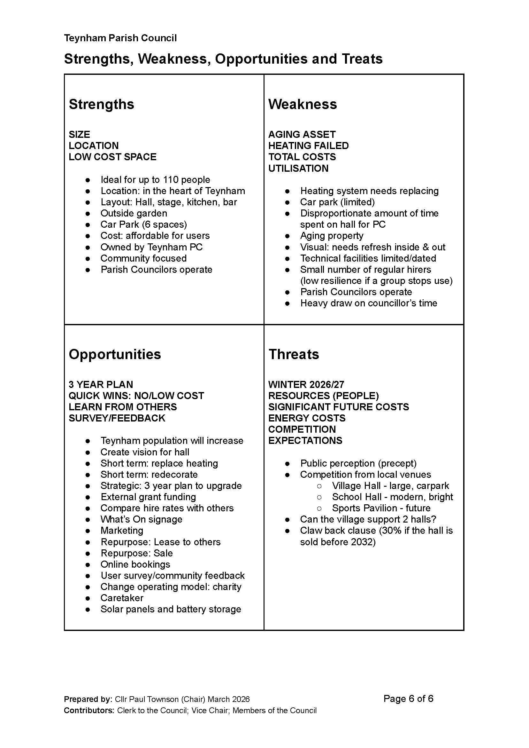

- Receive updated financial position end of February 2026 (Scribe financial report).

The Clerk presented the updated financial position as of the end of February 2026, as detailed in the Scribe financial report. Members were invited to raise any immediate questions or, alternatively, to submit more detailed comments and queries to the Clerk following the meeting for further clarification.

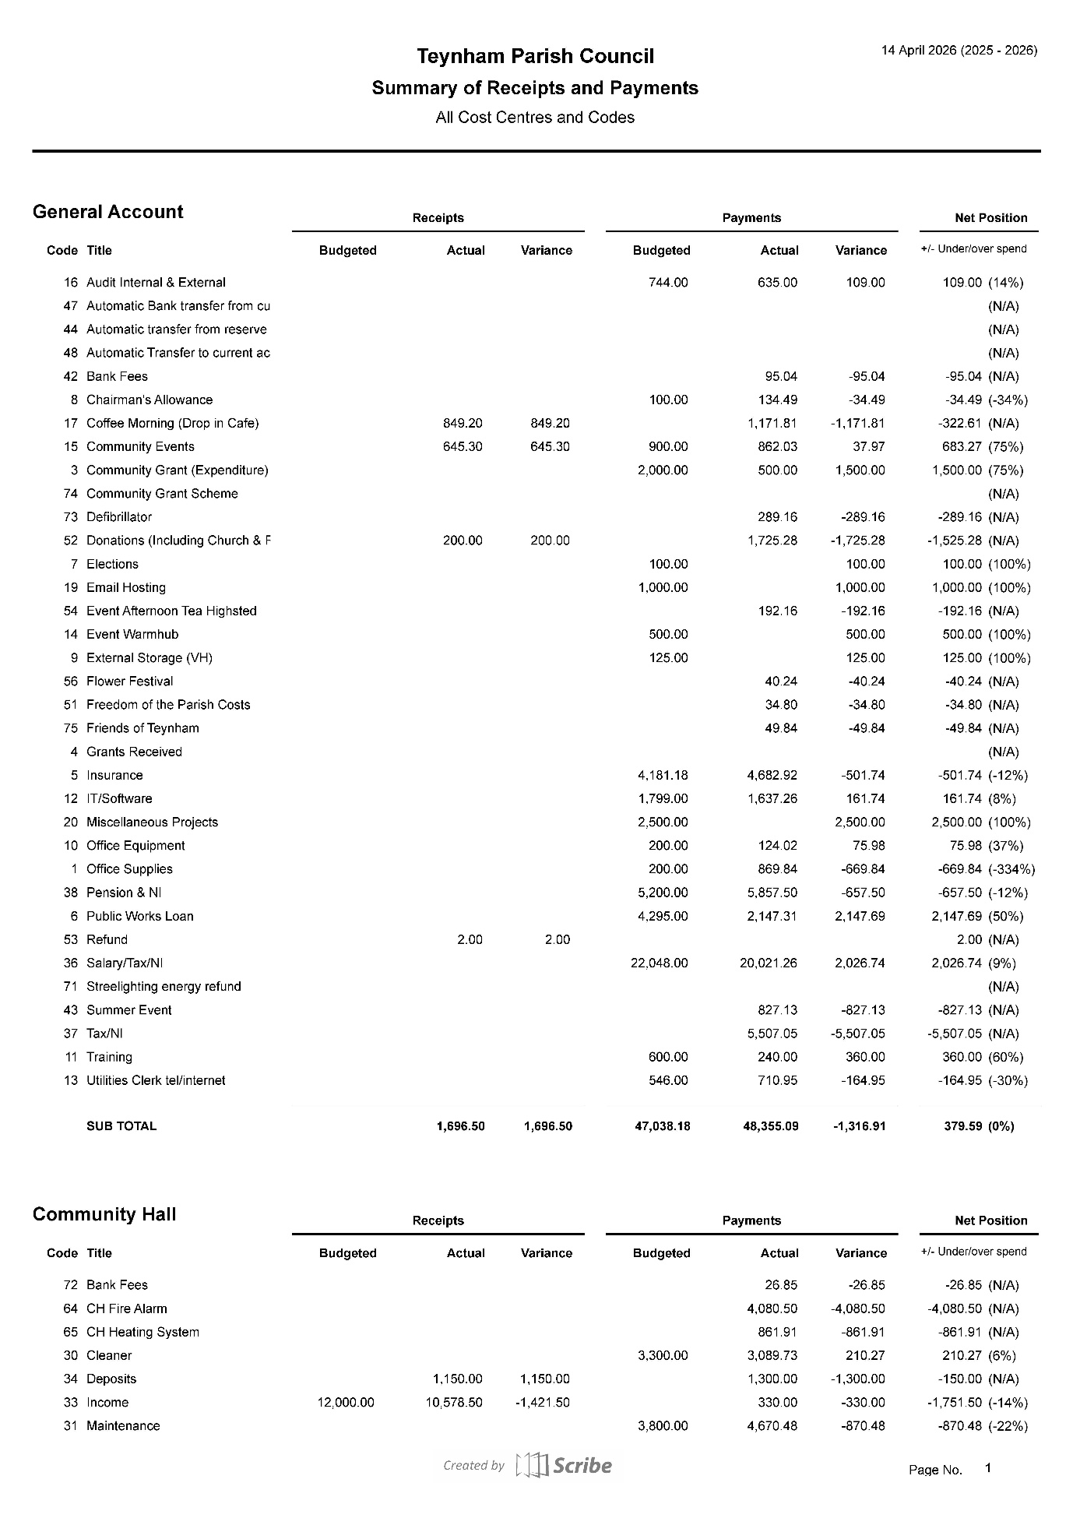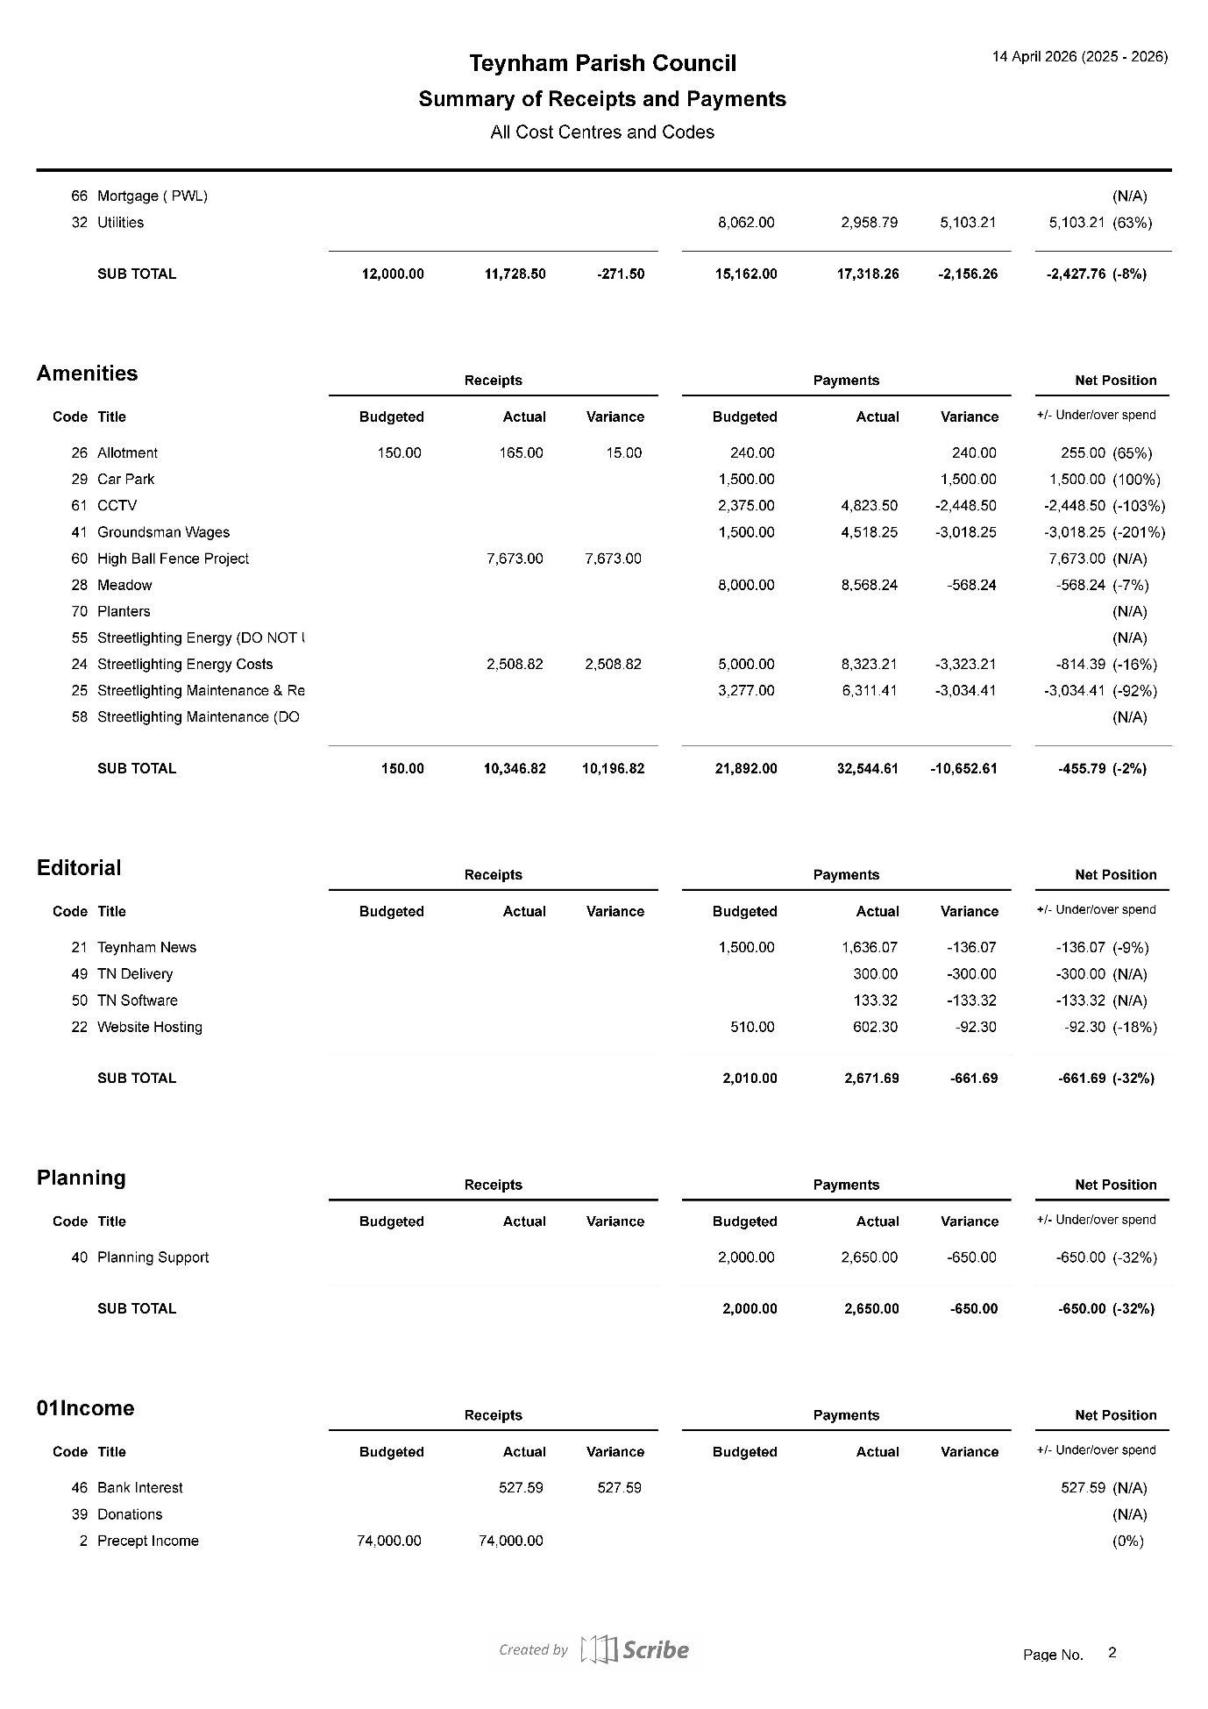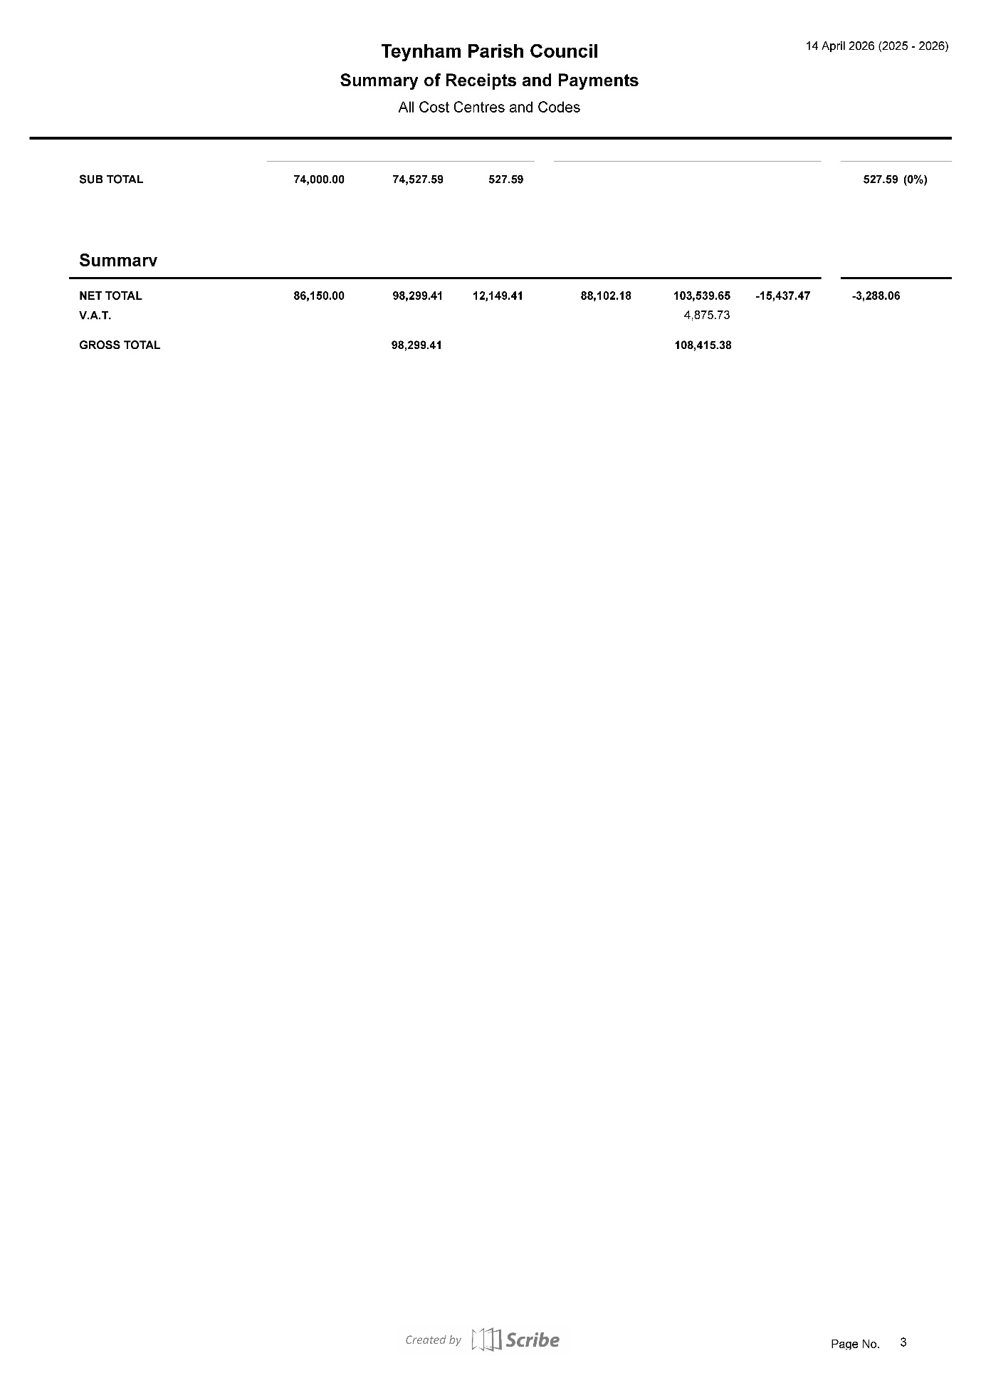

- Advanced Notice of Items for the Agenda of next Ordinary Meeting.

It was noted that an Extraordinary Meeting would be required to reach a final decision on the future of Teynham Community Hall. While a provisional date of 28th April 2026 was proposed during the meeting, this was subject to final confirmation of Member availability.

Post-meeting note: Following the meeting, it was confirmed that the April date was not viable; the meeting will instead be scheduled for May 2026, with the date to be finalised shortly.

- To note next year’s meeting dates
    - Tuesday 26th May 2026 Annual Parish Council Meeting & Ordinary
    - Tuesday 16th June 2026 Extra Ordinary Parish Council Meeting
    - Tuesday 7th July 2026 Ordinary Meeting
    - Tuesday 1st September 2026 Ordinary Meeting
    - Tuesday 6th October 2026 Ordinary Meeting
    - Tuesday 10th November 2026 Ordinary Meeting
    - Tuesday 15th December 2026 Budget/Precept & Ordinary Meeting

Noted.

- Chairman’s Closing Remarks

The Chairman thanked everyone for coming and the meeting closed at 9.50pm.

