MINUTES OF THE ORDINARY MEETING OF TEYNHAM PARISH COUNCIL HELD ON MONDAY 9TH MARCH 2026 AT TEYNHAM VILLAGE HALL, BELLE FRIDAY CLOSE, TEYNHAM AT 7PM.

Present: Cllr Barnett, Cllr Dixon, Cllr Dunne, Cllr Jessup, Cllr Mcdonald,
Cllr Townson (Chairman). Clerk – Hayley Steel.

Absent:

- Apologies for absence.

Cllrs Mann, Simester, Sharman, Saromi and SBC Bowen, SBC Speed and KCC Lehman.

- Declarations of Interests on Items on the Agenda.

None.

- To confirm that any changes to the Registers of Interests have been forwarded to the Monitoring Officer.

None.

- Public Session for 20 minutes to allow members of the public and Councillors with pecuniary interests to speak for no more than three minutes in respect of the business on the agenda. A question shall not require a response at the meeting nor start a debate on the question.

None.

- Receive brief update from ward councillor(s) on items relating to the parish of Teynham (total of 5 mins, max)

No members of the public were present. Speedwatch is on the agenda.

- To approve the minutes from the Ordinary Parish Council Meeting on 9th December 2025.

It was moved by Cllr Barnett, seconded by Cllr Dunne and

RESOLVED: “That the minutes of the Ordinary Parish Council Meeting on 9th December 2026 be taken as a true record.”

- Matter arising.

None.

- To approve the minutes from the Extra Ordinary Parish Council Meeting on 13th January 2026.

It was moved by Cllr Jessup, seconded by Cllr Mcdonald and

RESOLVED: “That the minutes of the Extra Ordinary Parish Council Meeting on 13th January 2026 be taken as a true record.”

- Matters arising.

None.

- To approve the minutes of the Ordinary Parish Council Meeting on 20th January 2026.

It was moved by Cllr Barnett, seconded by Cllr Mcdonald and

RESOLVED: “That the minutes of the Ordinary Parish Council Meeting on 20th January 2026 be taken as a true record.”

- Matters arising.

None

- Chairman’s report.

The Chairman welcomed the attendees and, noting the busy agenda, moved quickly into the main items of business.

Community
- To consider applications for a new councillor.

A member of the public applied for the vacancy and the Parish Council unanimously voted that Gwen Parr be co-opted onto the Parish Council with immediate effect.

It was moved by Cllr Dixon, seconded by Cllr Dunne and

RESOLVED: “That Gwen Parr be elected onto the Parish Council.”

- To receive and consider a draft list of opportunities for younger people, and to agree next steps.

Cllr Townson highlighted the importance of signposting local activities for young people, extending from early years through to the 18–25 age group. The Council supported the initiative and discussed promoting these opportunities via flyers and posters. It was agreed that Cllr Townson would continue to refine this research before sharing an updated version with the full Council for further input.

- To note vehicle speed concerns on Lower Road Teynham and initial feedback from Kent Police and consider actions/next steps including engagement with KCC Highways and Tonge PC and encourage volunteers to form a Community Speed Watch group.

The Clerk offered to co-ordinate this and Cllr Townson will advertise for volunteers.

- To agree to host a community litter-pick on Saturday 11th April 2026 at 10am.

It was moved Cllr Mcdonald, seconded by Cllr Dixon and

RESOLVED: “That Teynham Parish Council will host a litterpick on Saturday 11th April 2026.”

Community Hall
- Consider and agree the recommendation for the heating system and source of funding.

After some discussion it was agreed that the Parish Council would ascertain the longevity of the Community Hall building and we agree to have a building conditions report carried out highlighting any major issues up to the value of £750.

It was moved by Cllr Dixon, seconded by Cllr Dunne and

RESOLVED: “That Teynham Parish Council would commission a Building Conditions report to be carried out on the Community Hall at a cost not to exceed £750.”

- Update and request for help from the Community Hall Committee.
It was ageed that the Clerk would ask the Groundsman if he would put the Community Hall bin out ready for collection every week.

Amenities
- Consider and agree the proposal for the community planters

It was agreed that we would seek volunteers to take on specific planters so they will be responsible for them.

It was moved by Cllr Jessup, seconded by Cllr Mcdonald and

RESOLVED: “That Teynham Parish Council seek volunteers to help with planters around the village.”
Finance
- Receive updated financial position (Scribe financial report).

Noted.

- Approve the addition of Colin Jessup as an authorised bank signatory.

It was moved by Cllr Townson, seconded by Cllr Barnett and

RESOLVED: “That Cllr Jessup be added as a bank signatory.”

- Receive an update on fundraising activities from the Drop-In-Café, agree financial controls and the distribution of funds.

It was agreed that the money raised in fundraising activities at the drop in café would be split 50/50 between a chosen charity and a fund to be used to improve the Community Hall. This money will be banked separately for audit purposes.

It was moved by Cllr Jessup, seconded by Cllr Dunne and

RESOLVED: “That Teynham Parish Council will split any money raised by the drop in café via fundraising 50/50 between a chosen charity and a fund to improve the Community Hall.”

Planning
- To ratify the response to Swale Borough Council’s Regulation 18 Local Plan consultation.

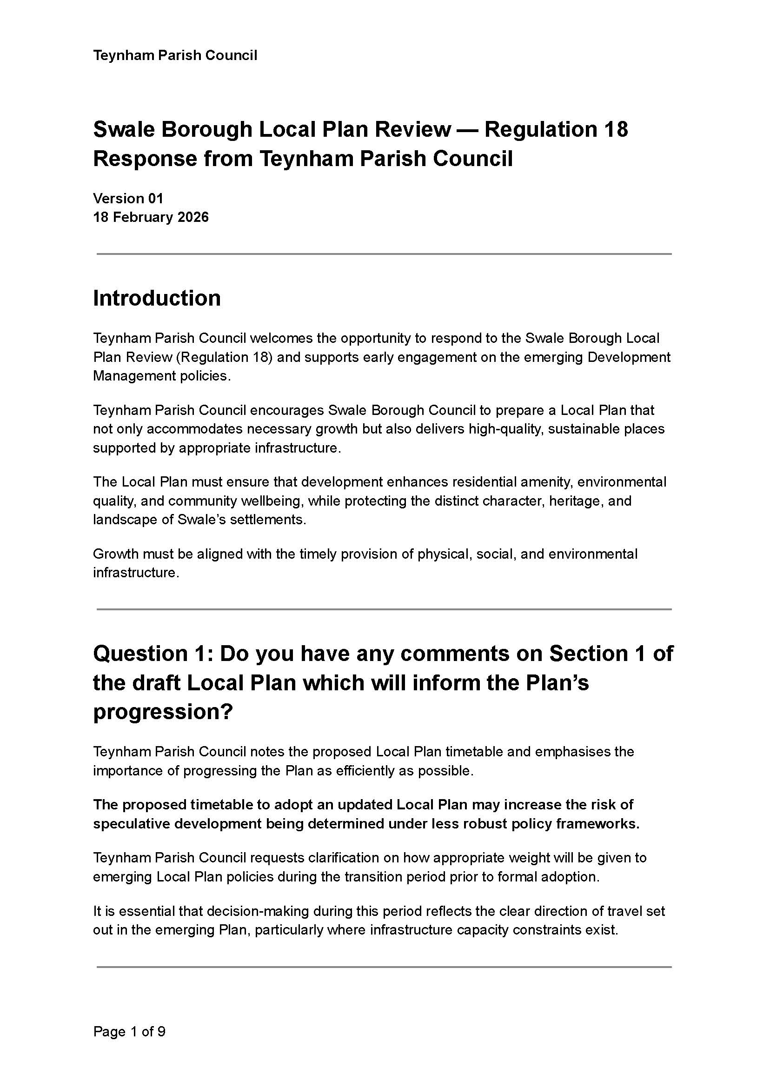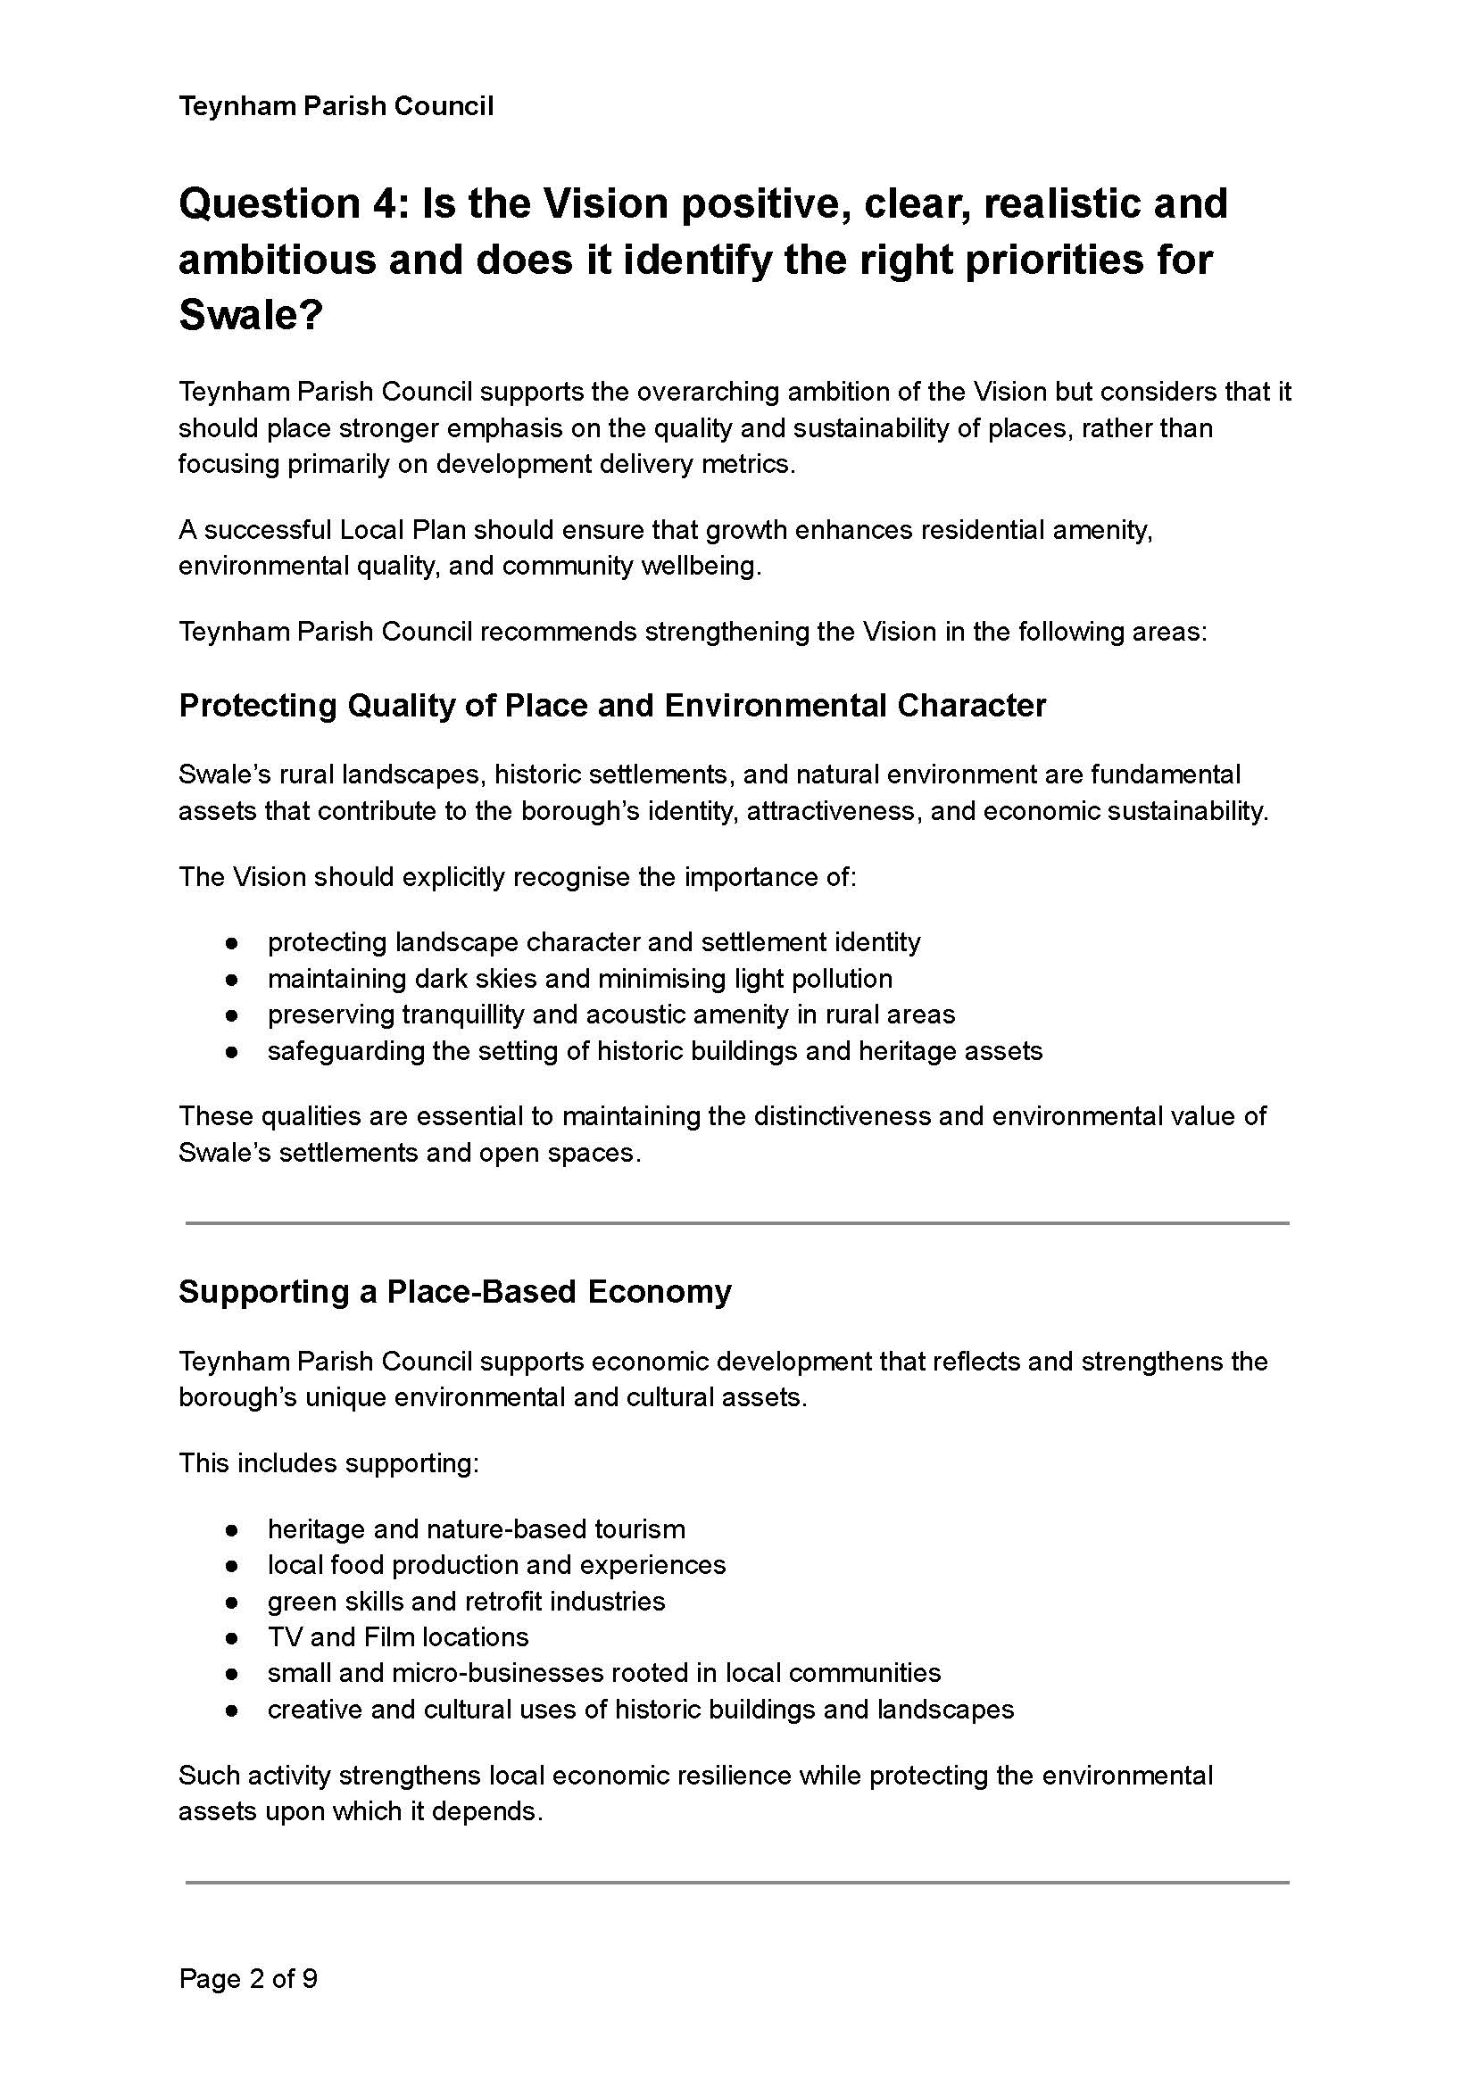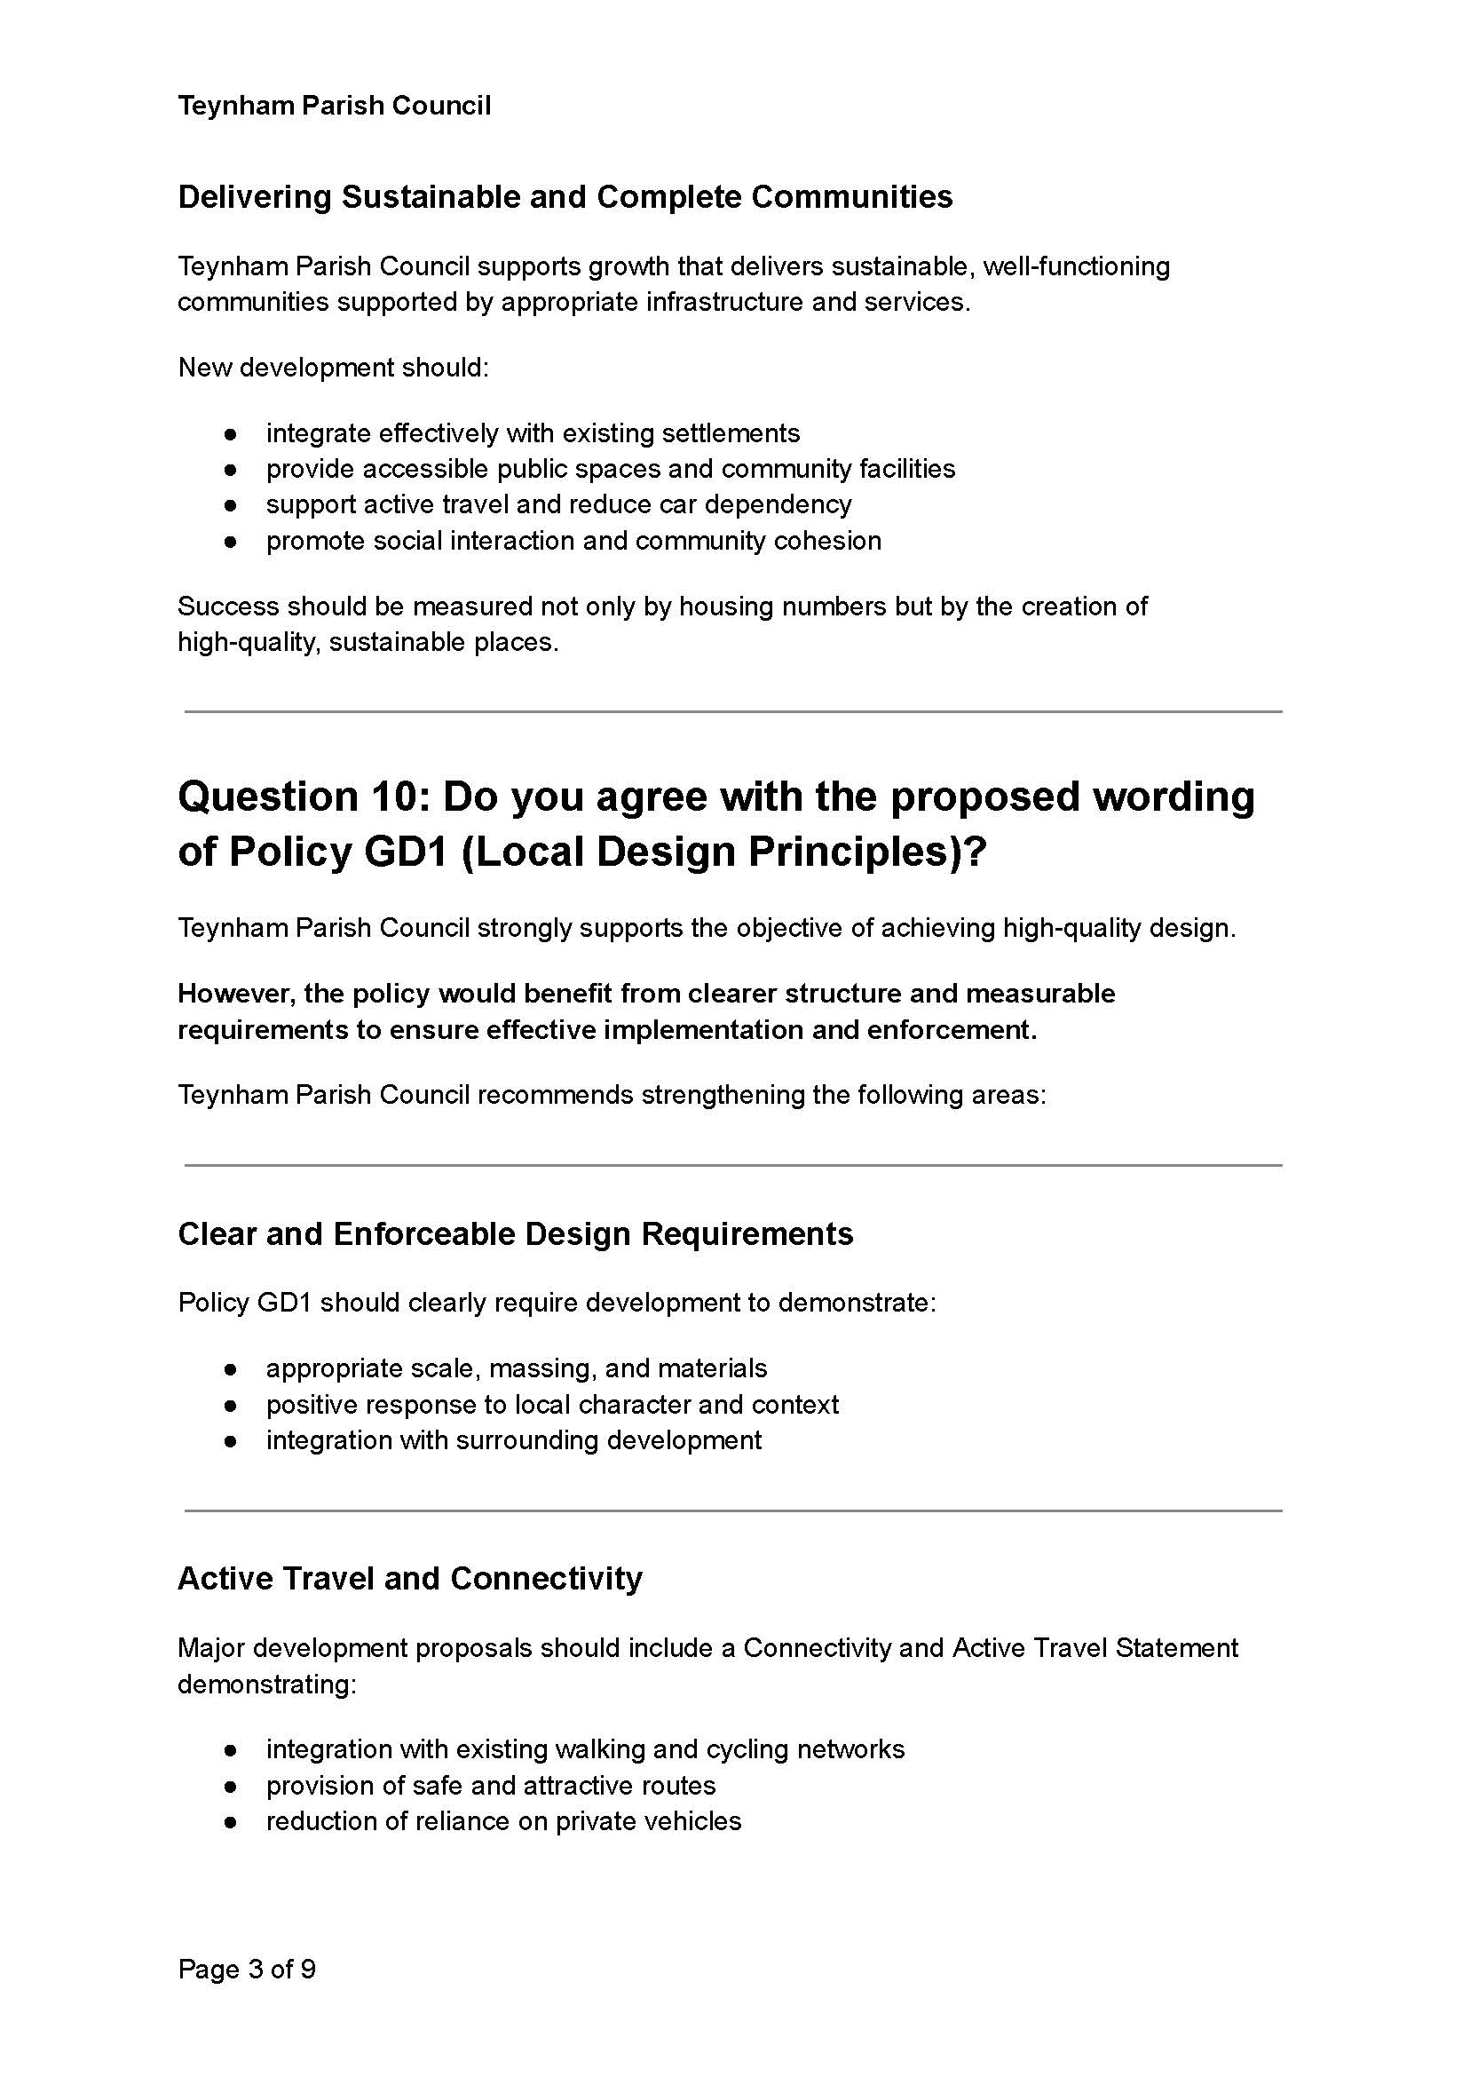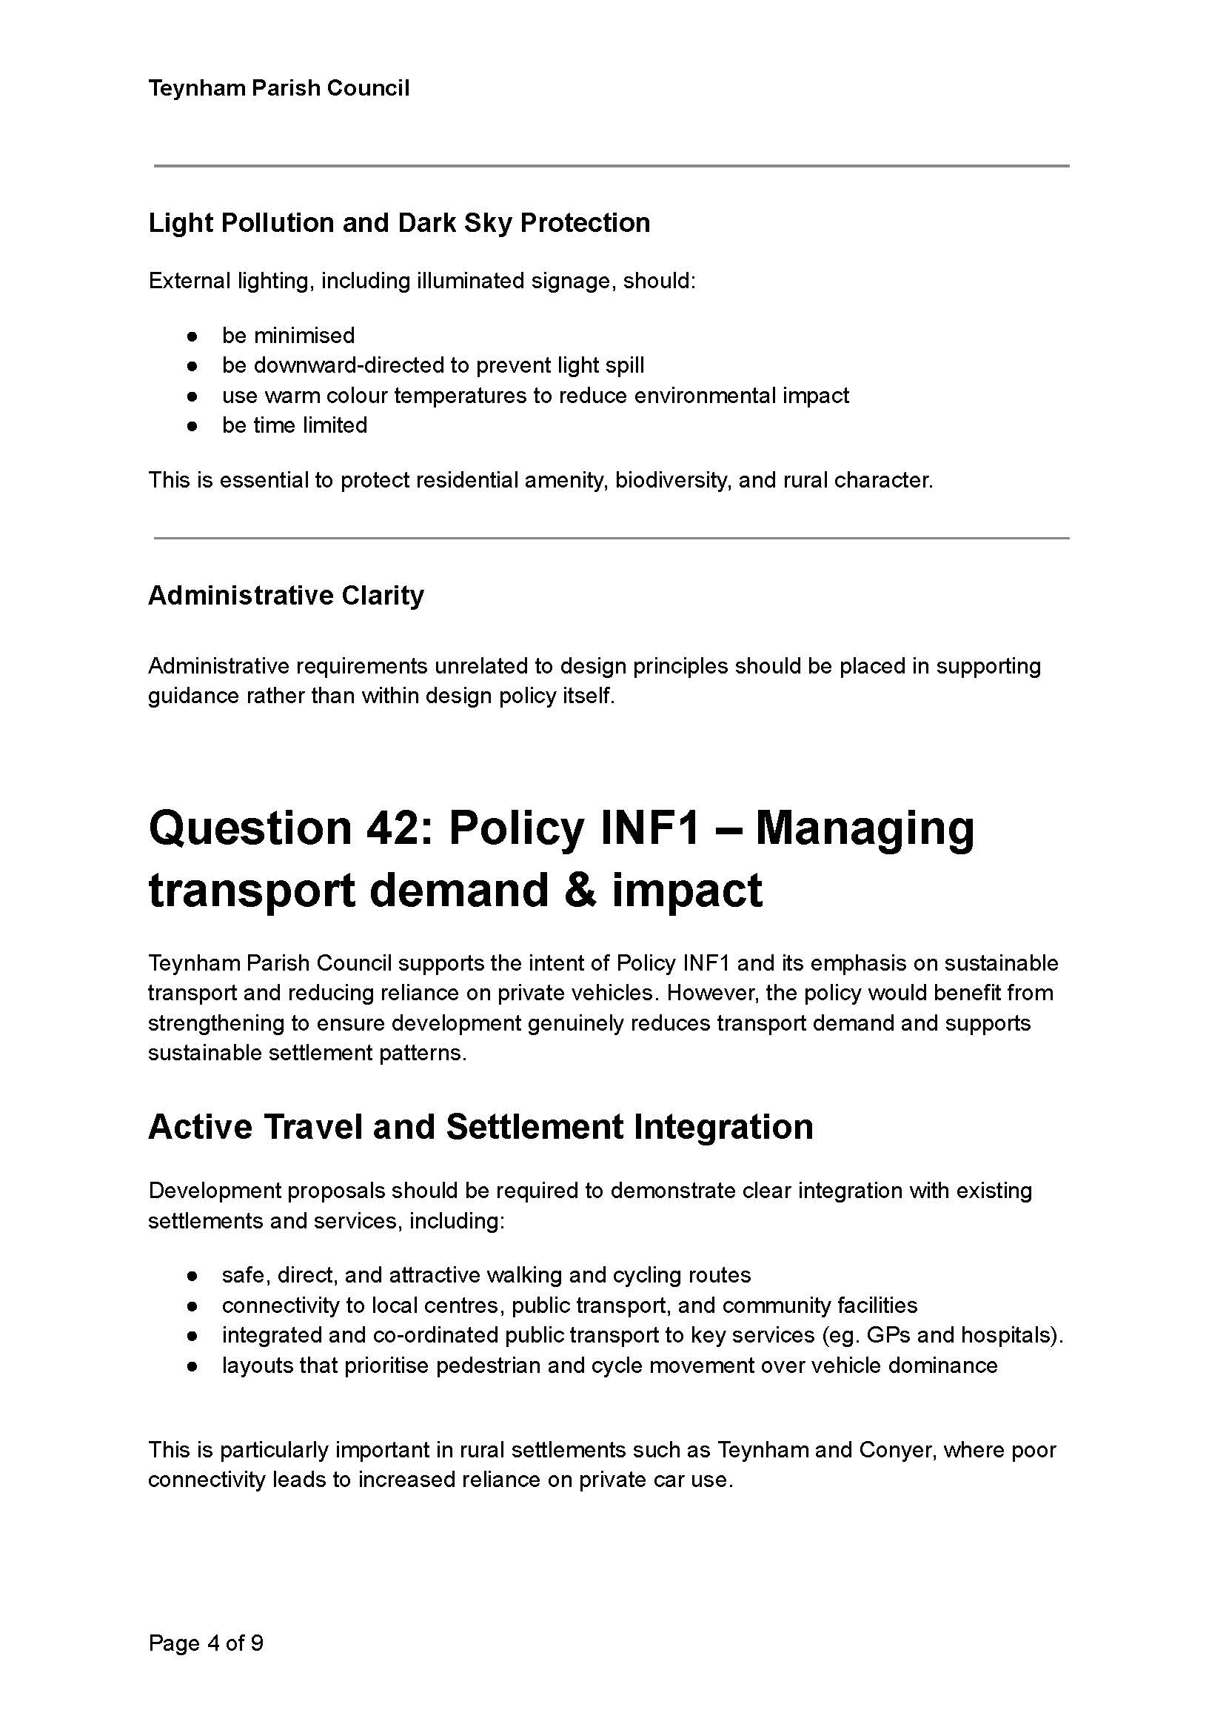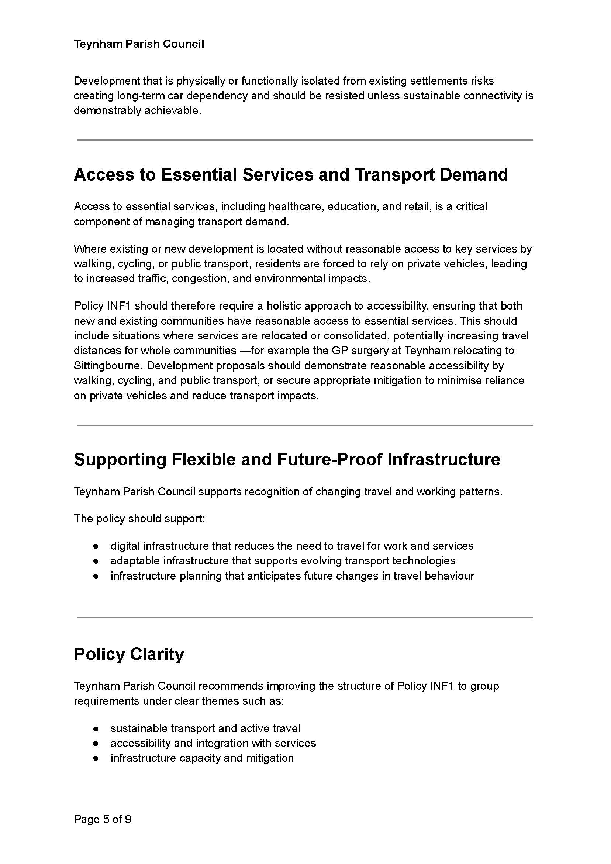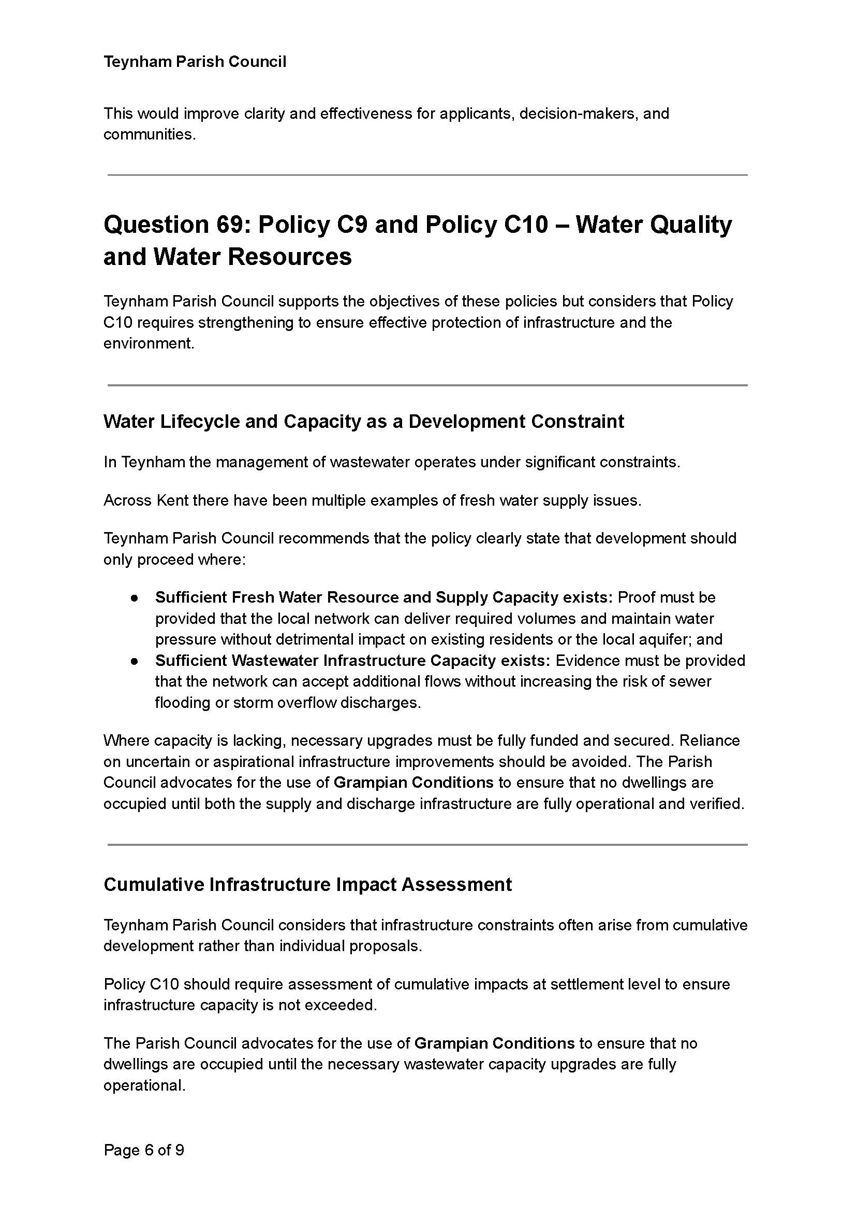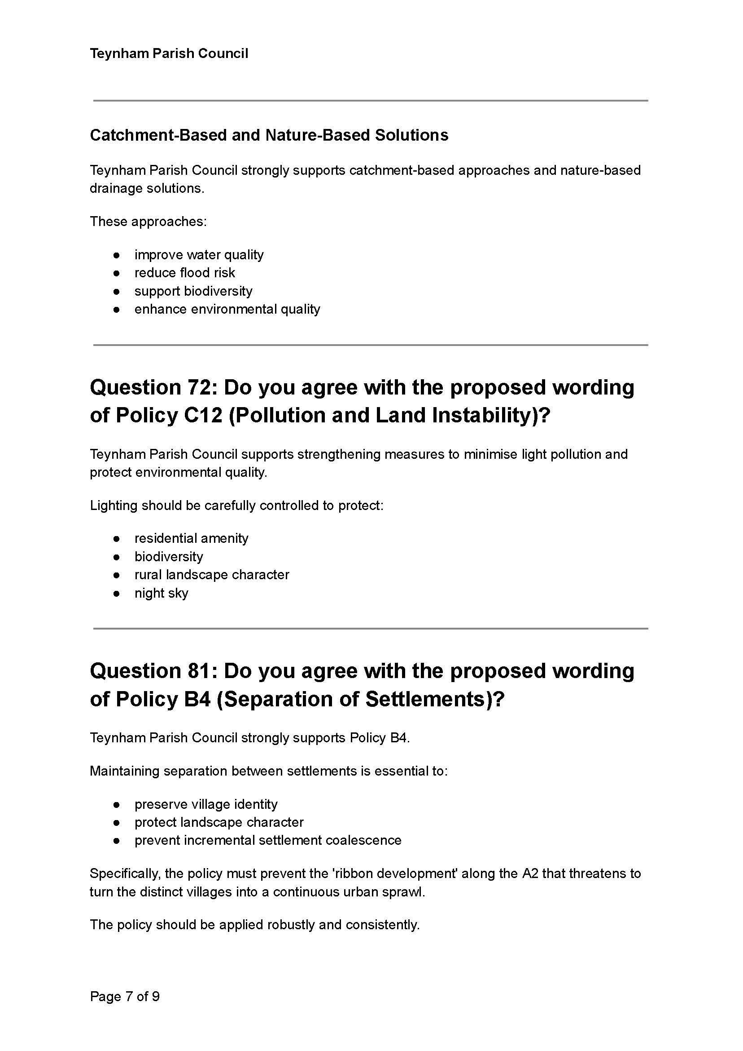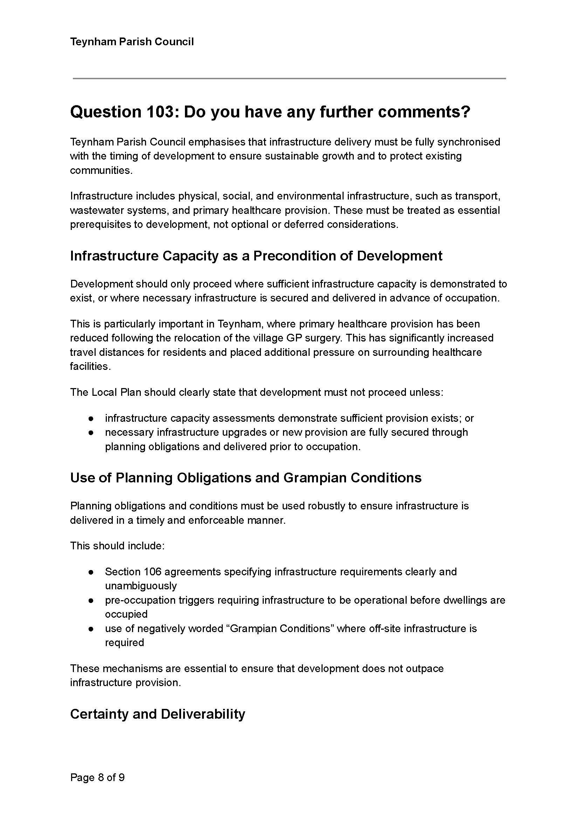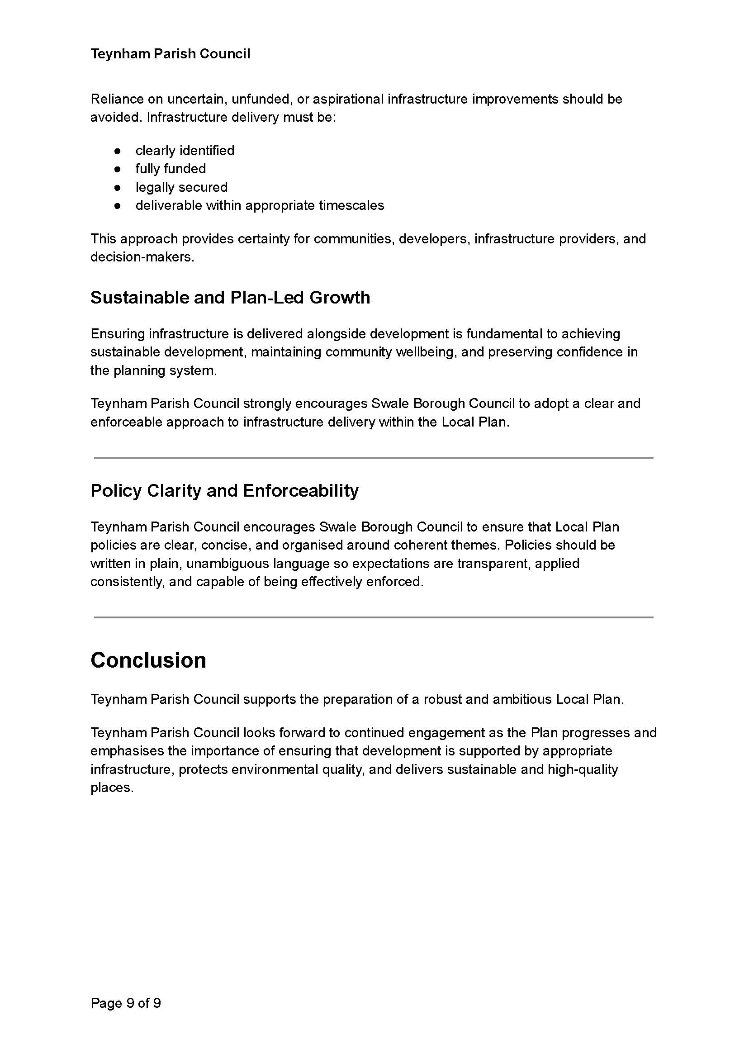
It was moved by Cllr Barnett, seconded by Mcdonald and

RESOLVED: “That Teynham Parish Council ratify the response sent to Swale Borough Council regarding the Regulation 18 Local Plan consultation.”

- To agree next steps in responding to the Local Government Reorganisation consultation.

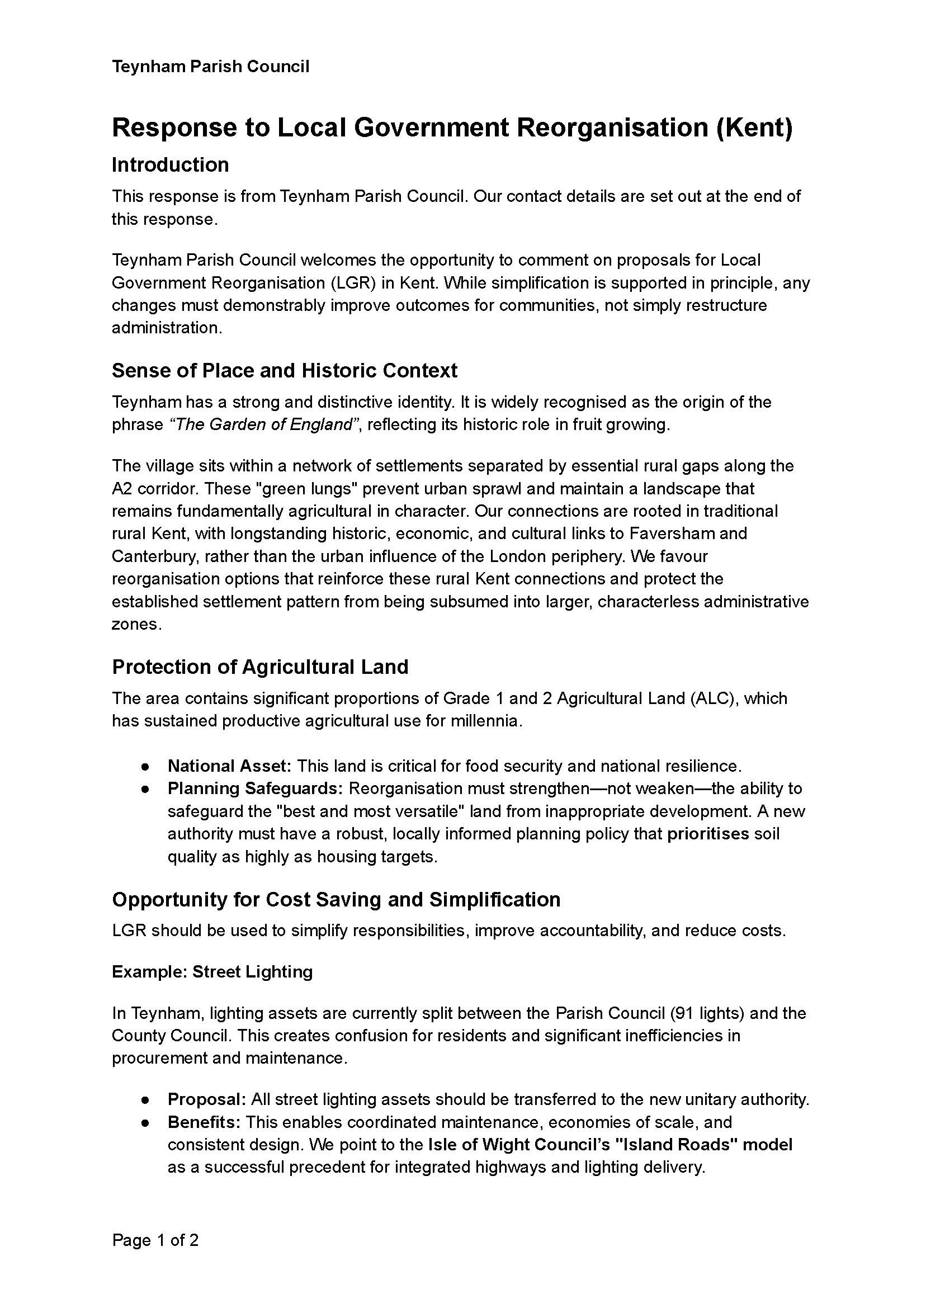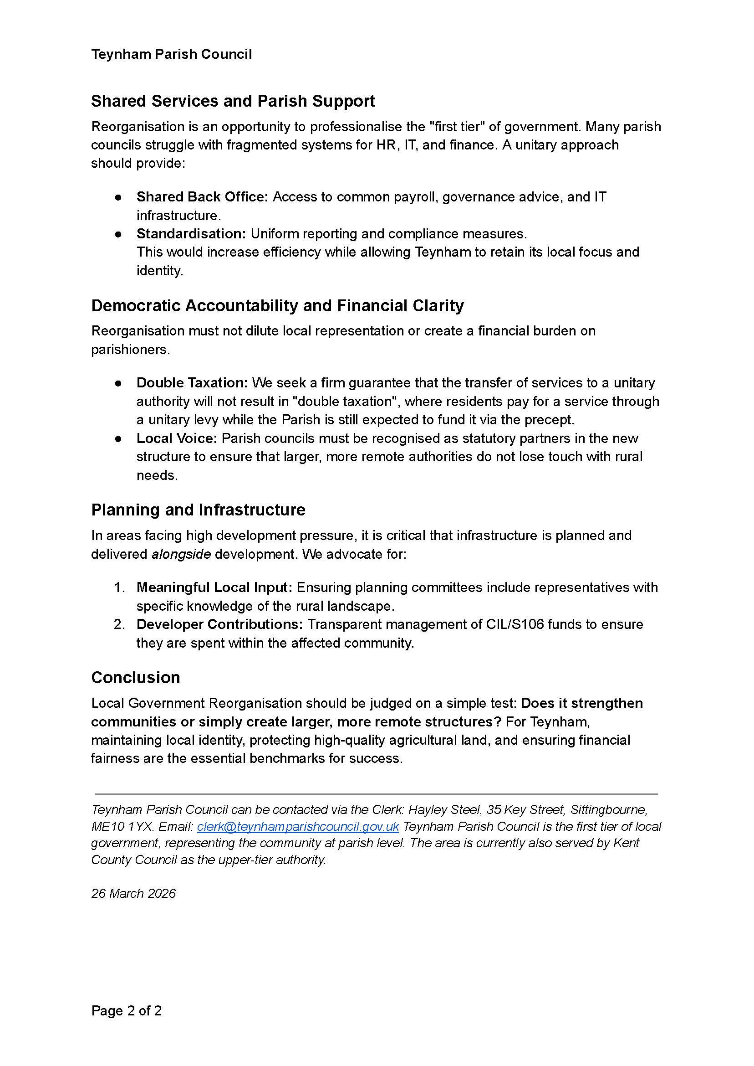
It was moved by Cllr Dixon, seconded by Cllr Barnett and

RESOLVED: “That Teynham Parish Council will respond to this before the deadline.”

- To ratify the statement concerning planning application 25/501882/FULL Land to the north of Lower Road and note it was presented to the Swale Planning Committee.

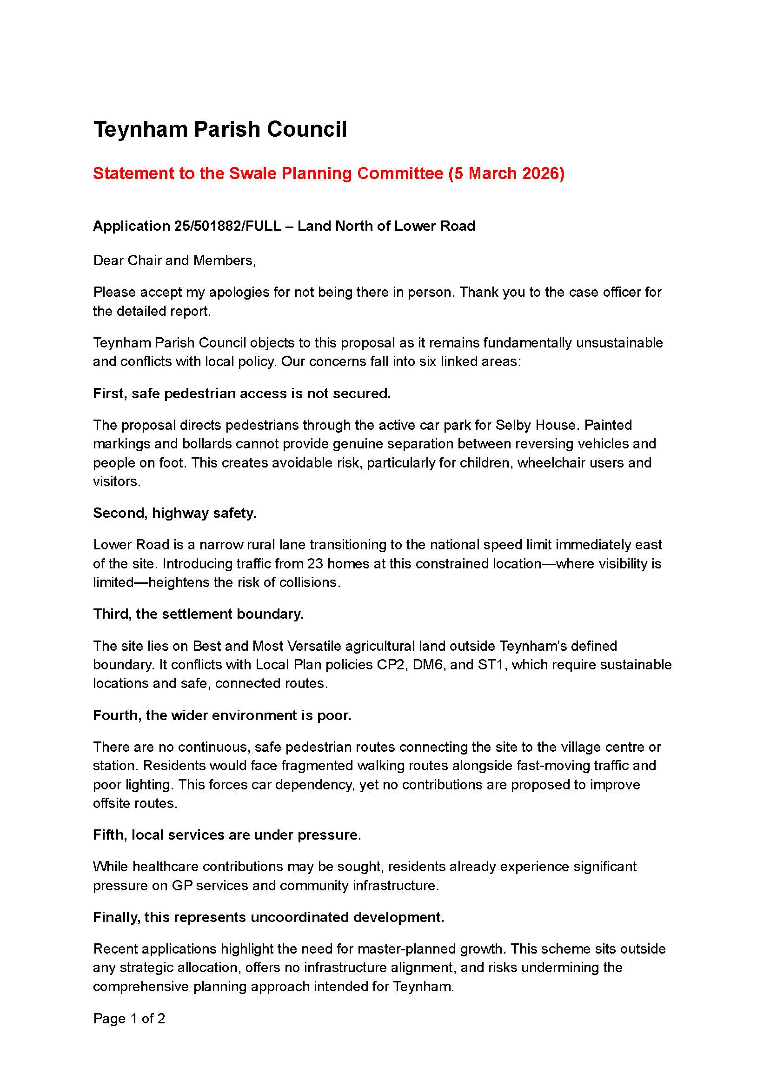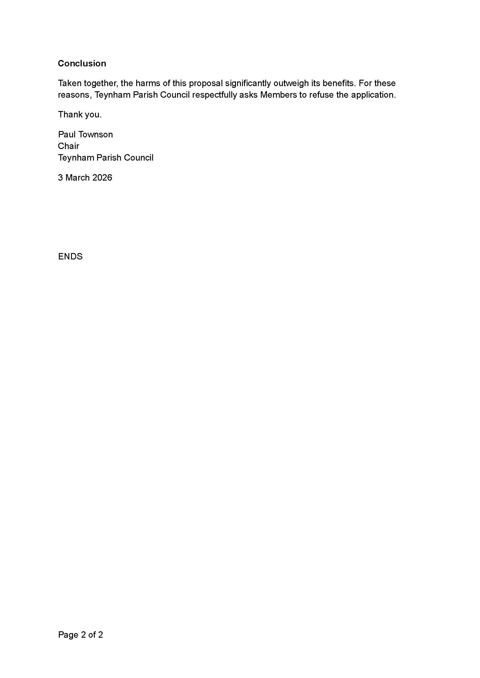

Forward Planning
- Advanced Notice of Items for the Agenda of next Ordinary Meeting.

Send to the Clerk.

- To note next year’s meeting dates
    - Tuesday 14th April 2026 Annual Parish Meeting & Ordinary Meeting
    - Tuesday 26th May 2026 Annual Parish Council Meeting & Ordinary
    - Tuesday 7th July 2026 Ordinary Meeting
    - Tuesday 1st September 2026 Ordinary Meeting
    - Tuesday 6th October 2026 Ordinary Meeting
    - Tuesday 10th November 2026 Ordinary Meeting
    - Tuesday 15th December 2026 Budget/Precept & Ordinary Meeting

- Chairman’s Closing Remarks

The Chairman thanked everyone for coming and the meeting closed at 8.50pm.

