MINUTES OF THE ORDINARY MEETING OF TEYNHAM PARISH COUNCIL HELD ON TUESDAY 20TH JANUARY 2026 AT TEYNHAM VILLAGE HALL, BELLE FRIDAY CLOSE, TEYNHAM AT 7.30PM.

Present: Cllr Barnett, Cllr Dunne, Cllr Jessup, Cllr Mcdonald, Cllr Saromi,
Cllr Townson (Chairman). Clerk – Hayley Steel.

Absent:

- Apologies for absence.

Cllrs Dixon, Mann, Simester, Sharman and SBC Bowen, SBC Speed and KCC Lehman.

- Declarations of Interests on Items on the Agenda.

None.

- To confirm that any changes to the Registers of Interests have been forwarded to the Monitoring Officer.

None.

- Public Session for 20 minutes to allow members of the public and Councillors with pecuniary interests to speak for no more than three minutes in respect of the business on the agenda. A question shall not require a response at the meeting nor start a debate on the question.

None.

- Receive brief update from ward councillor(s) on items relating to the parish of Teynham (total of 5 mins, max)

No one present.

- Chairman’s Update

Resignation of Councillor Clive Brodigan
Councillor Clive Brodigan has resigned from the Parish Council. His resignation has been formally acknowledged by the Clerk. I would like to thank Clive for his many years of service to the Parish Council. Clive has also indicated that, where possible, he is willing to continue supporting parish events and activities as a volunteer.

Focus of Tonight’s Meeting
The principal focus this evening is agreement of the budget and the precept for 2026/27. I would like to thank Hayley for the significant work involved in preparing the budget papers.

Community Hall
Over recent weeks, a substantial amount of time and resource has been dedicated to Community Hall matters, including the fire alarm proposal, heating system failure, and the defibrillator. I would like to thank Colin, Fay, and Pat for their time, support, and constructive input during this period.

Local Plan – Regulation 18 Consultation
The Regulation 18 consultation for the new Local Plan has now commenced. The Planning Committee will prepare an initial draft response, which will then be brought back to Full Council for wider discussion, refinement, and community input.

Teynham News
The next edition of Teynham News is planned for publication towards the end of February. A call for contributions and advertisers will be issued later this month.

2026/27 Budget

The Finance & General Purposes Committee has reviewed the proposed budget.
The main budget report has been prepared by the Clerk using Scribe accounting software, providing clearer financial information, improved transparency, and stronger financial oversight

- Agree to advertise the vacancy on Parish Council

It was moved by Cllr Barnett, seconded by Cllr Mcdonald and

RESOLVED: “That Teynham Parish Council advertise the vacancy on the Parish Council.”

- To elect a Vice Chairman

Cllr Townson proposed Cllr Jessup, it was seconded by Cllr Barnett and

RESOLVED: “That Cllr Jessup be elected as Vice Chairman.”

- Budget 2026/27
The chairman gave an overview of the proposed budget:
A key theme this year has been clarity — grouping related costs, removing duplication, and basing figures on known costs and confirmed statutory changes (including Employer National Insurance and National Living Wage increases).

Income and Precept

It is proposed that the precept increases from £74,000 to £81,245.
Despite this increase, the budget remains tight and is partly reliant on reserves.
- Band D charge increases from £74.48 to £81.10
- This represents an 8.89% increase
- A copy of the detailed budget spreadsheet is included in the papers

Budget Headings – Key Points

Amenities
Covers maintenance and operation of parish assets including street lighting, meadow open space, play equipment, and CCTV. Rising energy and repair costs are reflected. Groundsman costs have been consolidated for clarity.

Community Hall
Community Hall costs are now clearly grouped, including utilities, maintenance, and the Public Works Loan Board (PWLB) mortgage. The precept supports:
- £4,295 PWLB mortgage repayment
- £2,000 contribution toward community use

Editorial
Costs for production and distribution of Teynham News, with website and digital costs consolidated to improve transparency and cost control.

General Account
Covers council governance, staffing, insurance, IT, and community events.
Updated pension and employer National Insurance assumptions are included.
The PWLB has been removed from this cost centre.
It is proposed to increase the Clerk’s salary by 3.9% to £25,300, based on a 30-hour week.

Planning
Provision for professional planning advice to ensure the Council can respond effectively to applications and protect parish interests.

Key Points to Note

- Reserves: Approximately £2,500 is proposed to be drawn from reserves.
- Groundsman costs:
  - In 2025/26, the £3,000 car park precept covered both hedge cutting and rubbish collection.
  - In 2026/27, these costs are separated to improve transparency and accountability.

Insurance:
The insurance policy covers all Parish Council-owned assets, including street lighting, the Community Hall, and play equipment.

  - To agree the budget recommendations from the Finance & General Purposes Committee for 2026/2027.

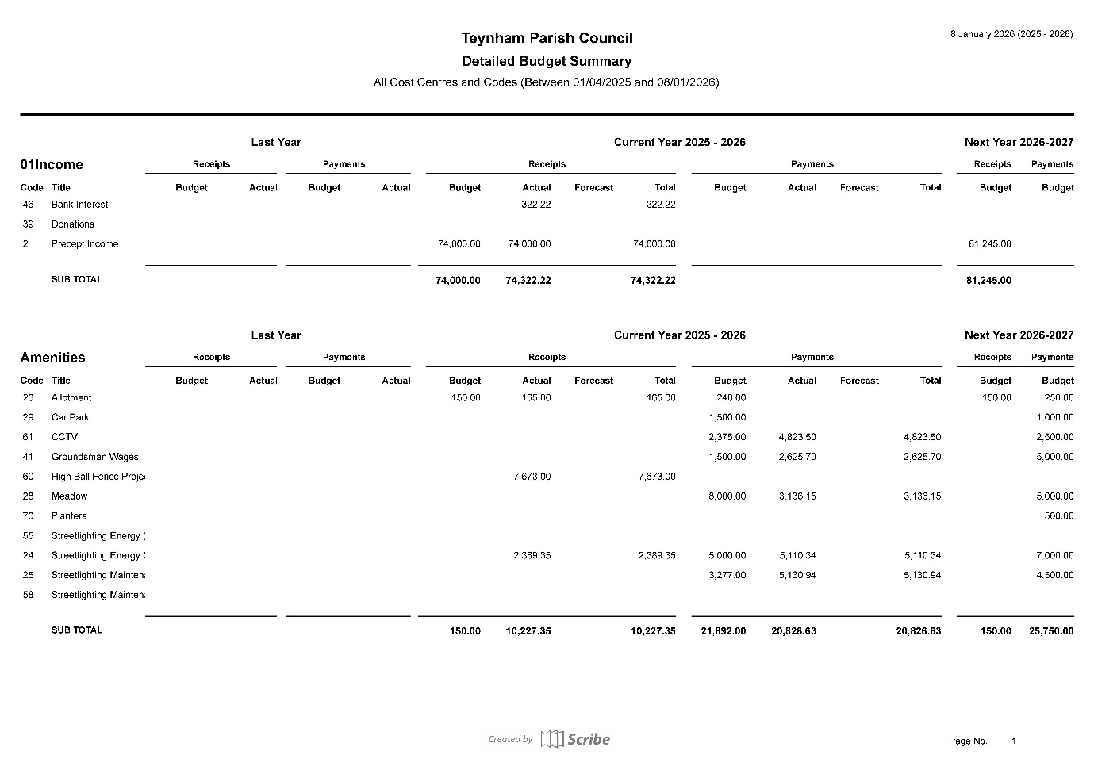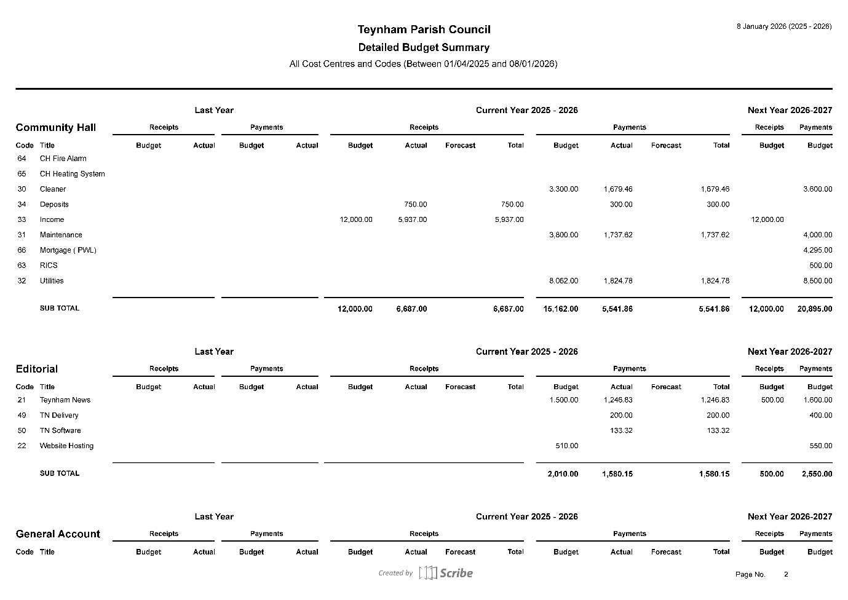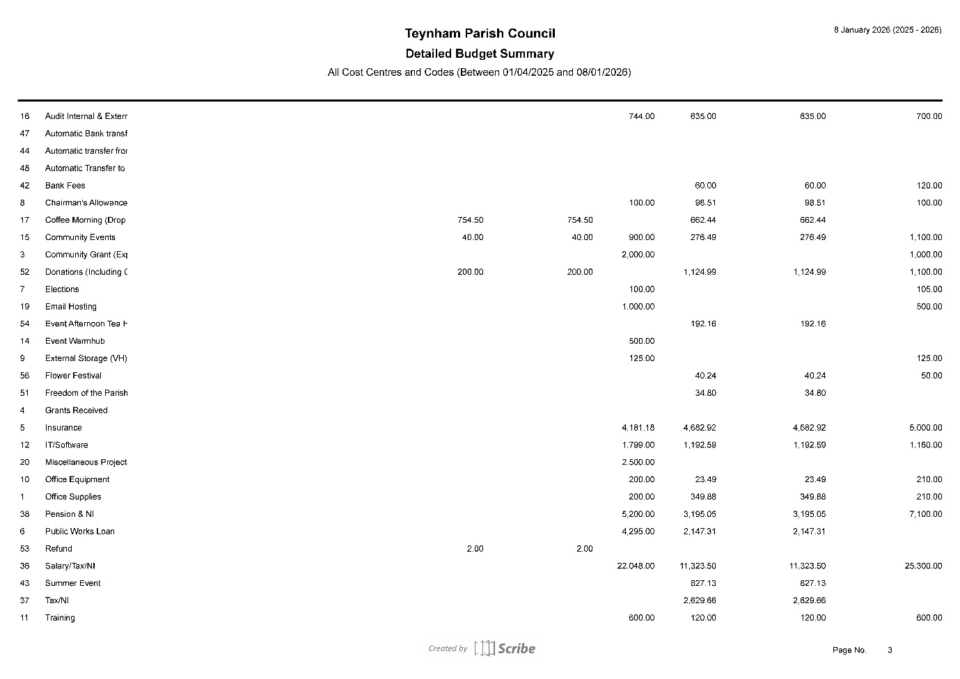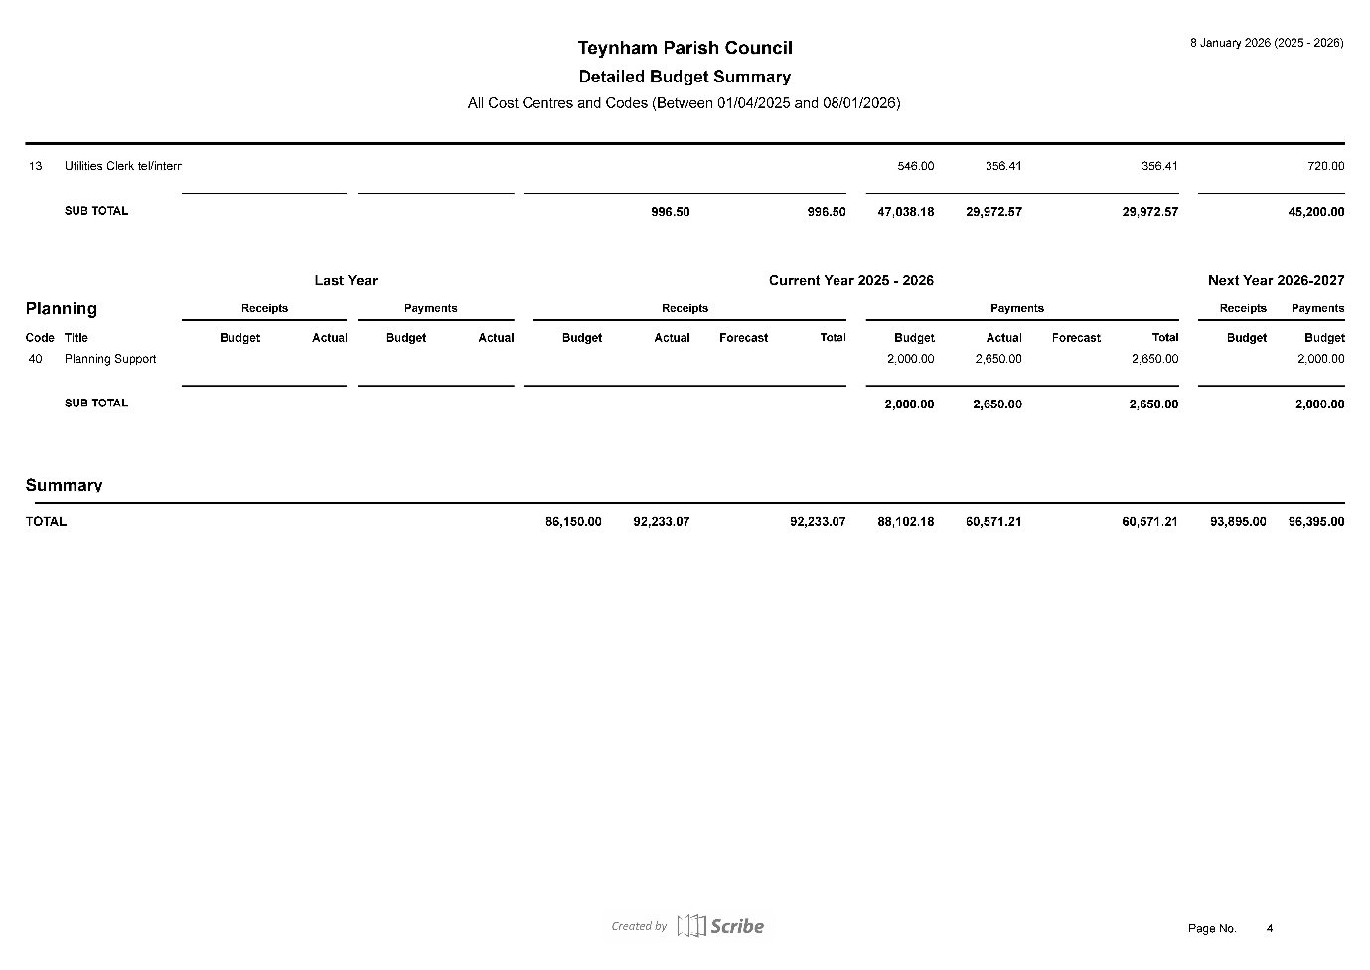
It was moved by Cllr Barnett, seconded by Cllr Mcdonald and

RESOLVED: “That Teynham Parish Council budget for 2026-27 will be set at £81,245.”
  - To agree the Precept recommendations from the Finance and General Purposes Committee for 2026/27 and agree precept amount for Swale Borough Council.

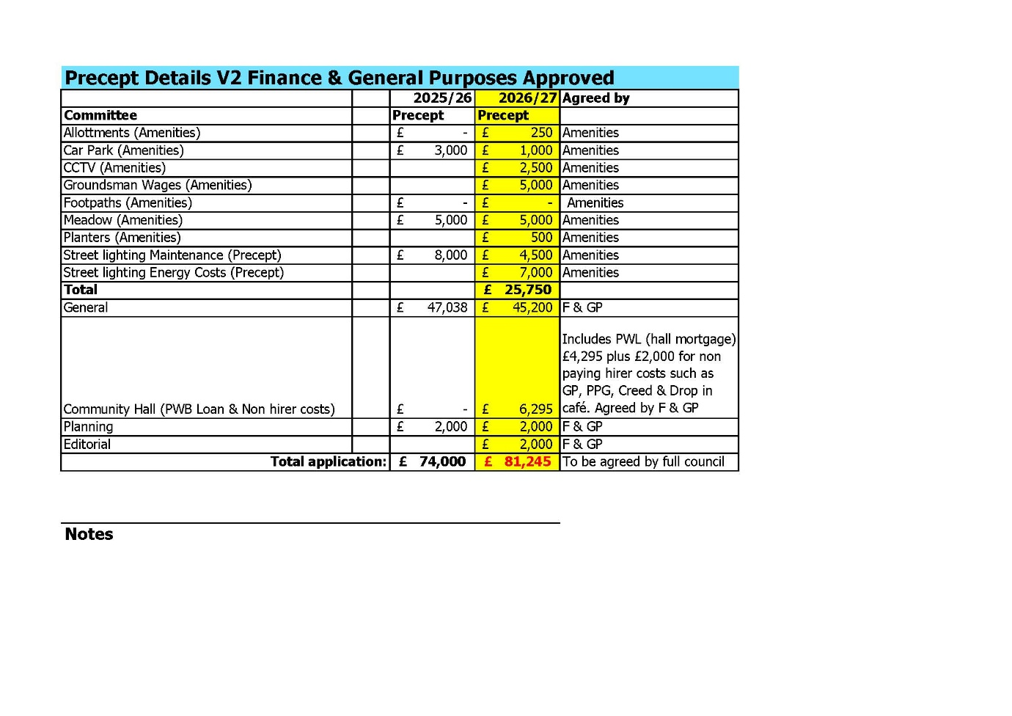
It was moved by Cllr Dunne, seconded by Cllr Jessup and

RESOLVED: “That Teynham Parish Council will request a precept amount of £81,245 from Swale Borough Council for the year 2026-27.”

  - To agree staff salaries for April 2026 – March 2027.

It was discussed and agreed that the Groundsman wages for 2026-27 would be increased to £12.71 per hour in line with minimum wage.

It was discussed and agreed that the Clerk’s salary for 2026-27 will be £25,300 which is a 3.9% increase in line with NALC recommendations.

It was moved by Cllr Jessup, seconded by Cllr Dunne and

RESOLVED “That the Groundsman wages will increase to £12.71 per hour and the Clerk salary will increase to £25,300 per annum for the year 2026-27.”

- Community Hall Heating
  - To note that the heating system has failed; temporary heating measures are in place; a risk assessment has been completed; and the Council’s insurers have been notified.

Noted.
  - To note that a tender document for replacement of the heating system has been prepared and issued to interested suppliers, with quotations requested by Monday 19th January 2026.

Noted.

  - To agree additional interim measures and agree a spending limit not exceeding £1,000.

It was moved by Cllr Barnett, seconded by Cllr Mcdonald and

RESOLVED: “That the Parish Council agree to additional interim measures for heating in the Community Hall and agree a spending limit not to exceed £1,000.”

  - To note that the expected cost of the replacement system and associated works is likely to exceed £25,000, and that Financial Regulation 11 will therefore apply.

Noted.

- Fire Alarm – Community Hall
To note the Fire Alarm Briefing Paper and to consider recommendation(s) from the Community Hall Committee in relation to the Community Hall fire-alarm provision, and to agree the Council’s next steps.

The Community Hall Committee agreed for Amiga Fire and Security to install our Fire Safety System.

It was moved by Cllr Barnett, seconded by Cllr Mcdonald and

RESOLVED: That Teynham Parish Council appoint Amiga Fire and Security to install our Fire Safety System.”

- Forward Planning
  - Advanced Notice of Items for the Agenda of next Ordinary Meeting.

To be sent to the Clerk.

  - To note next year’s meeting dates
    - Tuesday 3rd March 2026 Annual Parish Meeting & Ordinary Meeting
    - Tuesday 14th April 2026 Ordinary Meeting
    - Tuesday 26th May 2026 Annual Parish Council Meeting & Ordinary
    - Tuesday 7th July 2026 Ordinary Meeting
    - Tuesday 1st September 2026 Ordinary Meeting
    - Tuesday 6th October 2026 Ordinary Meeting
    - Tuesday 10th November 2026 Ordinary Meeting
    - Tuesday 15th December 2026 Budget/Precept & Ordinary Meeting
It was agreed that the Parish Council would hold an Extra Ordinary Meeting on Tuedday 10th February to review final quotes on heating system installation for the Community Hall as all quotes will be in by then.

- Chairman’s Closing Remarks

That Chairman thanked Cllr Jessup for becoming Vice Chair, thanked everyone for coming and the meeting closed at 8.32pm.

