MINUTES OF THE ORDINARY MEETING OF TEYNHAM PARISH COUNCIL HELD ON TUESDAY 1ST SEPTEMBER 2026 AT TEYNHAM COMMUNITY HALL, 89 STATION ROAD, TEYNHAM AT 7PM.

Present: Cllr Barnett, Cllr Dunne, Cllr Macdonald, Cllr Mann, , Cllr Jessup, Cllr Townson (Chairman). and Clerk – Hayley Steel.

Absent:

- Apologies for absence.

Cllr Dixon, Cllr Saromi, Cllr Parr, SBC Bowen, SBC Speed and KCC Lehman.

- Declarations of Interests on Items on the Agenda.

None.

- To confirm that any changes to the Registers of Interests have been forwarded to the Monitoring Officer.

Clerk will contact SBC.

- Public Session for 20 minutes to allow members of the public and Councillors with pecuniary interests to speak for no more than three minutes in respect of the business on the agenda. A question shall not require a response at the meeting nor start a debate on the question.

A member of the public asked for an update on the Frognal Lane development. Cllr Towson informed them that members of the PC will be meeting with Moat soon and that Moat plan to have a public meeting to keep residents informed.

A member of the public also asked for an update on Highsted Park planning inquiry and Cllr Townson informed them that the Action Group would be responding to a “Reference back letter” that has been received by 8th September.

- Receive brief update from ward and county councillor(s) on items relating to the parish of Teynham (total of 5 mins, max)

No SBC’s were present.

- To approve the minutes of the Ordinary Parish Council Meeting on 7th July 2026.

It was moved by Cllr Barnett, seconded by Cllr Jessup and

RESOLVED: “That Teynham Parish Council approve the minutes of the Ordinary Parish Council Meeting on 7th July 2026 as a true record.”

- Matters arising.

None.

- Chairman’s report.

This is what your Parish Council has been doing since we last met. Thank you to local residents, the WI, parish and borough councillors, and our Parish Clerk for helping to make this happen.

Representation
- Spoke at the Swale Planning Committee on the Lower Road development.
- Prepared the Parish Council’s draft Regulation 19 Local Plan response.
- Attended a drop-in session with the Police and Borough Councillor.
Thank you to PC Divers and Julien Speed for attending.

Communications
- Published updates during the water outage, working with Borough Councillors Julien and Lloyd to share information. Thank you both.
- Published updates on Highsted Park and a recent planning decision.
- Produced and published Teynham News – 1,500 copies delivered. Thank you to everyone who helped gather material and deliver copies door-to-door. Five local businesses are also acting as collection points.
- Facebook: 127,940 page impressions; 16,000+ unique viewers in the last 28 days.

Campaigns & Community
- Speed Watch: 8 volunteers trained; five 60-minute sessions completed.
- Litter pick: next session scheduled for 13 September.
- Joint Transportation Board: next meeting on 21 September.
- Drop-in Café: three sessions held, with around 50 people attending each session.

Facilities & Administration
- Streetlights: following up general faults and the Honeyball Walk column; investigating solar lighting as a potential replacement option.
- Play equipment: damaged green child’s swing removed from the Meadow.
- Planters: thank you to those maintaining them; dedicated webpage being developed.
- Community Hall: establishing the Friends of Teynham Community Hall group and welcomed CHiP Productions.
- Administration: setting up a new online booking calendar for the community hall and starting the process of moving to a new banking provider.

Workload
- The Regulation 19 Local Plan and latest Highsted Park submission have created significant additional workloads, with externally determined deadlines requiring substantial work at short notice.

- Community
9.1 Receive an update on requests to hire Teynham PC assets and consider next steps (sent in advance)

Situation:
The Parish Council has received requests to use its land and assets, including the
Meadow, Community Hall chairs and mugs. There is currently no consistent policy.

Action taken:

The Clerk, Chair and F&GP Committee reviewed a recent request to hold a sports day at the Meadow. Due diligence was completed, including recording organiser and event details, requesting/reviewing a simple risk assessment and obtaining a copy of the organiser’s public liability insurance.

Proposal:

Develop a simple policy covering:

- Assets are for the benefit of the whole community.
- Community / non-profit use – normally free or nominal charge.
- Commercial / for-profit use – hire charge normally applies.
- Separate arrangements for land/venues and Council assets.
- Users remain responsible for relevant licensing, insurance, health & safety and safeguarding requirements. Users responsible for loss or damage.
- Manage expectations and risks for both parties.

Next Steps

- Seek a councillor volunteer to lead this small project and bring a draft policy and proposed charges back to Council for agreement.

Cllr Barnett agreed to draft a proposal for this.

9.2 To note arrangements for St Mary’s Flower Festival and agree expenditure up to £25 from the events budget

The budget was agreed at a previous meeting. Cllr’s Townson, Barnett, Mann,
Jessup offered to help with our flower arrangement.

9.3 To agree to order a wreath for Remembrance Sunday (from the events budget)

It was moved by Cllr Barnett, seconded by Cllr Dunne and

RESOLVED: “That the Parish Council will order a poppy wreath and make a donation to the Royal British Legion.”

9.4 To agree to order a Christmas Tree for the Community Hall (up to the value of £150, from the events budget)

It was moved by Cllr Barnett, seconded by Cllr Mann and

RESOLVED: “That the Parish Council agree to order a Christmas Tree for the
Community Hall (up to the value of £150, from the events budget.”

It was also agreed that we would look at possible alternatives in the January 2027
meeting.

9.5 To agree to extend the closing date for applications for co-option to the Parish Council to 1 October 2026.

It was moved by Cllr Macdonald, seconded by Cllr Mann and

RESOLVED: “That the Parish Council agree to extend the closing date for
Applications for co-option to the Parish Council to 1st October 2026.”

9.6 To review the terms of the Teynham PC grant scheme and invite applications for 2026/7.

Current wording: Teynham Parish Council has allocated a total of £XXXX for this
year's small grant scheme. Grants for community purposes may be considered for
projects and works that bring cultural, sporting, recreational, health, environmental,
heritage, community safety, crime reduction or educational benefits to the local
community (within the Parish of Teynham).

Grants which may be made available to applicants such as the village hall
management committee, local clubs, voluntary committees, community
organisations, the school and the church.

The grant cannot be given to support functions that would have otherwise been
funded by statutory education or support political or directly religious activities. Also,
grants will not be approved for organisations operating for direct commercial gain.

Noted.

9.7 To note requests to hold drop-in sessions at Conyer and Teynham and agree next steps.

The Swan on London Road and the Ship Inn in Conyer have agreed we can hold the
sessions there.

We will try and arrange drop-in sessions with PC Divers.

9.8 To agree to remove, refurbish and re-install the memorial plaque in memory of the Bray family on the log in London Road (up to a maximum of £100).

It was moved by Cllr Dunne, seconded by Cllr Barnett and

RESOLVED: “That we will remove, refurbish and re-install the memorial plaque in
memory of the Bray family on the log in London Road (up to a maximum of £100).

- Community Hall
10.1 To receive an update from Friends of Teynham Community Hall Working Group.

Report from Cllr Jessup:-

- We have 18 Friends of Teynham members
- We have had 2 constructive meetings
- First meeting was to discuss future events to encourage more use of the hall
- We asked each member for their top 3 ideas
- Top of the list were, beetle drive, card afternoon and cake picnic
- Other ideas included, barn dance, quiz’s, indoor boot fair, live music and wrestling
- Each of these ideas have been allocated to members to drive these forward
- The second meeting discussed top priorities for enhancement to the hall
- Once again members wrote 3 priorities
- Top of the list was new noticeboard, painting outside and lobby and cleaning the chairs
- Other ideas included tarmacking the car park and new heaters in the toilets
- Next meeting 14th October 2026
- Cllr Jessup explained that all expenditure must go through the Parish Council

10.2 To agree to allocate the money donated to the Parish Council from the Drop In Cafe to the Community Hall account.

a. £149.86 – Raffle & Quiz in July 2026

It was moved by Cllr Barnett, seconded by Cllr Macdonald and

RESOLVED: “That the Parish Council agree to allocate this money to the Community
Hall account.”

b. £263.70 – WI refreshments August 2026

It was moved by Cllr Barnett, seconded by Cllr Macdonald and

RESOLVED: “That the Parish Council agree to allocate this money to the Community
Hall account.”

c. £60 – Quiz August 2026

It was moved by Cllr Barnett, seconded by Cllr Macdonald and

RESOLVED: “That the Parish Council agree to allocate this money to the Community
Hall account.”

d. £19.50 – Teynham Safari refreshments August 2026

It was moved by Cllr Barnett, seconded by Cllr Mann and

RESOLVED: “That the Parish Council agree to allocate this money to the Community
Hall account.”

- Planning
Consider response to Swale 2026 Local Plan

Reg 19 Local Plan – At a Glance
The Local Plan sets out where development will take place across Swale and the policies guiding growth to 2042. At Regulation 19, responses must address the four tests of soundness: positively prepared, justified, effective and consistent with national policy.
Proposed key points:
- Main concern: cumulative growth without supporting infrastructure.
- Services and transport: roads, healthcare and public transport must keep pace.
- Protect Teynham: strengthen countryside gaps and settlement separation.
- Sustainable growth: development must be deliverable and supported by infrastructure.
Work Completed
- Reviewed the Plan and identified Teynham’s key issues
- Sought residents’ views on those priorities.
- Reviewed feedback and supporting evidence.
- Prepared the draft TPC response (inc summary of development) for consideration
Proposed Next Steps
Stage | Action | Timing
- Overview | Provide overview at meeting | 1 Sept
- PC Review | Review and agree draft response | 2-5 Sept
- Public Review | Publish public draft | 7-14 Sept
- Finalise | Incorporate relevant feedback | 14-15 Sept
- Submit | Submit representations to SBC | 16 Sept
- Ratify | Ratify submission and record in minutes | October meeting
What do Councillors need to do?
Review the draft 2026 Local Plan Reg 19 Response
Then consider:
- Is our overall stance right?
- Have we covered the major issues for Teynham? Is anything significant missing?
- Are our concerns supported by sufficient evidence?
- Are the changes we are asking SBC to make clear and reasonable?

- Finance
12.1 Update on faulty street light column, located in Honeyball Walk, and consider next steps

This column is near the garages at Honeyball Walk. The pole is corroded and will be
too expensive to repair at the moment so we do not have the budget for it. It is
cheaper to but the pole down.

It was moved by Cllr Jessup, seconded by Cllr Dunne and

RESOLVED: “That the Parish Council ask for the column to be cut down.”

12.2 To receive the Income and Expenditure Report for June & July

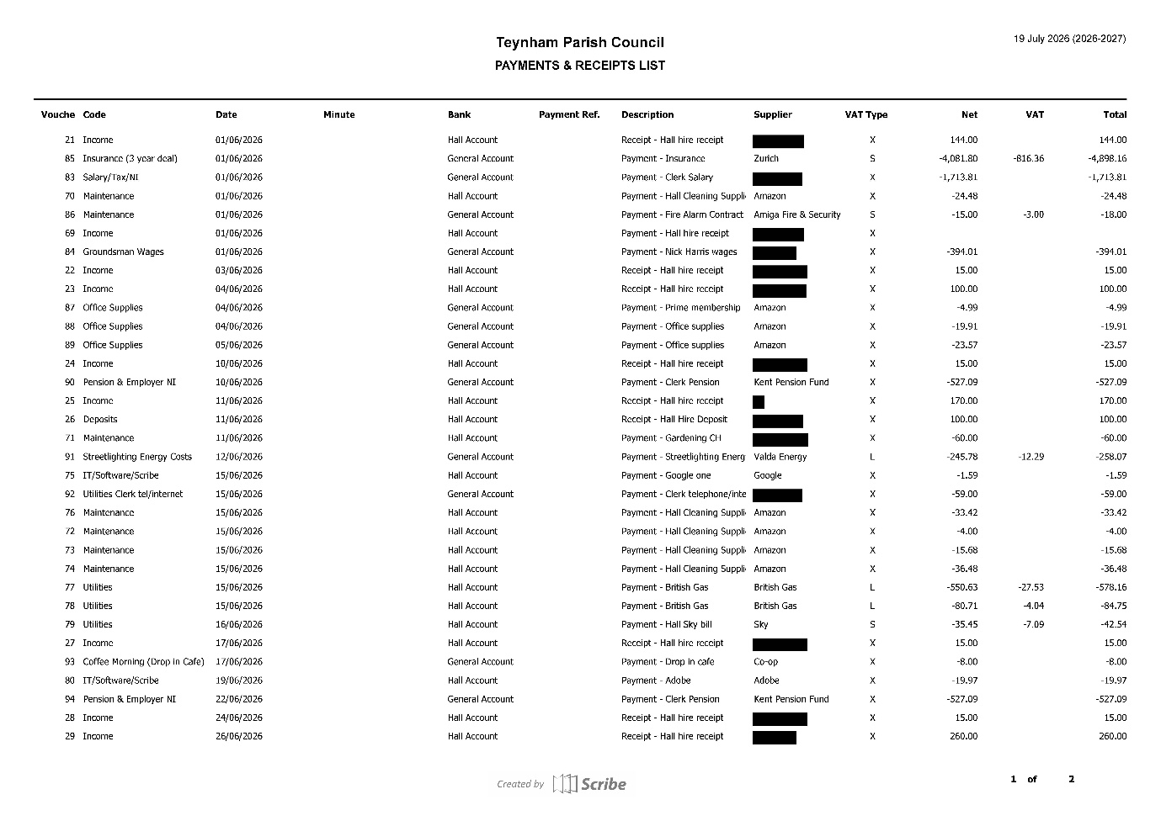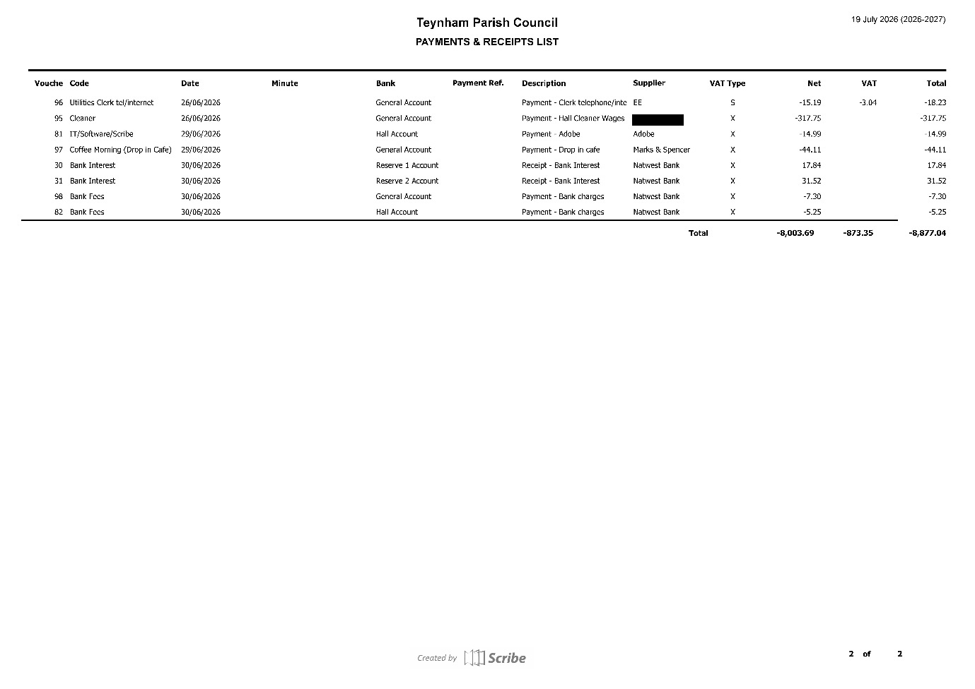
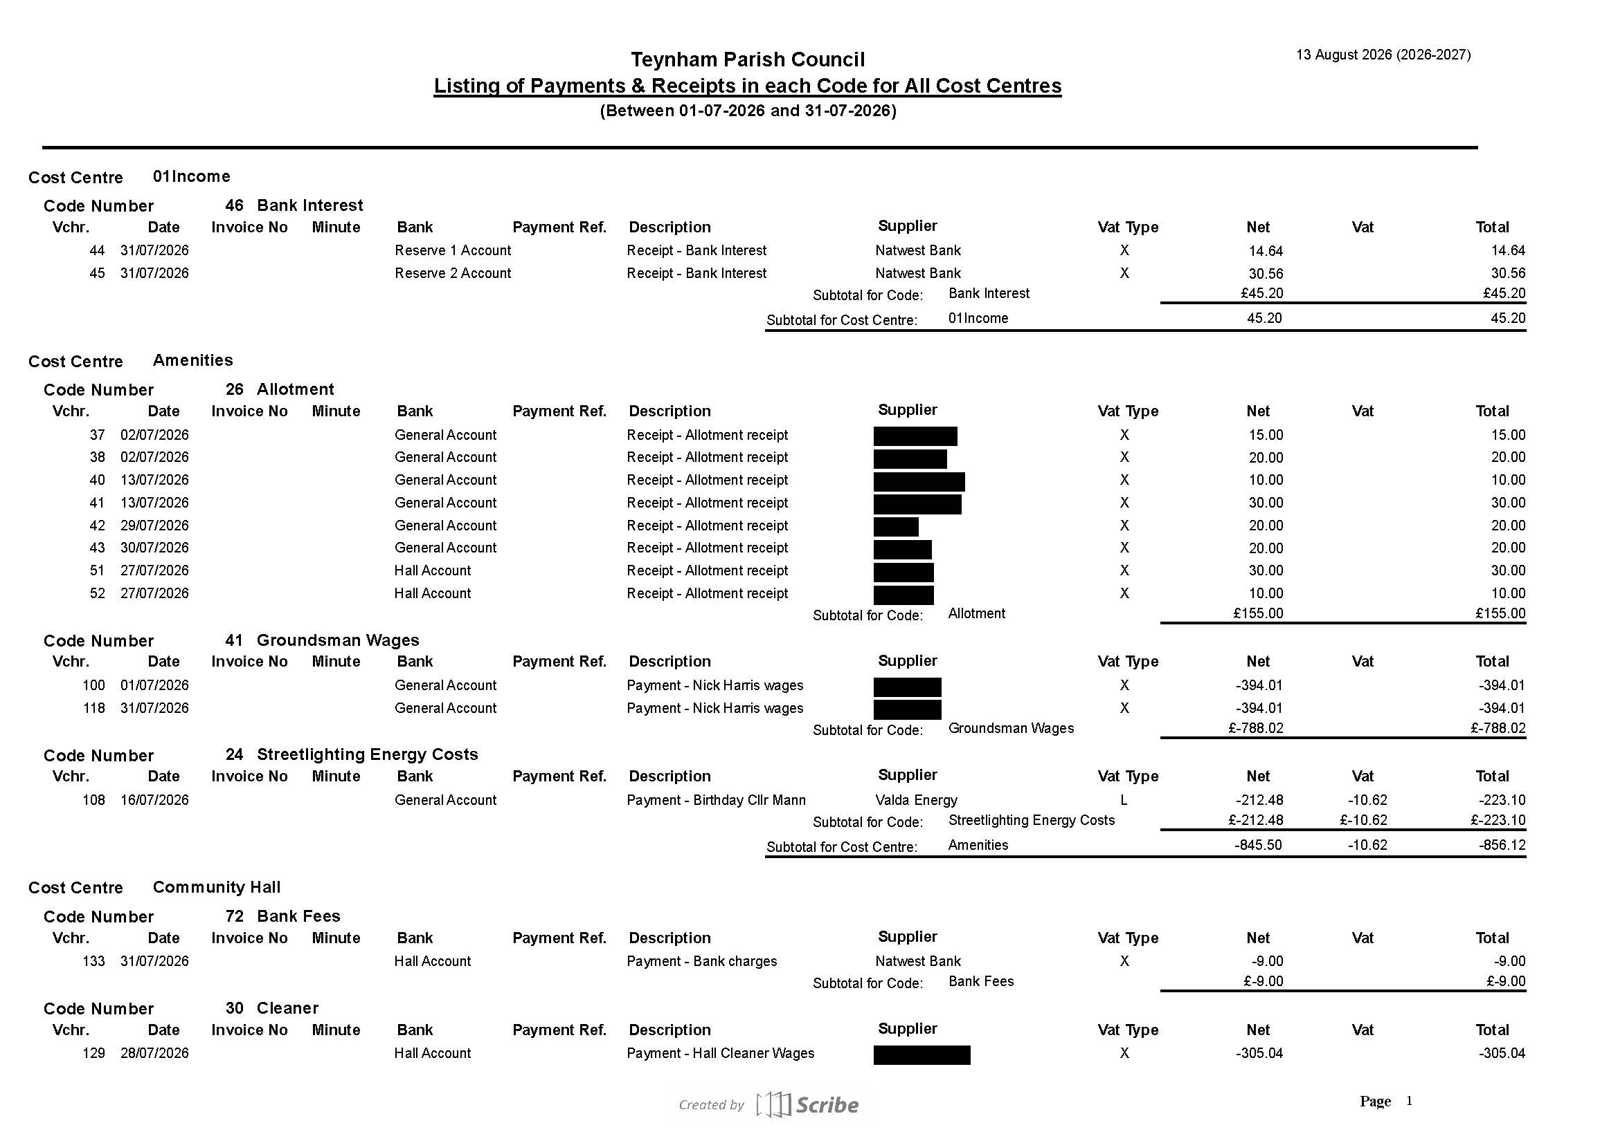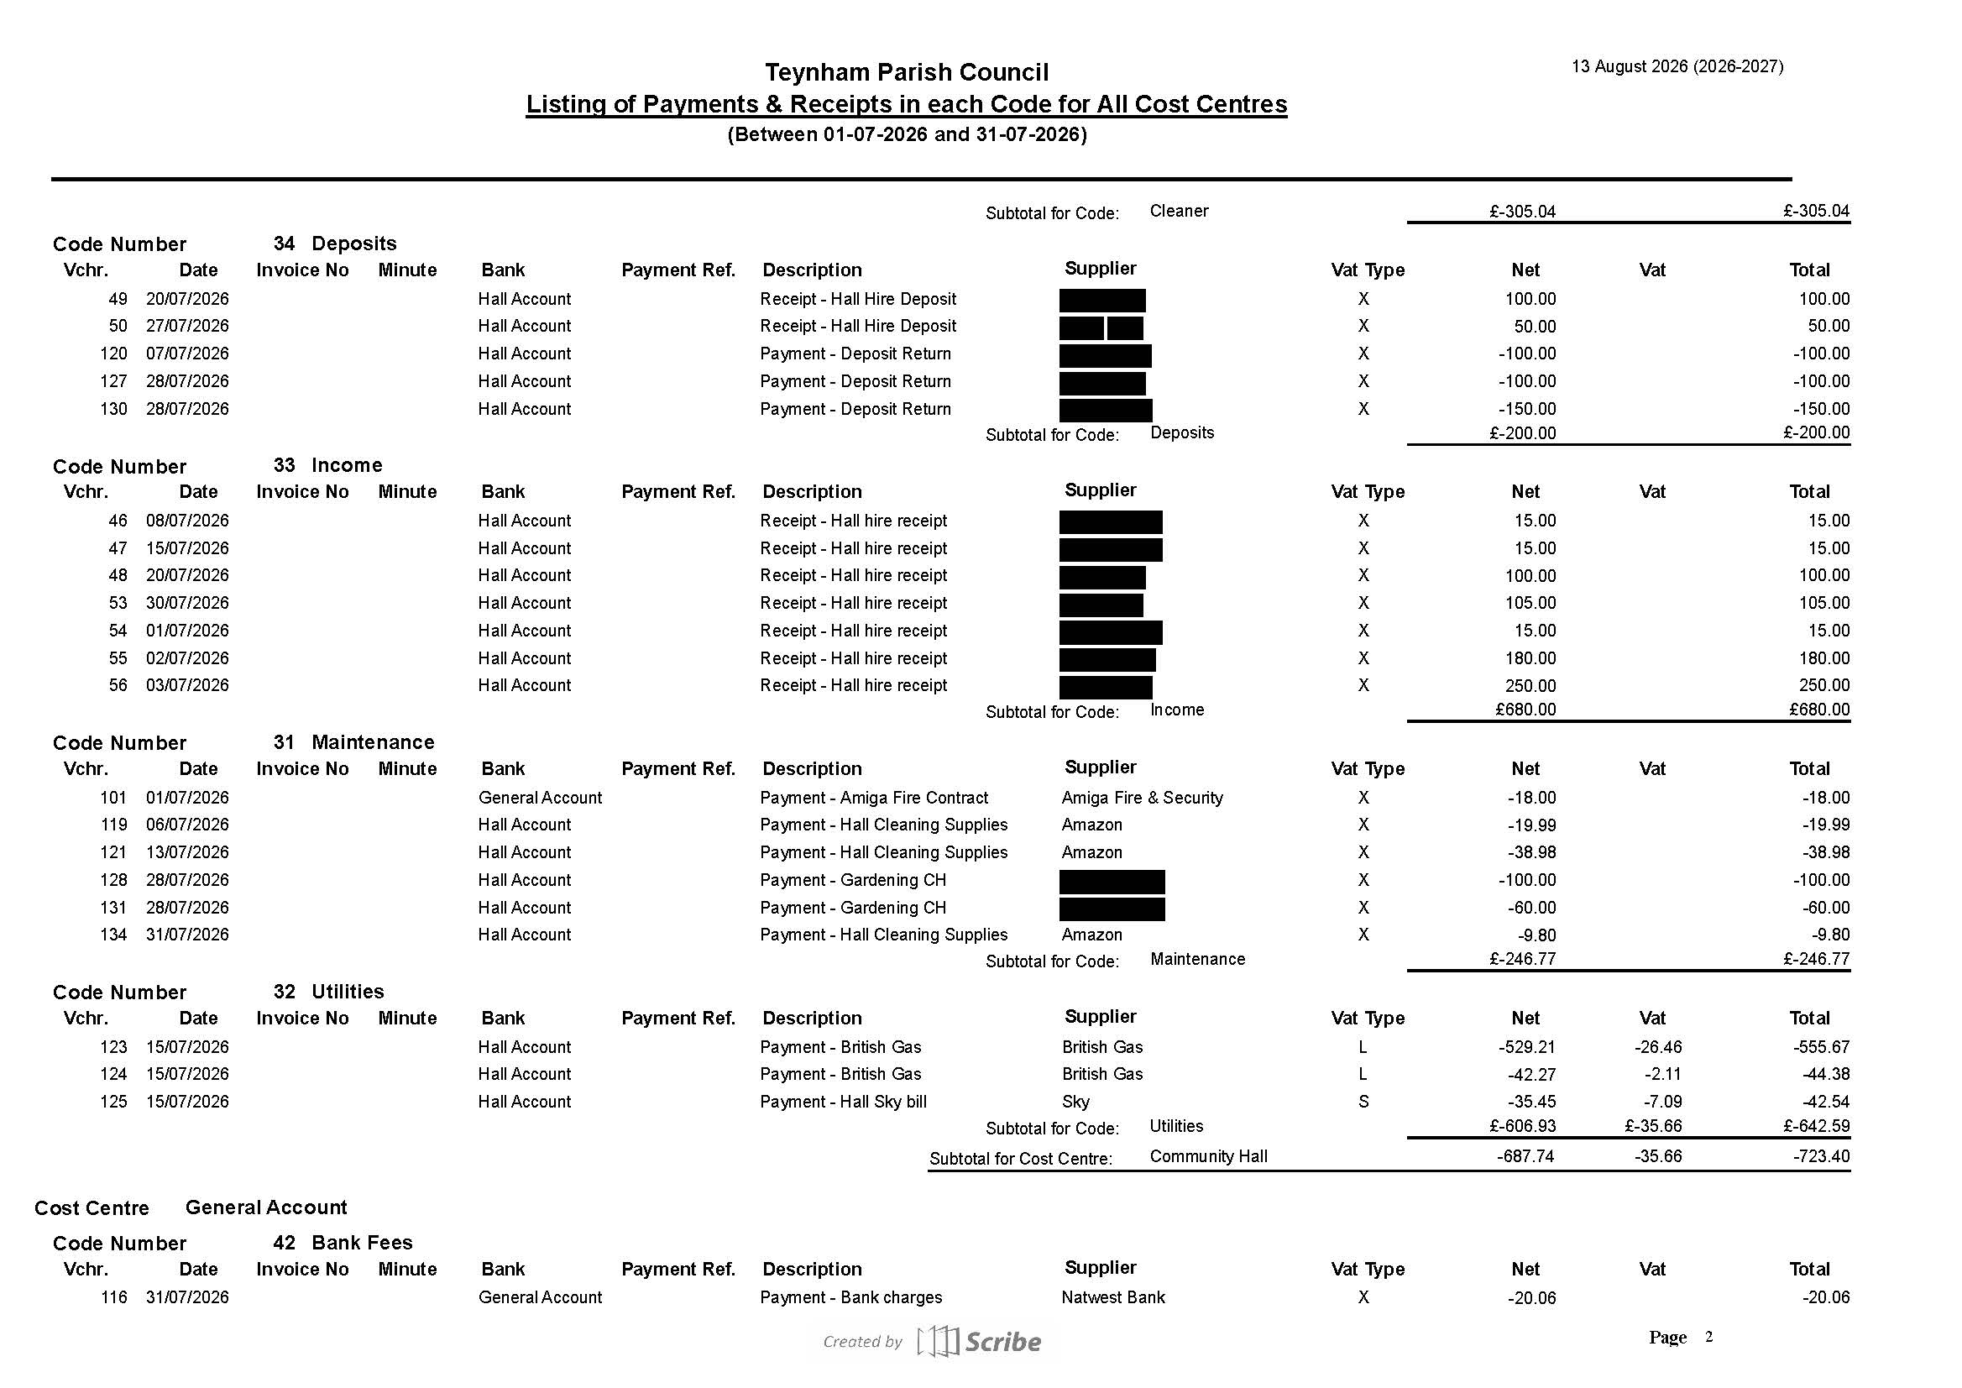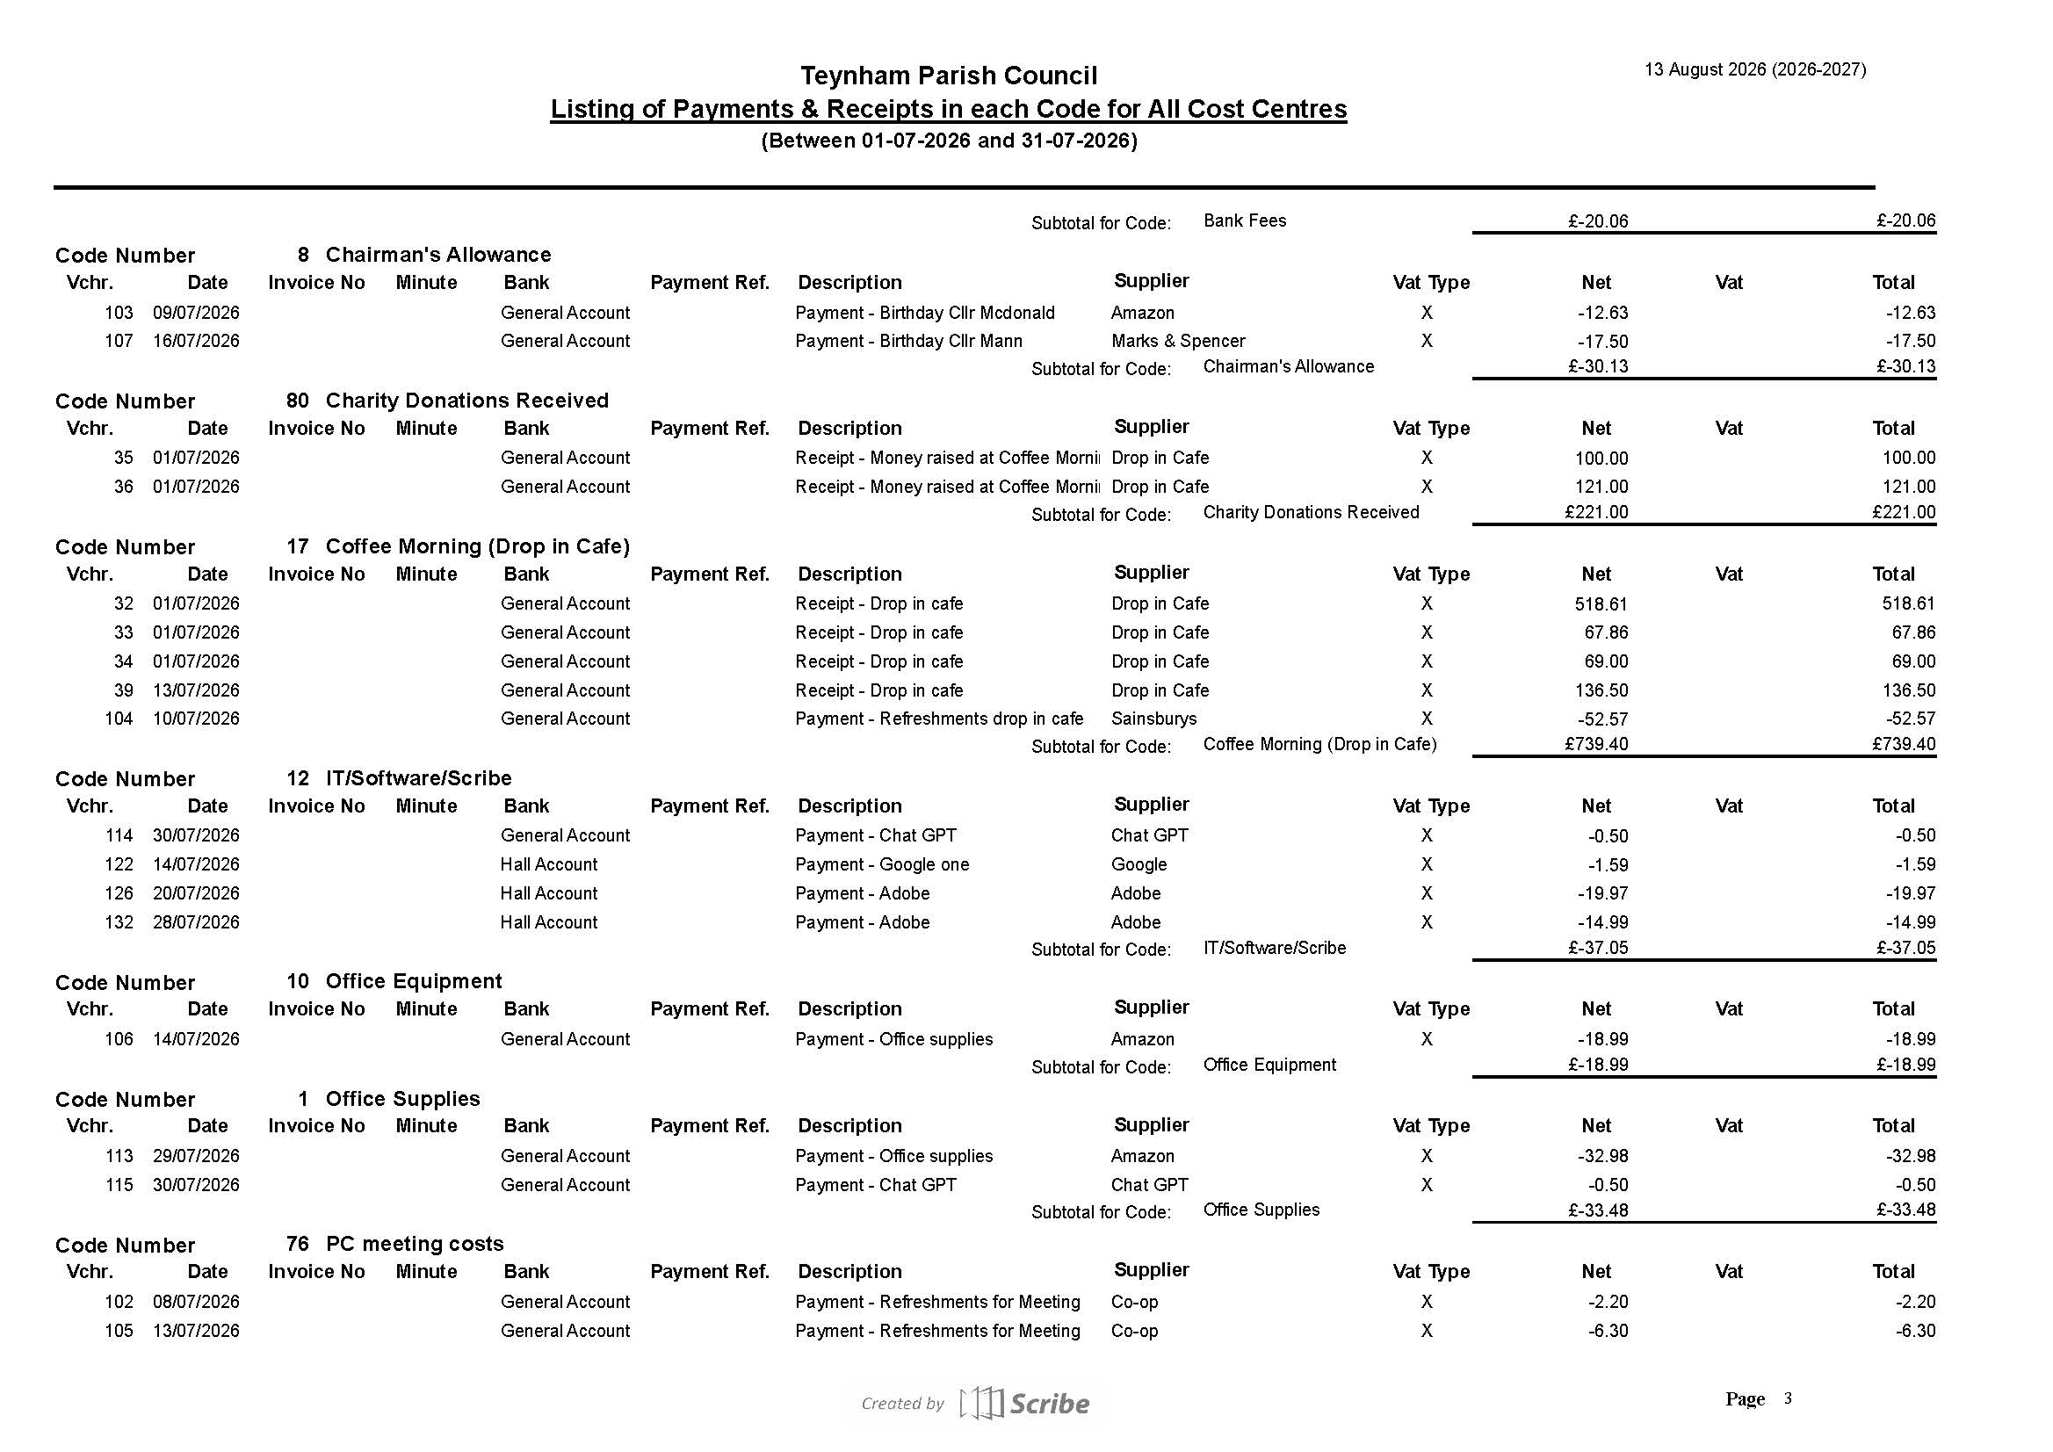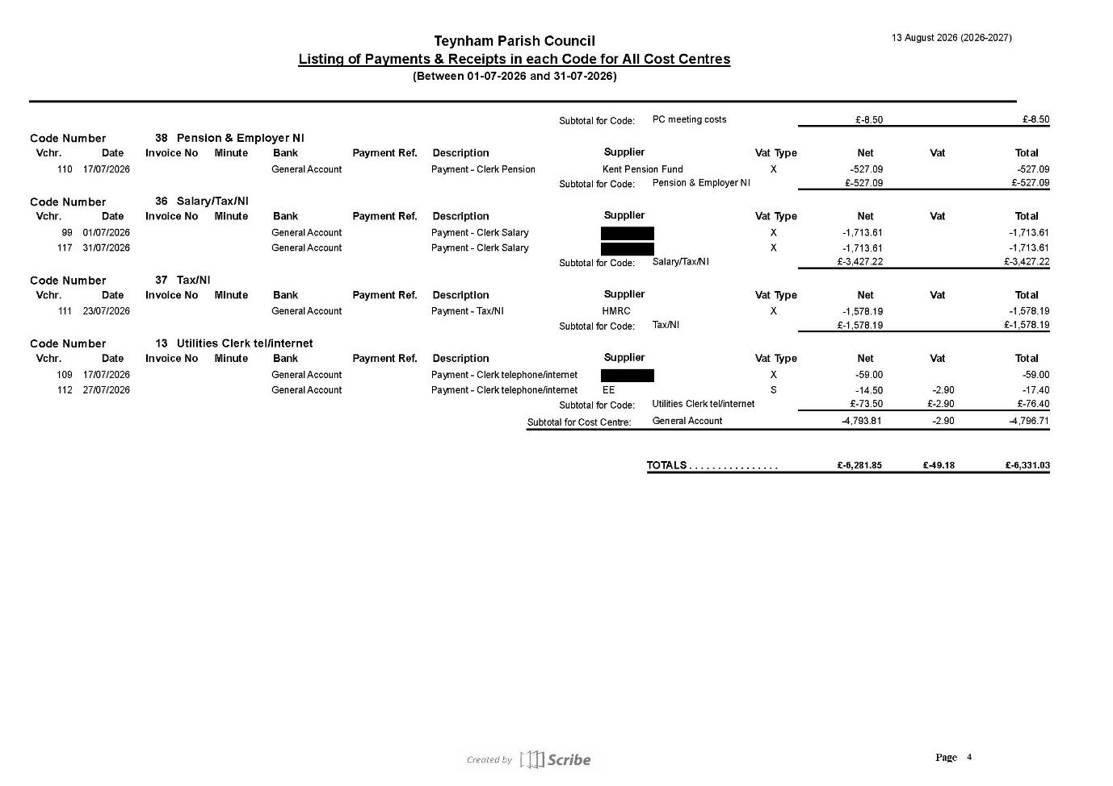
Please contact the Clerk with any questions by Friday 4th September.

12.3 To receive an update on transition to Unity Bank

The Clerk is awaiting a reply from Unity Trust Bank in answer to some questions.

12.4 To receive an update on call for Tradespeople

Name | Contact Details | Contractor Typehttps://www.facebook.com/share/19QUKnJt1L/?mibextid=wwXIfr | Liability Insurance
Stephen Fielder | Kent Property Cleaning Ltd  Steve Fielder  07392 007579  www.kentpropertycleaning.com | Play area cleaning and graffiti removal  Roof cleaning and moss removal  Gutter clearing and cleaning  Render, brick and cladding cleaning  Pressure washing of paths, patios and communal areas  Graffiti and general exterior cleaning  High-level cleaning and maintenance using our own 20-metre tracked cherry picker  Operated cherry-picker access for other trades where required | Yes
Frankie Ward | 07535866159  Forwardbuildinguk@gmail.com | We are a general building company so can carry out a huge range of works if your require. We have a large network also so if there’s something we can’t do, we know someone who can. We also specialise in disabled adaptions and work closely with local authorities and housing associations. Namely Southwark and Bexley councils, along with Town and country housing where we cover the whole of the south east of England. | Yes
Paul Abnett | T&P Garden Maintenance  Mob: 07983141755  https://www.facebook.com/share/19QUKnJt1L/?mibextid=wwXIfr | Garden Maintenance | Yes

Noted.
12.5 To agree to donate the £121 raised at the coffee morning on 26th June 2026 to Vincent Simester for his physio room.

It was moved by Cllr Barnett, seconded by Cllr Jessup and

RESOLVED: “That the Parish Council agree to donate the £121 raised at the coffee
morning on 26th June 2026 to Vincent Simester for his physio room.”

- Advanced Notice of Items for the Agenda of next Ordinary Meeting.

Send to Clerk.

- To note next year’s meeting dates
    - Tuesday 6th October 2026 Ordinary Meeting
    - Tuesday 10th November 2026 Ordinary Meeting
    - Tuesday 15th December 2026 Budget/Precept & Ordinary Meeting

- Chairman’s Closing Remarks

The Chairman thanked everyone for coming and noted that he will not be at the next meeting as he is on holiday. The meeting closed at 8.55pm.

