**MINUTES OF THE ORDINARY MEETING OF TEYNHAM PARISH COUNCIL HELD ON TUESDAY 22ND JULY 2025 AT TEYNHAM COMMUNITY HALL, 89 STATION ROAD, TEYNHAM AT 7.30PM.**

**Present:** Cllr Barnett, Cllr Brodigan, Cllr Dixon, Cllr Dunne, Cllr Mann, Cllr Mcdonald, Clerk Hayley Steel, SBC Bowen.

**Absent:** Cllr Saromi

**1. Apologies for absence**

Cllr Jessup, Cllr Simester, Cllr Sharman, Cllr Townson and KCC Lehman.

**2. Declarations of Interests on Items on the Agenda.**

None.

**3. To confirm that any changes to the Registers of Interests have been forwarded to the Monitoring Officer.**

None.

**4.Public Session for 20 minutes to allow members of the public and Councillors with pecuniary interests to speak for no more than three minutes in respect of the business on the agenda. A question shall not require a response at the meeting nor start a debate on the question.**

Lloyd Bowen thanked the Parish Council for his Freedom of the Parish award and was very surprised and touched to have received it. The Parish Council congratulated him and unanimously said it was well deserved.

A member of the public has reported overhanging bush outside number 69 Lower Road and he is going to investigate who is responsible.

A member of the public attending the meeting reported that cars are parking on the footpath right up to the hedges so it is unpassable at the bottom of Frognal Lane. The Clerk is going to report this to PC Divers and put a reminder in the Teynham News and Facebook.

**5.Receive an update from ward and county councillor(s) on items relating to the parish of Teynham (max 5 mins each).**

Cllr Bowen gave the following updates:-

* Approval was granted by Swale Planning for the building of 10 houses in Lynsted which is disappointing.
* There is to be a Community Governance Review to be carried out by Swale Borough Council and consultation will be going out in the next few weeks.
* Highsted Park continues to roll along. It was noted at the SBC Planning meeting that additional dates have been added for October. We will probably not receive any feedback/decision from Secretary of State until next year.
* Cllr Bowen has contacted Chartway regarding the overgrown bushes on the A2 Frognal Place site and was advised to speak to KCC. KCC are not able to help either. There is no indication as to when building will start at Frognal Place.
* Roadworks – Station Road has been closed and then re-opened but the sign remain. It seems that they are closing it as and when is needed.
* Bins – It was witnessed when the last time the brown bins were collected that the brown and green bins were emptied into the same truck – this has been reported but if anyone see’s this happening please take a photo and send it to Cllr Bowen.
* There is a water leak at Orchard View. Southern Water are working on it.

**6. To approve the minutes of the Annual Parish Council Meeting on Tuesday 27th May 2025.**

It was moved by Cllr Barnett, seconded by Cllr Dunne and

**RESOLVED:** “That the minutes of the Annual Parish Council Meeting on Tuesday 27th May 2025 be taken as a true record.”

**7.Matters Arising.**

None.

**8. To approve the minutes of the Ordinary Parish Council Meeting on Tuesday 24th June 2025.**

It was moved by Cllr Mcdonald, seconded by Cllr Dunne and

**RESOLVED:** “That the minutes of the Ordinary Parish Council Meeting on Tuesday 24th June 2025 be taken as a true record.”

**9. Matters Arising.**

Amendment to item 5. Devolution being delayed to March 2026 changed to KCC have asked for a delay to March 2026.

Dr Sikdar changed to Dr Nilan.

Amendment to item 10.2. Was moved by Cllr Barnett changed to Cllr Brodigan.

**10. Chairmans update.**

Thank you, Clive, for chairing tonight’s meeting.

The recent quiz night in aid of the Action Group raised £532. A big thank you to everyone who took part.

Local Council Reorganisation: Swale must indicate its preferred partner for future collaboration by November. Do we have any suggestions for potential partners?

Visit to Teynham School: A remarkable building and a real asset to the community. Thank you to everyone who joined the visit. We’ve now received some photographs of the school from KCC, which will be published in the next edition of Teynham News.

Highsted Park Planning Inquiry: The inquiry runs this week (Tuesday to Friday), and will resume in October.

Railway Tragedy: Teynham Parish Council responded to the recent tragic accident on the railway line by issuing a Joint Statement with Tonge Parish Council.

Freedom of the Parish: It was a pleasure to present the Award to Lloyd Bowen on Saturday evening. Safe to say—he was completely surprised! Photos and a Facebook update will follow.

Health & Safety: A paper has been prepared and will be discussed later in the agenda.

**11.Correspondence**

None.

**12.Community**

* 1. London Road Car Park: Request Clerk to investigate options for civil enforcement.

The PC took a vote on whether we wanted to consider civil enforcement options and it was unanimously decided to NOT explore civil enforcement at this time as we are monitoring the car park regularly and have spaces available.

* 1. Frognal Garden: Provide brief update on land opposite London Road car park.

The Clerk gave an update that she contacted Swale Borough Council asking about the possibility of leasing the land as we do for the London Road car park. This didn’t seem very hopeful but she said she would ask. She is also going to let me know the guide price.

* 1. HIP: Consider proposal to update HIP plan and request update from KCC.

The Parish Council received the below letter for a resident.

**To the Parish Council,**

I hope this email finds you well.

I am writing to raise a concern regarding the speed limit on **Conyer Road**, specifically the stretch between **Station Road in Teynham and Conyer , and also Teynham Street**at present, the national speed limit of 60mph applies to these roads, which I believe poses a significant risk to pedestrians, cyclists, horse riders, drivers of mobility scooters and drivers alike, given the nature of the routes.

I would like to kindly request that the Parish Council consider contacting **Highways Improvement Planning Services (HIPS)** to explore the possibility of reducing the speed limit from 60mph to 30mph on these roads. Lowering the speed limit would greatly enhance safety for local residents and visitors, particularly as this route is frequently used by walkers, horse riders and cyclists and lacks adequate pedestrian infrastructure.

I understand that these matters require consultation and careful consideration, but I hope this suggestion can be formally raised and progressed through the appropriate channels.

Thank you for your time and for the continued work you do on behalf of our community. I would welcome any updates or information regarding how this issue might be taken forward.  
Yours sincerely,

Cllr Dixon helped on our HIP plan some time ago so offered to draft an email that the PC can send to our HIP contact at KCC.

* 1. To receive an update on Highsted Planning Inquiry (sent in advance)

The below update was noted.

**Highsted Park Planning Inquiry – Update (July 2025)**

The planning inquiry continues this week and pauses for summer on Friday 25 July, resuming on 2 October due to barrister availability.

• KCC have this afternoon changed their position on Highways costs and viability to support a northern scheme only!

• Access: The Inspector noted it’s highly unusual for a scheme of this scale to proceed without detailed access plans.

• Inquiry Overrun: Extended by at least 6 days, pushing key topics—community concerns (to be presented by Julien Speed) and planning—to October.

• Costs: Our barrister flagged the financial impact of the extension, and will formally follow up in writing.

• Funding (to July): Estimated costs: £33k. Funds raised: £31.5k, with remaining expected from quiz and auction—on track to meet costs up to end of July.

• October Overrun Costs: Estimated at £11.5k total, to be split 50/50 with the Five Parishes (our share ~£6k). We are negotiating this figure down.

• Barrister Change: Simon Barnes will take over from Simon Bell in October. Day rate has increased—currently under negotiation.

• Additional Funding: Plans underway for further fundraising; details to follow.

• Public Update: A community update event is planned. Date TBC.

• Help Needed: Fundraising volunteers welcome—please get in touch.

* 1. To consider request(s) to support “Teynham Tuesday” during the winter months.

Cllr Saromi was not present at the meeting so the Clerk will ask for an update.

* 1. To note that the Christmas Market & Lantern Parade is booked for 30th November 2025.

The Clerk informed the PC that the Christmas Market and Lantern Parade will take place on Sunday 30th

1. **Health & Safety**
   1. To note paper on Health and Safety (Update 2025 – received in advance)

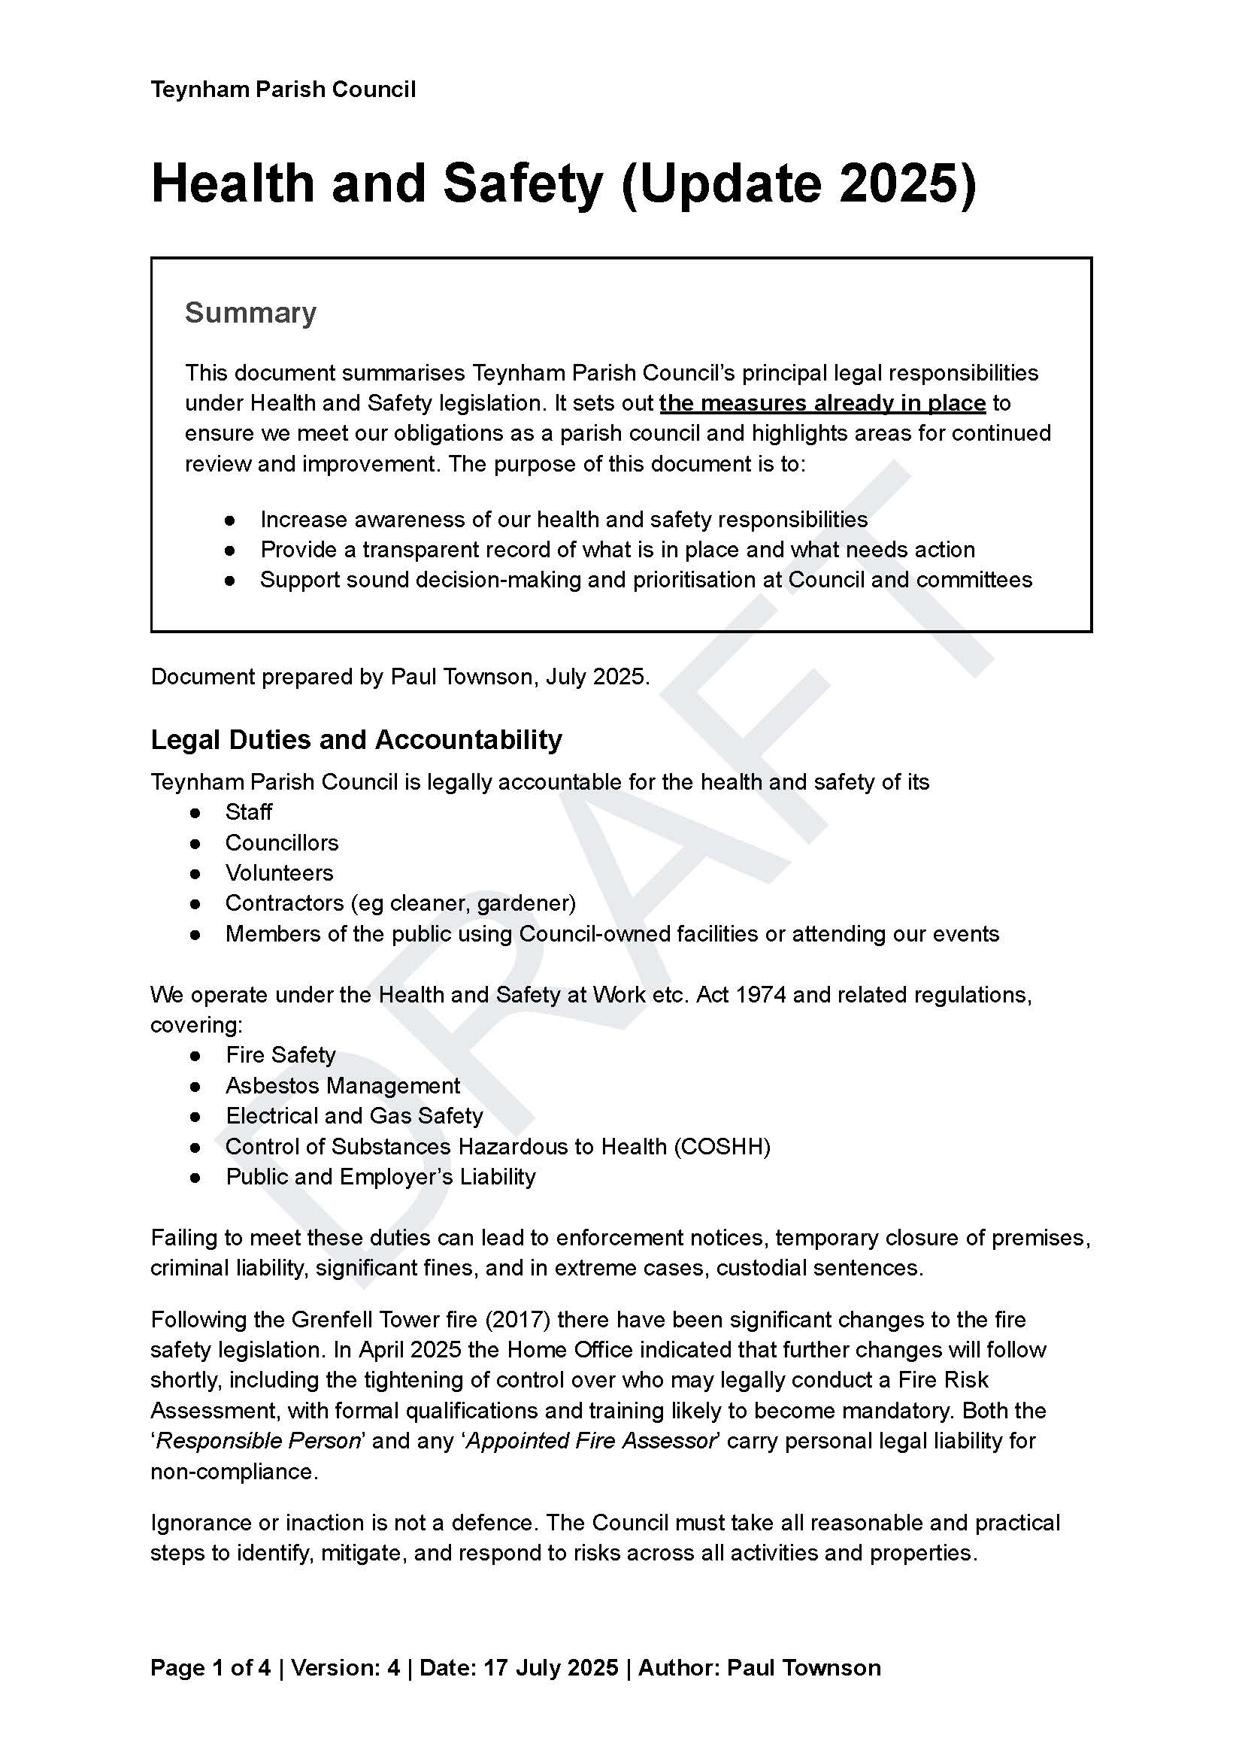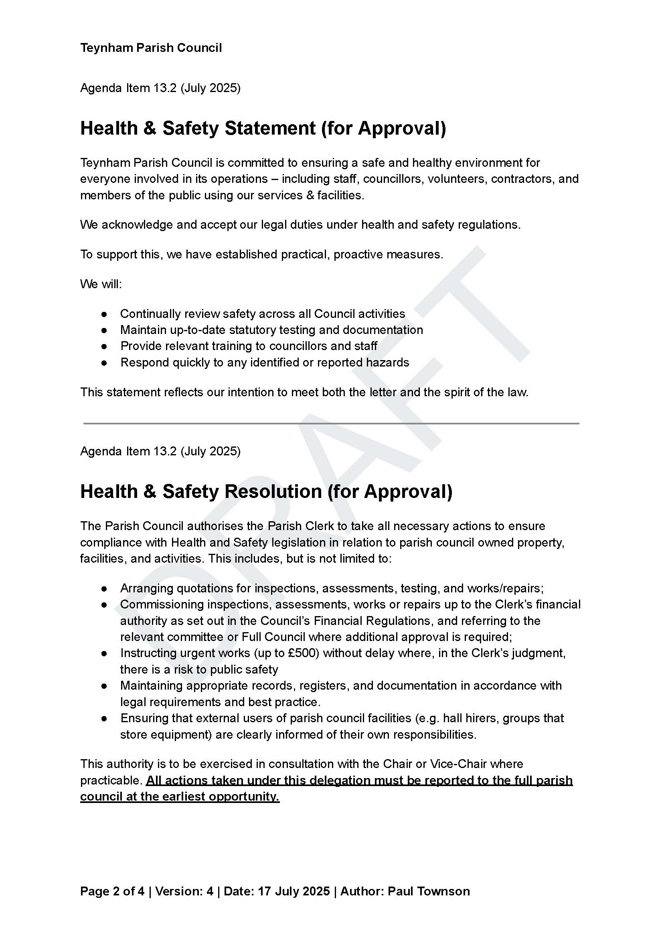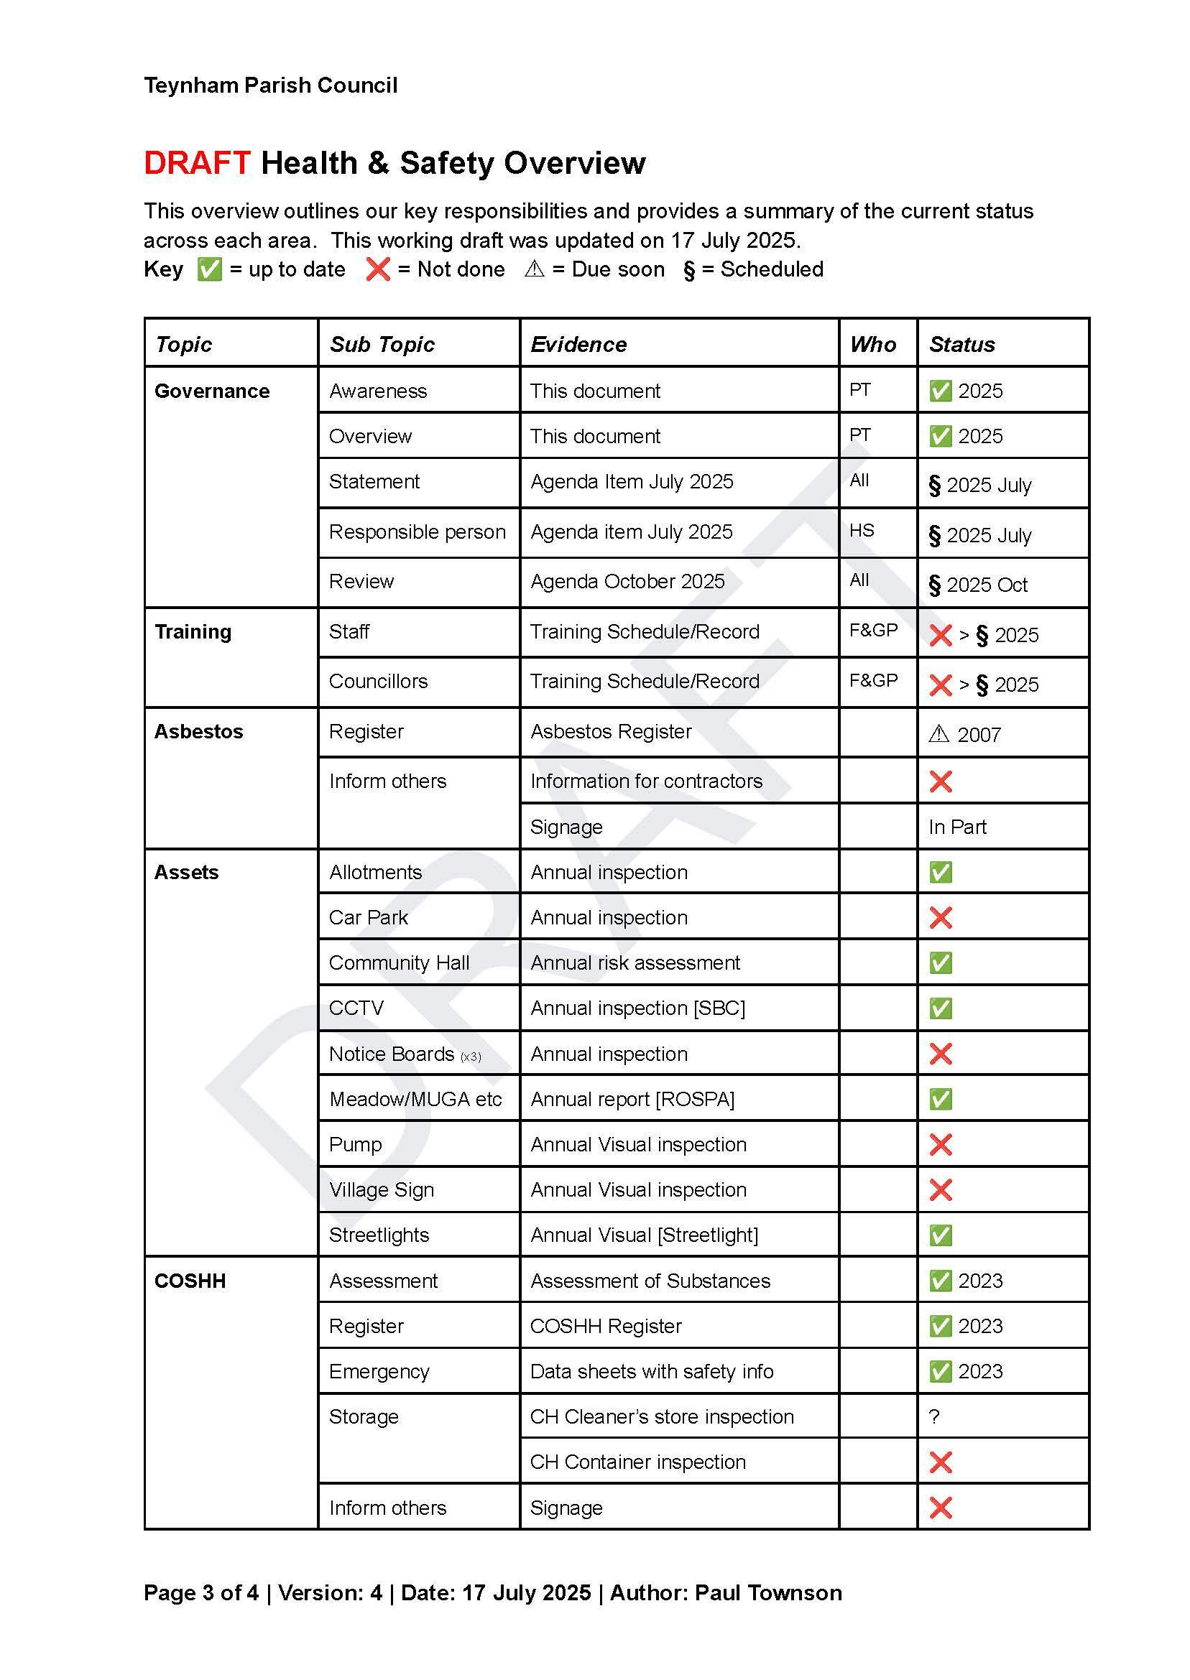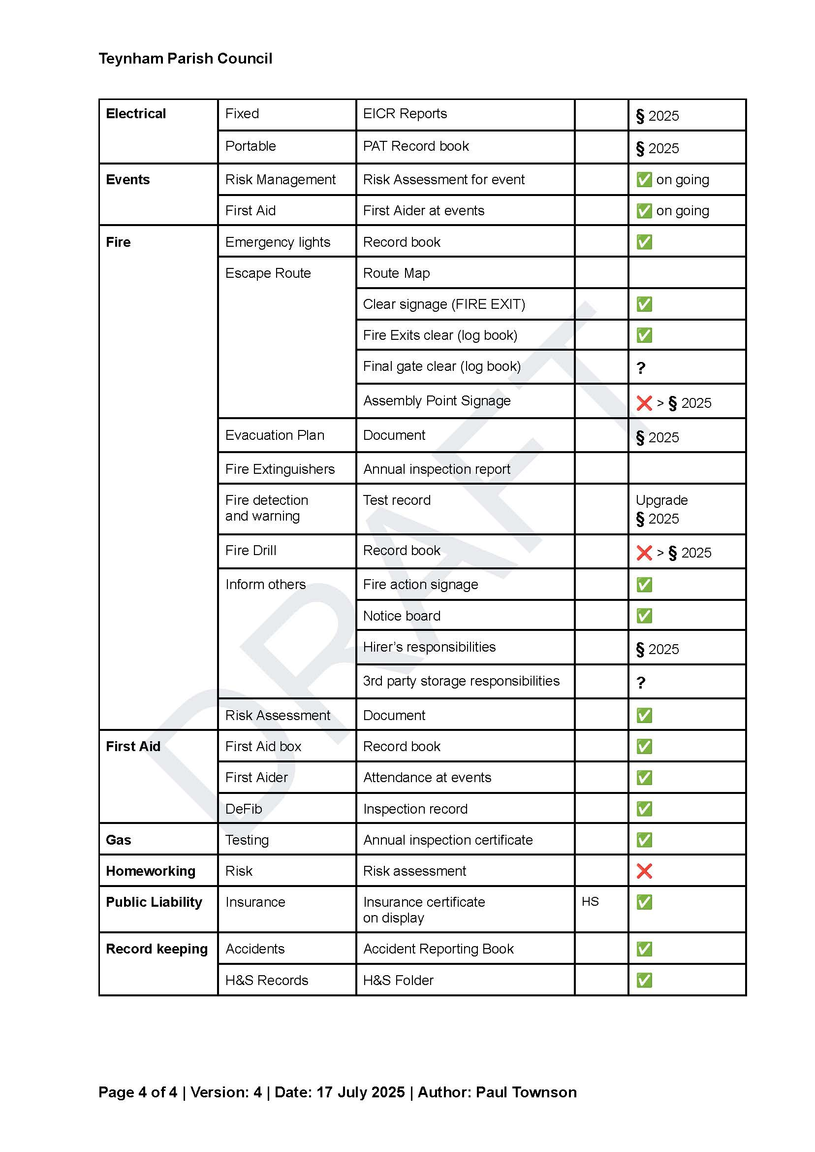

Noted.

* 1. **To agree ‘Health & Safety Statement’ and ‘Health & Safety Resolution’(as outlined in the Health & Safety Update 2025).**

It was moved by Cllr Barnett, seconded by Cllr Mann and

**RESOLVED:** “That Teynham Parish Council agree the Health & Safety Statement and the Health & Safety Resolution.”

* 1. To agree to pay for testing of fixed wiring up to the value of £1,000.

It was moved by Cllr Mcdonald, seconded by Cllr Barnett and

**RESOLVED:** “That Teynham Parish Council agree to pay for testing of fixed wiring in the Community Hall up to the value of £1,000.”

1. **Finance**
   1. Items to authorise

Nothing to authorise.

* 1. To receive details of income and expenditure since last meeting

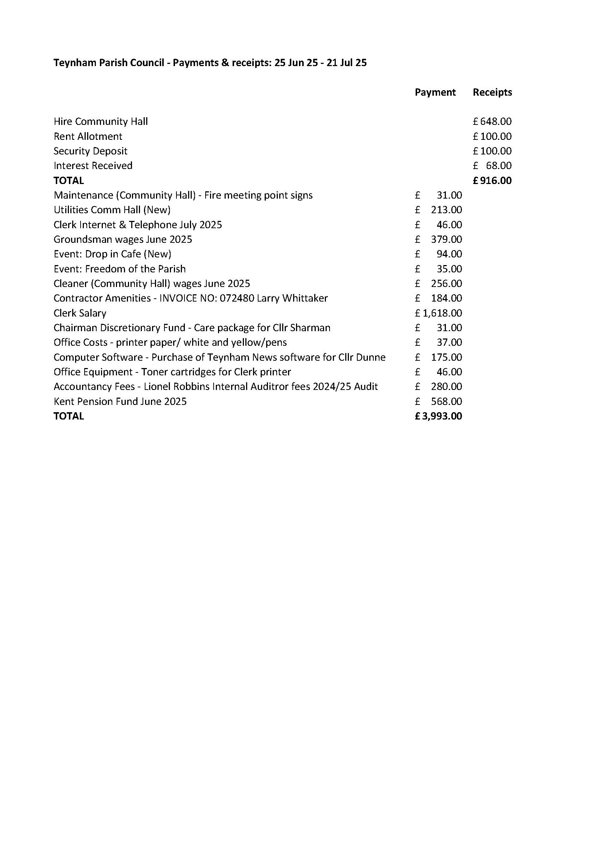

It was moved by Cllr Barnett, seconded by Cllr Dunne and

**RESOLVED:** “That Teynham Parish Council agree the income and expenditure since the last meeting.”

* 1. Receive Update on Authorised Signatures

The Clerk informed the PC that when the mandate was received to add Cllr Simester and Cllr Mann as signatories it was sent to Cllr Townson and Cllr Brodigan to approve as Cllr Sharman is unwell. Unfortunately, Natwest Bank came back and said that Cllr Townson is not a signatory so it was agreed to ask Cllr Sharman to approve it.

* 1. To request the initial Scribe financial report be ready for the September meeting

Noted.

1. **Grant Applications**
   1. To consider applying for a SBC Community Infrastructure Grants, to cover   
      Fire Alarm, Automatic Door, Heating Noise Attenuator and Heater boost timer at the Community Hall.

It was moved by Cllr Dunne, seconded by Cllr Mcdonald and

**RESOLVED:** “That Teynham Parish Council agree to apply for a Swale Borough Council Community Infrastructure Grants, to cover   
Fire Alarm, Automatic Door, Heating Noise Attenuator and Heater boost timer at the Community Hall.

1. **Meadow**
   1. To receive an update on repairs to playground equipment and alternative proposals

The Clerk informed the PC that the quote we have received is in excess of £23,000 and we cannot afford to pay that amount. It was agreed to as Gransdens to provide a quote for this work.

* 1. To receive an update on grant application for high ball fence

The Clerk informed the PC that the grant application for the high ball fence was submitted on Friday 18th July and can take up to twelve weeks.

* 1. To receive the CCTV report (via PC Drivers)

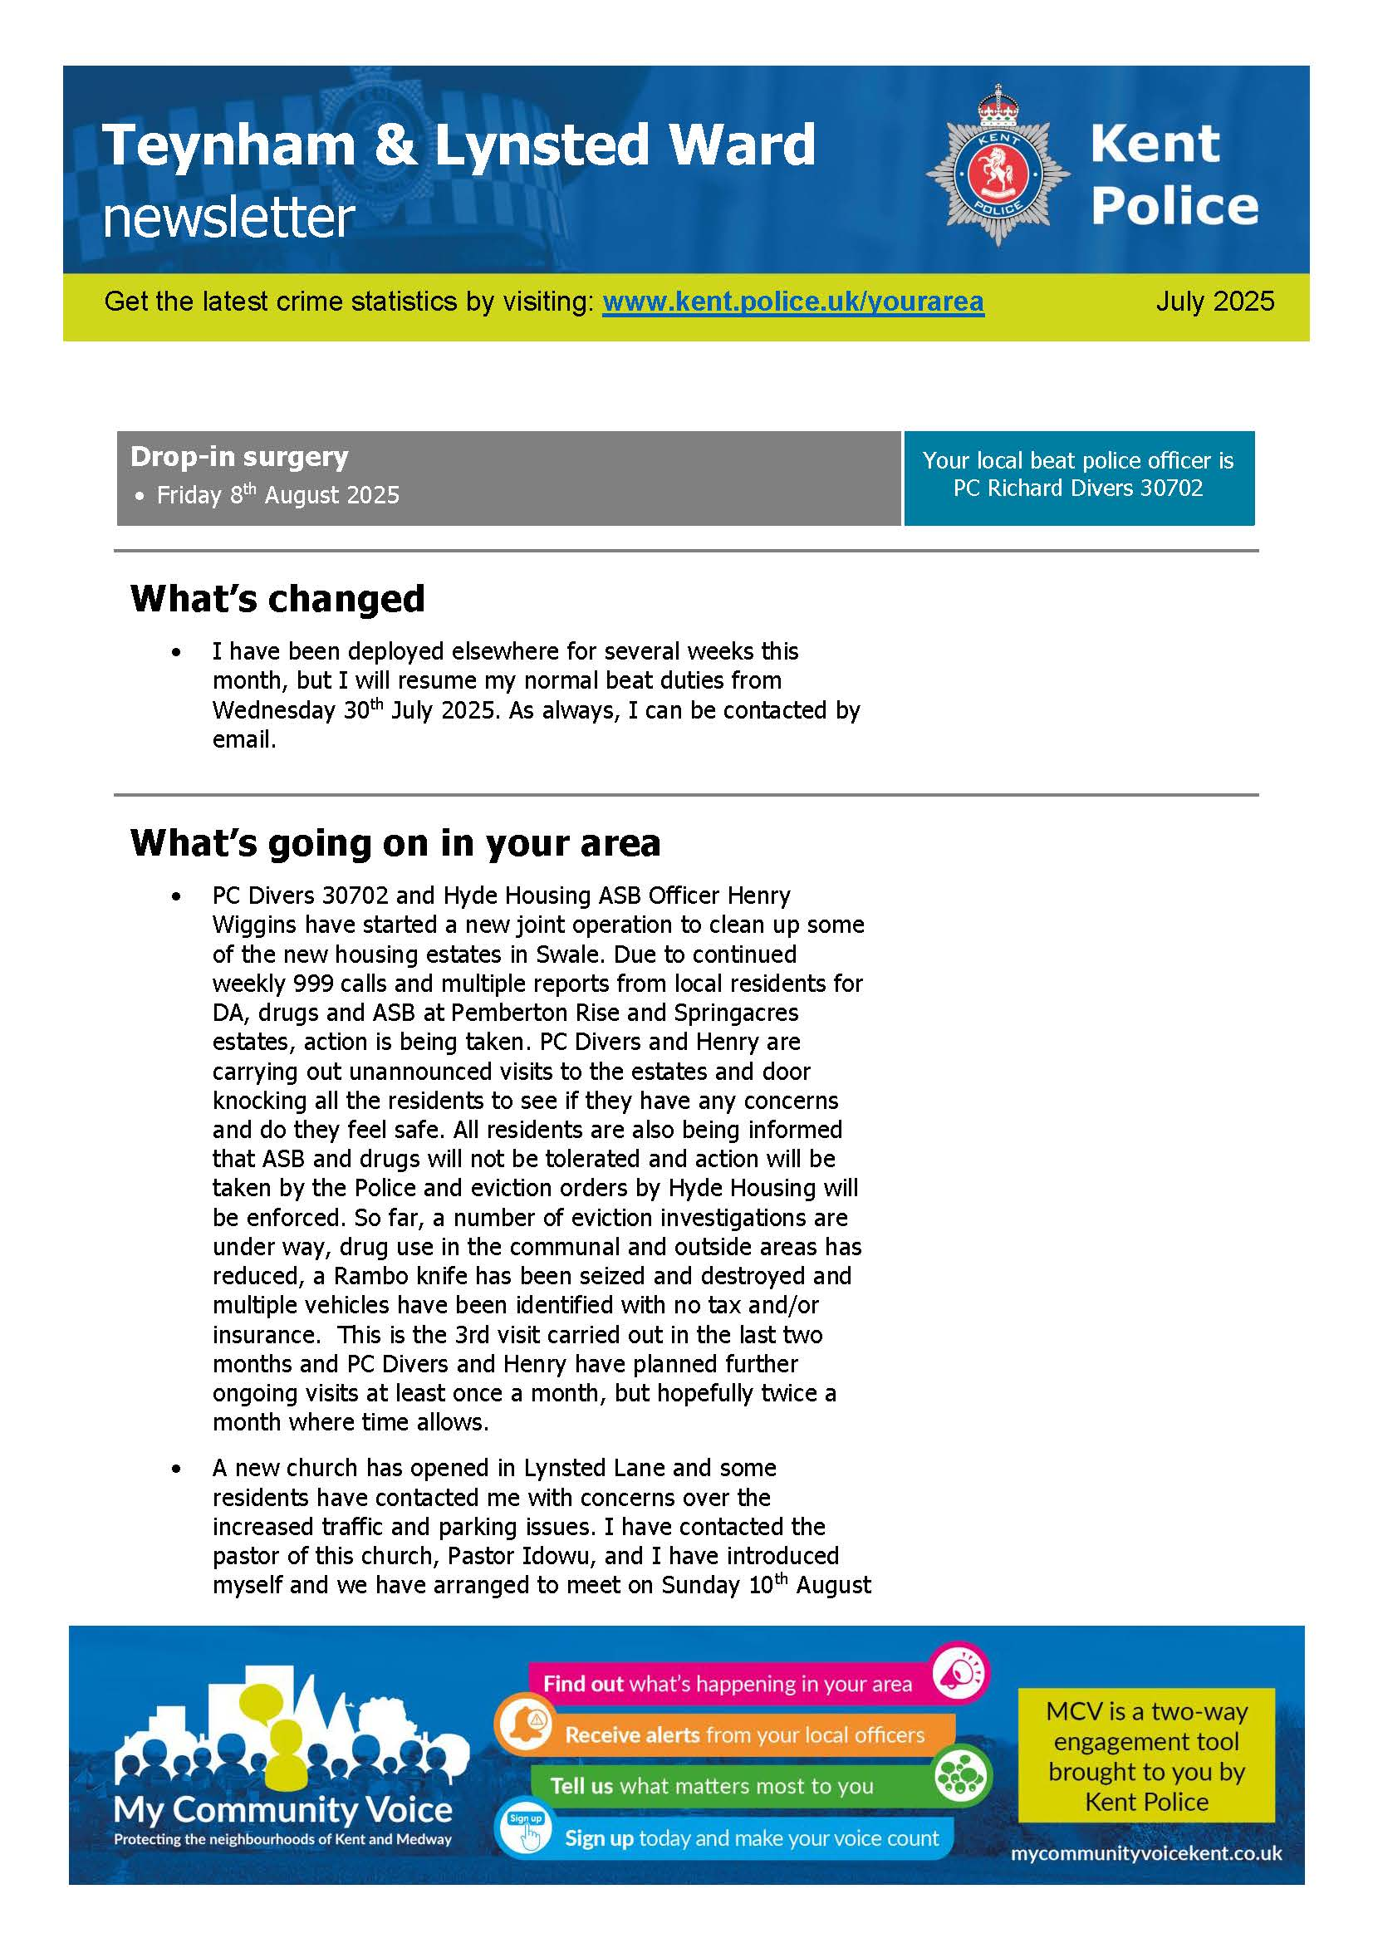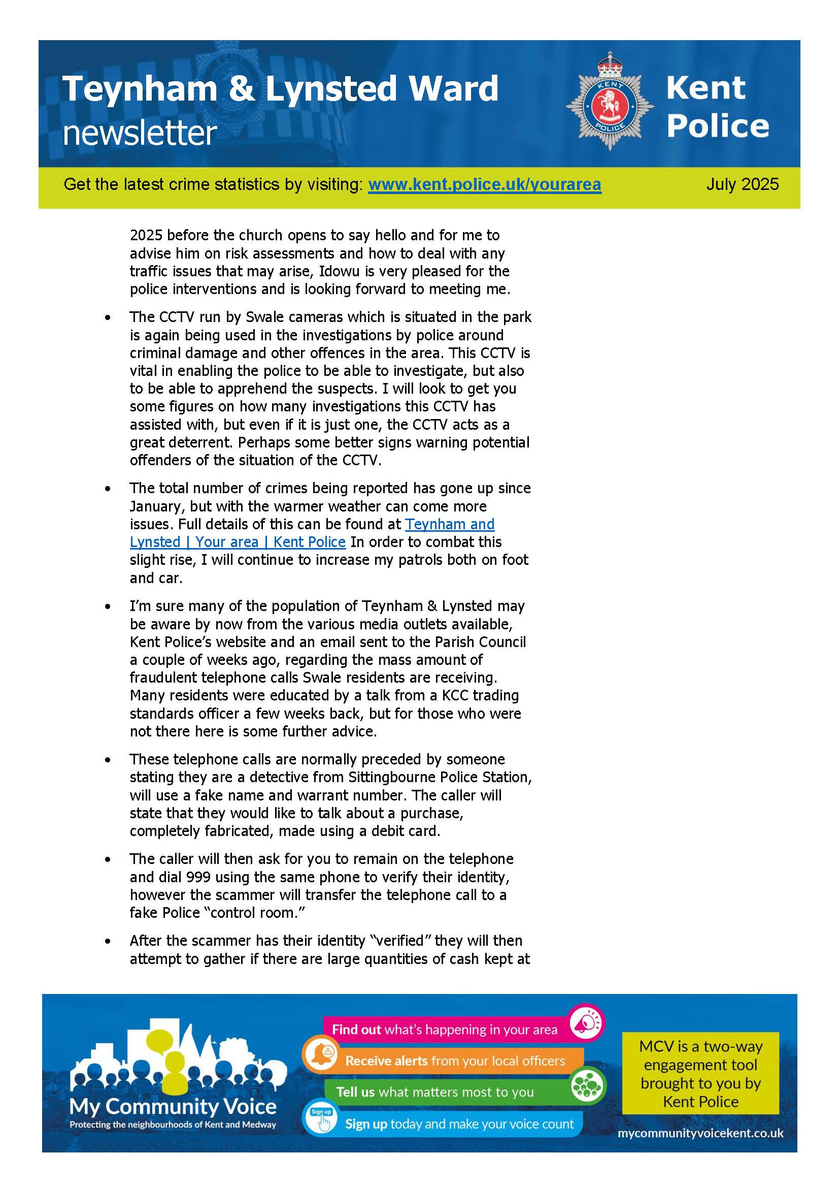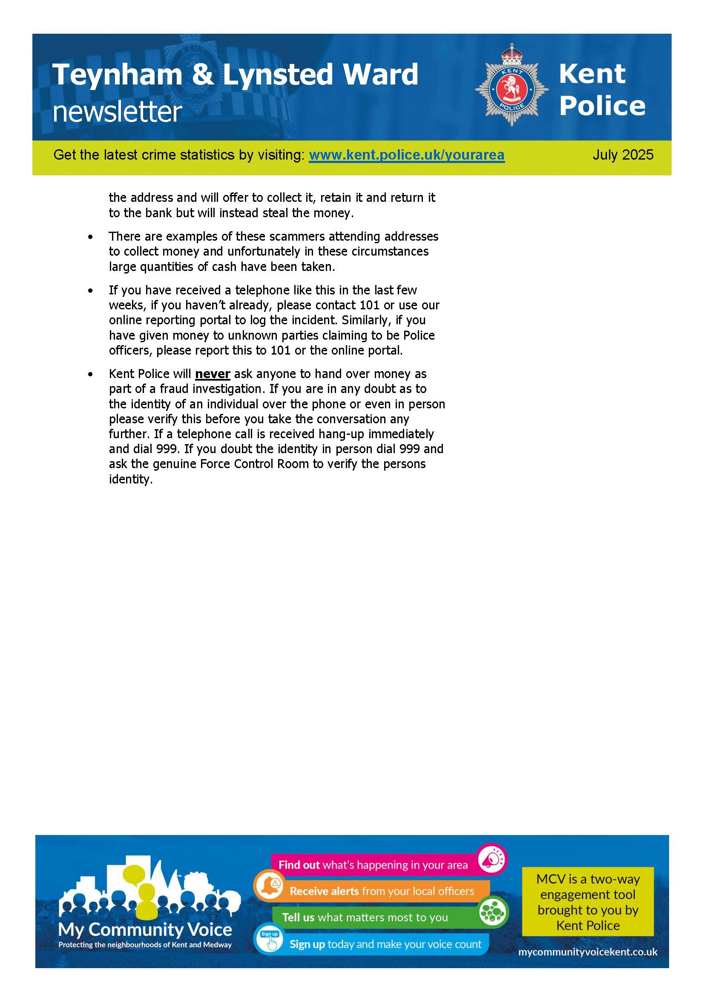

Noted.

* 1. To note the schedule for trees/shrubs to be cut back

It was noted that Dave Gurney will cut back the tree/shrubs mid-September after nesting season.

1. **Reports of Committee Chairman** 
   1. Planning – Highsted Park update already given, nothing else to report.
   2. Amenities – Update on repairs to the Meadow already given and nothing else to report.
   3. Finance and General Purposes - Nothing to report.
   4. Editorial – The Editorial Committee are currently working on the summer edition.
   5. Teynham Community Hall – Health & Safety document has been approved and quotes are being obtained.
2. **Reports by representatives on outside organisations** 
   1. TVHMC – nothing to report
   2. KALC Swale Area Committee – Nothing to report
3. **Advanced Notice of Items for the Agenda of next Ordinary Meeting.**

Send to the Clerk.

1. **To note next year’s meeting dates**

Tuesday 9th September 2025 Ordinary Meeting

Tuesday 21st October 2025 Ordinary Meeting

Tuesday 9th December 2025 Budget/Precept & Ordinary Meeting

Noted.

1. **Chairman’s Closing Remarks**

The Vice Chairman thanked everyone for coming and everyone wished Cllr Sharman a speedy recovery. The meeting closed at 9.10pm.